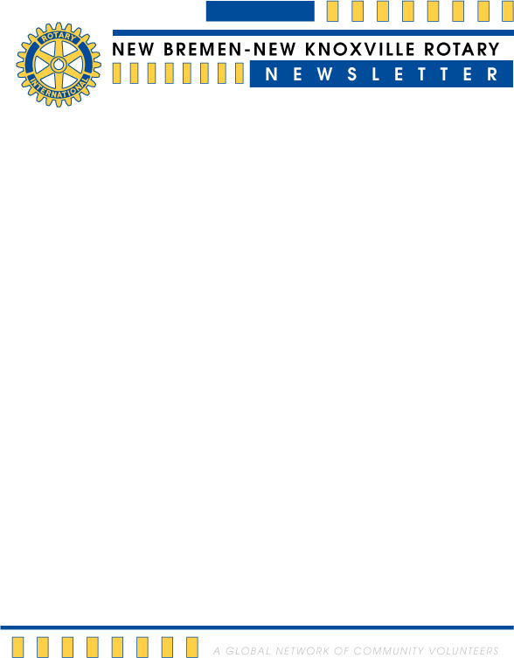

**July 2017**

***Upcoming Events …***

July 4 No Rotary Meeting

July 10 Bagging groceries for the Agape Summer Meal Program

July 23 Installation of District Governor Deb Cheney – Findlay University

Aug 15 Program - District Governor Deb Cheney

Aug 18-20 Bremenfest French Fry Stand

***From the Rotary Board …***

* There will be no meeting, next Tuesday, July the 4th.  Have a safe and happy holiday!
* The club will be bagging groceries for the Agape Summer Meal program on July 10th at 9:00 am.  Contact Neal Brady if you are interested in helping with this project.
* The nature path by Aqua View and Coldwater Creek were dedicated on June 16th.  A big “Thank You” goes out to those who came out on short notice to join in with some of the members of the St Marys and Celina clubs for this event.
* District Governor Deb Cheney will be visiting our club on August 15th and will be bringing her “Piggy for Polio” piggy bank.  Be prepared to be inspired and also donate to the continuing Rotary effort to fight polio.
* The new Rotary board members were sworn in on June 27th.  First of all, thank you Tim Eiting, Jeff Piper and Steve Hartwig for your service as you leave the board of directors.  Thank you to the continuing and new board members as well for offering your time and energy to support the club:
  + Dale Bertke for renewing for another 3 years on the board.
  + Bernie Schroer, Devin Kuck, Anna Rammel, and Rob Kuenning, for joining the board.
  + Lesia Arnett for accepting the President elect position.
  + Becky Strang as she continues on the last year of her term.
  + Also thank you to Mark Cisco, Keith May and Larry Dicke for their continuing service.  I can appreciate the amount of work that they put in as treasurer and secretary and we should all be thankful for their willingness to do the work of the club.
* **Last but not least, a big thank you goes out to Dave Kelch for an outstanding Rotary year.  His dedication, energy and caring attitude has been an inspiration for all of us.  Thank you Dave for being a great leader!**
* I will send an update soon about the new Rotary year and some of the areas of focus that we discussed in the club assembly.  I’m looking forward to our club doing some great things this year!

Yours in service,

Steve

.

July birthdays are Stan Wietholter on the 10th and Joni Leffel on the 31st. Anniversaries for July are

Jim & Janet Dicke on the 6th, Jeff & Holly Bertke on the 9th, Dan & LaRita Condon on the 22nd, John &

Sandra Wierwille on the 26th and Becky & Jim Erb Strang on the 28th.

**Programs:**

|  |  |  |  |  |  |
| --- | --- | --- | --- | --- | --- |
| **Jul 4** | ***No Meeting*** | **Aug 1** | **Anna Rammel** | **Sep 5** | **Lesia Arnett** |
| **Jul 11** | **Jeff Bertke** | **Aug 8** | **Wayne Lybarger** | **Sep 12** | **Brent Henschen** |
| **Jul 18** | **Renee Arnold** | **Aug 15** | **DG Deb Cheney** | **Sep 19** | **Steve Hartwig** |
| **Jul 25** | **Jim Dicke II** | **Aug 22** | **Becky Erb Strang** | **Sep 26** | **Jim Kronenberger** |
|  |  | **Aug 29** | **Alyssa Winner** |  |  |

***One of the most important leadership lessons is realizing that you’re not the most important or the most intelligent person***

***in the room at all times . . . . Mario Batali***

*Rotary websites*:

Our local site [www.nbnkrotary.org](http://www.nbnkrotary.org)

portal.clubrunner.ca/10903

District 6600 [www.rotarydistrict6600.org](http://www.rotarydistrict6600.org)

Rotary International [www.rotary.org](http://www.rotary.org)

