Contact: Alyssa Reginella  DONEGAL HIGH SCHOOL  Counseling & Career Resource Center  Phone: (717) 492-1209  Fax: (717) 492-1242 | alyssa.reginella@donegalsd.org  1025 Koser Road  Mount Joy, PA 17552  www.donegalsd.org

Press Release

Donegal High School Announces Mount Joy Rotary
Students of the Month

Mount Joy, October 2025: The DHS Counseling Office & Career Resource Center has announced the Mount Joy Rotary Students of the Month. The selected outstanding students will be honored by members of the Mount Joy Rotary during their monthly luncheon meeting.

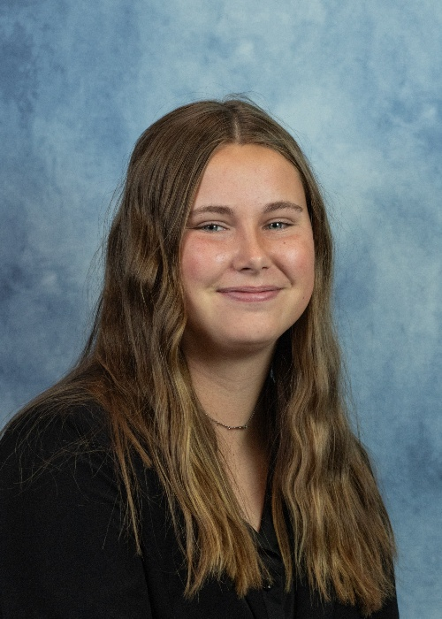
The Mount Joy Rotary Student of the Month for October is Samantha Alampi, daughter of Michael and Kimberly Alampi, of Marietta.
Samantha is Treasurer of the Donegal Performing Arts, President of the Marching Band, Concert Master of the Orchestra, Vice President of the Tri-M Music Honor Society, Historian of the National Honor Society, and President of the Gender and Sexuality Alliance. She is also a member of the Rhythm Singers, Big Brother Big Sister, Concert Band, and Jazz Band.

Outside of school, Samantha is an active member at Trinity Lutheran Church. She attends the church youth group, church mission trips, is a vacation bible school counselor, and is the Assistant Director for the summer church choir camp.

Samantha enjoys spending time with her younger sister Dani and her Donegal Youth Soccer team. She also loves babysitting for several families in the community.

Samantha plans to attend a four-year college, studying Political Science as well as Women’s, Gender, and Sexuality studies, and minor in Spanish.

The Mount Joy Rotary Student of the Month for October is Caiden Karpel, son of Sean and Beth Karpel, of Mount Joy.
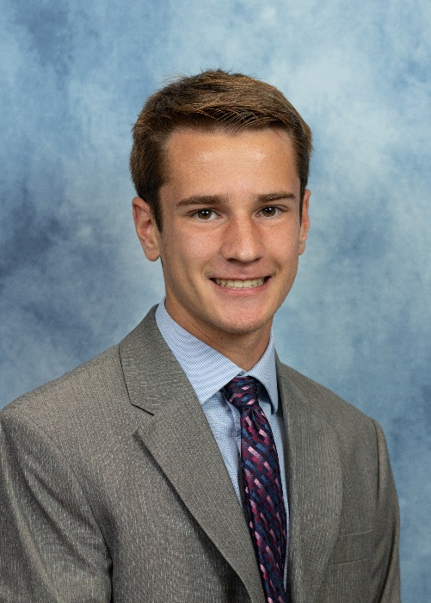
Caiden is Vice President of the Math Honors Society, a member of the National Honors Society, and a Peer Tutor. Caiden is also a member of the chess and bible study clubs. He enjoys being a Prayer Group Leader at Donegal. He is the captain of the Cross Country team and was selected as a second team all-star. Caiden is also a member of the Track and Field team.
Outside of school, Caiden attends Community Bible Church and helps lead a Sunday night bible study group.
He has worked at Bicycle Outfitters for the past three years.
After graduation, Caiden plans to attend college for Electrical Engineering.

