The Pavilion School aims to re-engage young people who are currently disengaged from any form of education, by providing students with a relevant and individually tailored education program.

The Preston Rotary Club, with the support of Darebin Council, have supported the school and in recent months the school has completed the building of a Skills shed. This will make Skills shed learnings

The next stage is the fit out of the shed with tools and equipment to the tune of $10,000
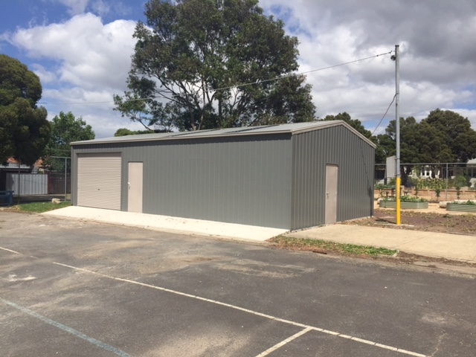

Rotary Skills Shed at the Pavilion School Preston 2016

