Club No. 87890
District 9820
Chartered 22 July 2016

SIXTH ANNUAL

CHANGEOVER MEETING

&

ANNUAL REPORT 2021/22

Wednesday 11 July 2022

7.30pm

Online

Rotary eClub of Latitude 38

Changeover Program
Monday, 11 July 2022

__________________________________________________

Call to Order – Chair –PDG Brian Norris 7.30pm

Welcome and Introduction of Guests Chair

Roll Call of Members Chair

Apologies Ruth Mount Chair
Petra Showell
Elli Adams
Pete Showell
Sophanit
Patricia Murray-Walton

Invocation and toast to Australia Chair

Four-Way Test Chair

Toast to Rotary International Don Crewe

Response to Toast to Rotary International PDG Janet McCahon

Presentation of 2021-22 Annual Report President Judy van de Vlugt
Judy to read President’s report with assistance from
Chairs as necessary ie. Treasurer)

Changeover Judy van de Vlugt /Don Crewe
Handover of Charter (Screen share of Charter)
PDG Janet to present Chain of Office President’s Badge and Theme Badge. PDG Janet McCahon /Don Crewe

President’s Remarks (thank you to PDG Janet) President Don Crewe

Introduction of 2022-23Theme (Screen share of RI Theme) President Don Crewe

Introduction / Presentation of 2022-23 Board
(Screen share of Board and Club Positions)

Closure of Meeting President Don Crewe

Club President’s Report

First, thanks to all our members for your support and help over my year as President.
I have enjoyed my year very much, which we have looked at many projects, had great discussions about them some we have gone ahead with some are still in discussion.
I wish incoming President Don all the best for his year as our President.

MEMBERSHIP
We started the year off with 13 members and welcomed new members: - Alfreda King, Elli Adams, Martin van Elst, Malcolm Findley, Michelle Worsley, Michelle Young, Patricia Murray-Walton, Pearl Findley-James,
And sadly, lost Vivian Armstrong, bringing our total membership to 22 a growth of 8.

Jim Armstrong and Pete Showell will leave us at the end of our Rotary year, with Pete becoming our second Honorary member.

PROJECTS: -

DIGNITY BAGS FOR THE HOMELESS
We were able to help some of the homeless with Dignity bags which contained in a large pencil type case personal hygiene products eg. Soap, Toothbrush, deodorant, etc.

GOOD FRIDAY APEAL
We were given the opportunity to help organize the Good Friday Appeal in Bairnsdale to collect the money and bank it, approximately 5 members helped on the day. Many thanks to Michelle Young who coordinated the program and did the liaison work with other agencies in the Bairnsdale region.

GUITARS FOR VETS
Members attended the district conference and were very impressed with Dave Coxs’ project Guitars for Vets which he gets donated guitars of any condition does them up and teaches Australian Defence Force members who are experiencing the effects of post-traumatic stress disorder to express themselves through music.

UKRAINE
We raised money to buy books for the Ukraine community in Australia and sent baby clothing to DIK to go over to Ukraine due to the war over there. Janet and Grant have also collected donations and delivered two large loads to the Ukrainian Community support group based in Essendon.

VIETNAM HEALTH CARE CARDS
We were able to send some money over to Vietnam to purchase Health Insurance cards.
We Supported Lift the Lid for Mental Health and Cambodia.

5 members attended the East Gippsland cluster Christmas Dinner and awards night we congratulate Michelle Young for all the work she has done for the Black Summer Bushfires.
Members will attend the movie Elvis the Movie - Donations will go to RAM
We also looked at purchasing and re branding our Rotary Shirts.

CLUB GOALS 2021-2022

INCREASE MEMBERSHIP INTERACTION- BY 2 | NET INCREASE 8
PROMOTE CAMBODIAN  VIETNAM PROJECTS | IN PROGRESS  CONTRIBUTED
ESTABLISH TWO OTHER PROJECTS – AT LEAST ONE IN AUSTRALIA | GUITARS FOR VETS  HOMELESS – DIGNETY BAGS  UKRAINE
HAVE A GOOD ATTENDANCE AT THE DISTRICT CONFERENCE | ATTENDED BY 5
MONTHLY MEETINGS PROJECTS | WE MEET 3 TIMES A MONTH
CONTRIBUTE $A2000 TO FOUNDATION | NOT AVALIABLE
CONTRIBUTE A$2000 TO POLIO PLUS | NOT AVALIABLE

Judy van der Vlugt

President 2021-2022

- Secretary’s Report
I am pleased with our efforts to improve our Zoom meetings again this year. With COVID effecting many clubs, we were able to ‘display’ our credentials online by visiting many of the other Rotary clubs, entities and supporters, assisting where possible to help their programs run just that little bit better. Now that we are (almost) back to normal with COVID, our presence is not so much online, but at least our members have been able to engage more with face-to-face meetings of other clubs. We continue to attract a range of guest speakers to our meetings. Provision of comprehensive minutes and videos of meetings continued to improve as I learned to listen, type, talk and edit videos. Storage of videos via my Cloud storage was also commenced and greatly assisted re-constructing meeting minutes without having to stop and ask questions. It was particularly useful when we entertained guest speakers.
While early in the Rotary year many of our efforts were thwarted by COVID considerations, we did manage to fundraise, with assistance from other clubs and District Grants, enough to continue the Vietnam Health Card project and the Cambodian Free to Shine support program.
There is still a fair amount of work required to bring our primary documents, website and Bulletin into line with Rotary and District norms. It’s more than just putting up a new logo every 12 months. The Club also needs to consider moving to a more integrated system of emails and document storage and retrieval. ClubRunner provides some of this functionality but there must be better systems out there that can provide a one-stop-shop for our needs.

Membership
The membership of the club has increased from 13 at the beginning of the year to 18 at the end, with now, 2 Honorary members (both of whom live in Cambodia).

Grant Ellers

Secretary 2021/22

New Directions: Youth

New Directions has been extremely quiet again this year.
There are two highlights that, considering the size of the club, are significant.
The first of these was the consideration by the club to nominate one of its own to undertake D9820 RYLA – at a significant cost to the club. I was very pleased that we were able to consider such an opportunity and to potentially support our youngest member to undertake the 5-day program. Unfortunately, it was not to be and so we did not put anyone forward.
The club also undertook to sponsor 1-2 students in the District MUNA program, and several members approached local schools to attempt to identify a team or 2. Again, sadly, we were unsuccessful. But – maybe next year.
The New Directions chair continued in his role as District Youth Exchange Chair and has been re-appointed to the role by DGE Paul Mee. The Youth Exchange Committee will be revitalized, and new members sought. The chair and past members are drafting advertising to send to all clubs seeking nominations and are developing Role Descriptions to assist applicants.
In Victoria, Rotary Youth Exchange is licensed by the Victorian Regulations and Qualifications Authority at a state level – all 5 current districts have previously agreed to establish RYEV as an un-incorporated entity with a constitution approved by the then DG’s. The most recent audit and licensing took place in 2018 with a 6-year license approved, subject to a mid-term review. The review is in progress as this report goes to print.
An enormous amount of work has been done by the 5 chairs and our ‘honorary’ Executive Officer. Once this is agreed, some districts plan to resume Youth Exchange. District 9820 will not do so until the new committee is in place and clubs have committed to support Youth Exchange.

Barry Rogers

Director, New Directions

Foundation Report

As Foundation Chair I have been busy at the Rotary Learning Centre learning what a Foundation Chair should do. I have printed copious notes to a folder on my laptop with the title ‘Foundation’ to which I have referred frequently.
I noted that in this current Rotary Year, the District Foundation Chair passed from PDG Charlie Speirs to PDG Mark Humphries whom I have contacted for information not on the Foundation web site.
I joined in the Foundation District Grant Seminar on 10 April as the instructions advised that at least one Club Rotarian should attend so that clubs may apply for grants.
Each month I donate to ‘The Rotary Foundation’ and to date have been presented with a double sapphire PHF pin. I was made a Paul Harris Fellow during my time in my previous Rotary Club. The PHF program recognizes individuals who contribute to The Rotary Foundation of Rotary International. My contributions demonstrate my commitment to serve others.
Foundation has a diverse program to which my contributions help:
- Help refugees.
- Provide clean water.
- Grow local economies.
- Prevent and treat disease, (my focus).
I should note here that recognition of contributions to The Rotary Foundation is not restricted to Rotarians only. Any person is welcome to contribute to the work of the Foundation.
As an aside: I have attended the President Elect programs.

Don Crewe

Foundation Chair and President Elect

Club Administration Report
- Website

I would like to thank members for sending in photos and updates on their projects. While members contributing ‘ready to publish’ stories and photos makes the process efficient and of course entertaining for all I would like to see more emphasis on reporting on our projects. We do a lot of mini-projects, and I would like them all to be included in our social media to show the community what we are doing.
The website has remained static except for updating the Vietnam Health Card project page after the last donation early 2022.

- Club Bulletin and Facebook
With the significant slowdown in information due to COVID, only one Bulletin was produced this year. Facebook was utilized more this year with club updates and members contributing photos and ideas for our Facebook page.
- Vietnam Health Card project
With a combination of donations, fundraising and a District Grant we purchased a total of 460 Vietnamese Health Cards which were distributed to those in need in Dong Thap Province in the south of Vietnam with the assistance of SAPP (Sponsoring Association of Poor Patients) who are based in Ho Chi Minh City, Vietnam

Pete Showell / Petra Showell

Community Service Report
Community Service Images

A few of the things we got involved in this past year

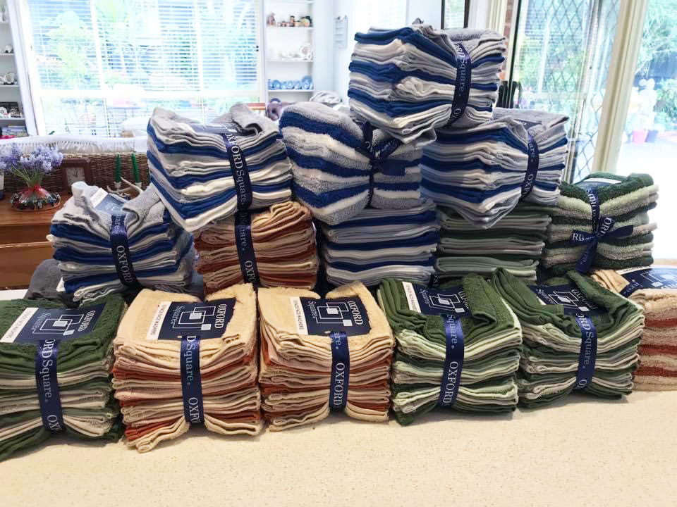  PDG Janet accepting Cheques  Face washers for End Trachoma | 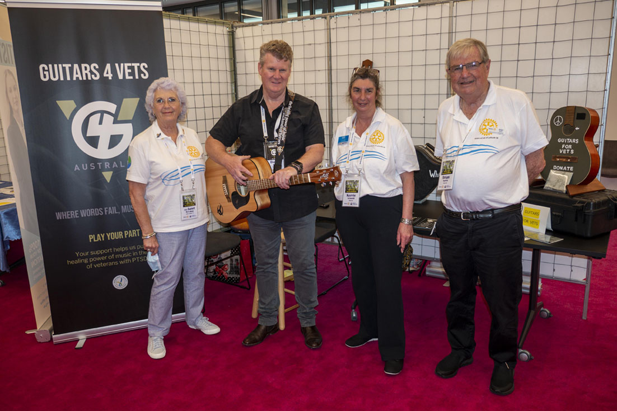  Club members Supporting Guitars 4 Vets
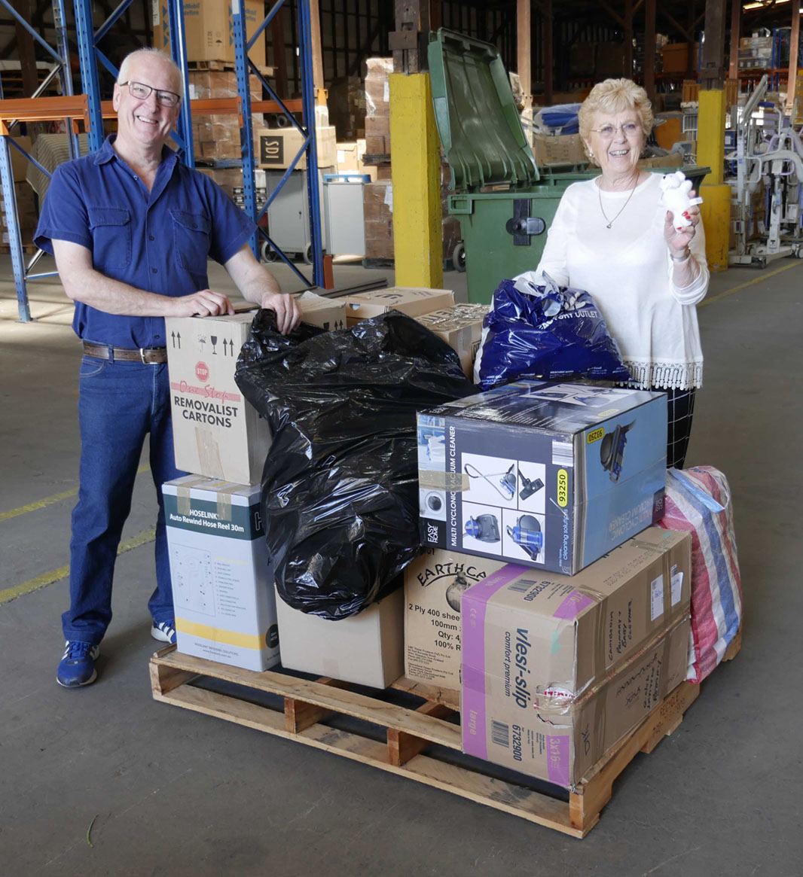Aid for Ukraine delivered to DIK | 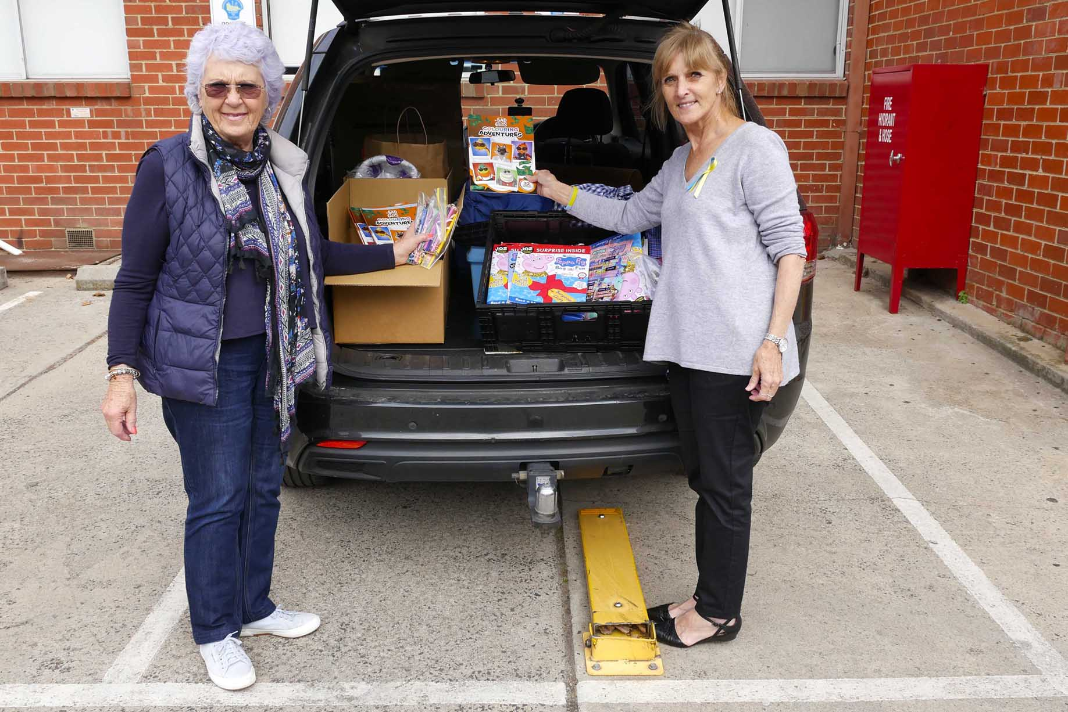  Aid for Ukraine delivered to Essendon
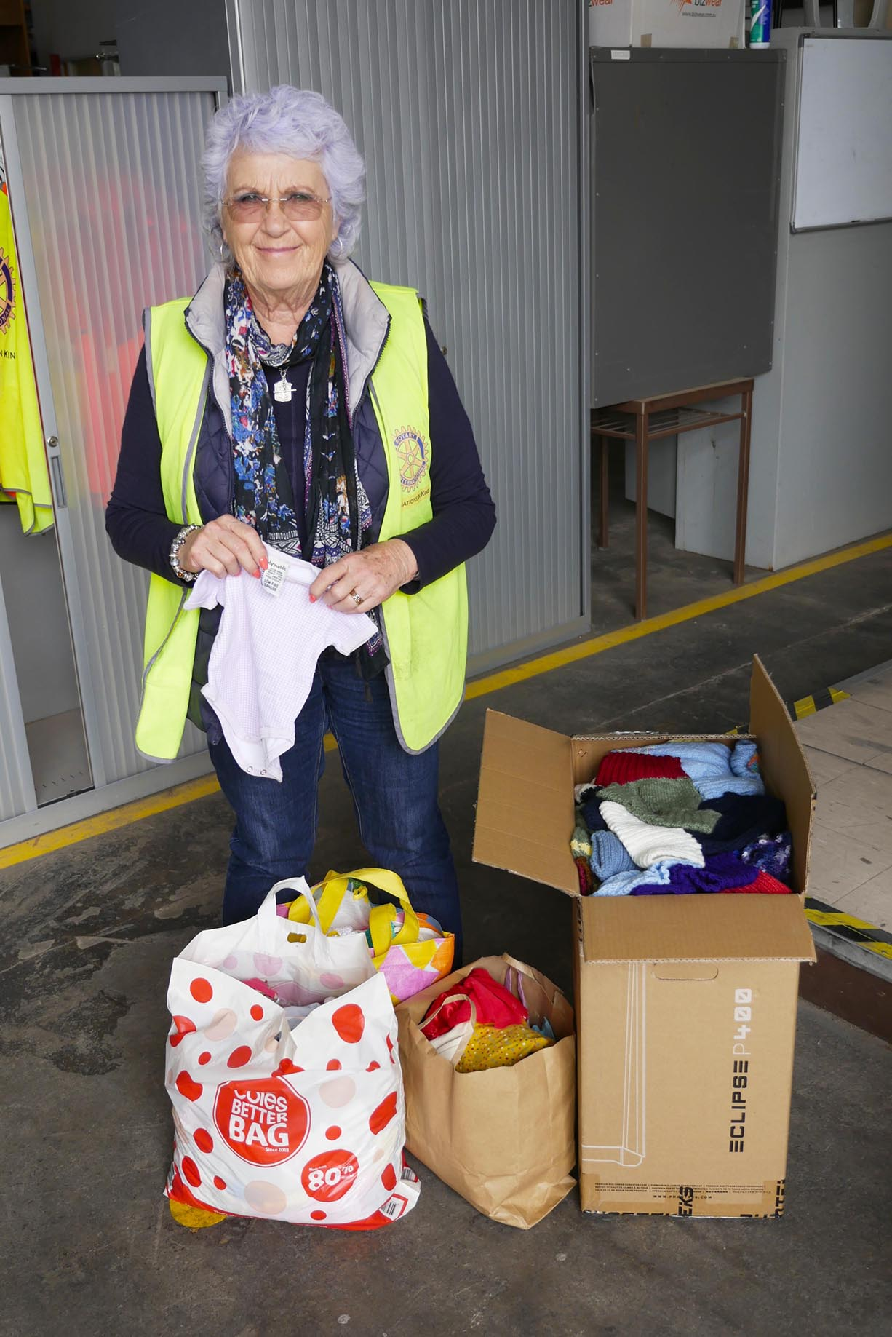  More aid for Ukraine  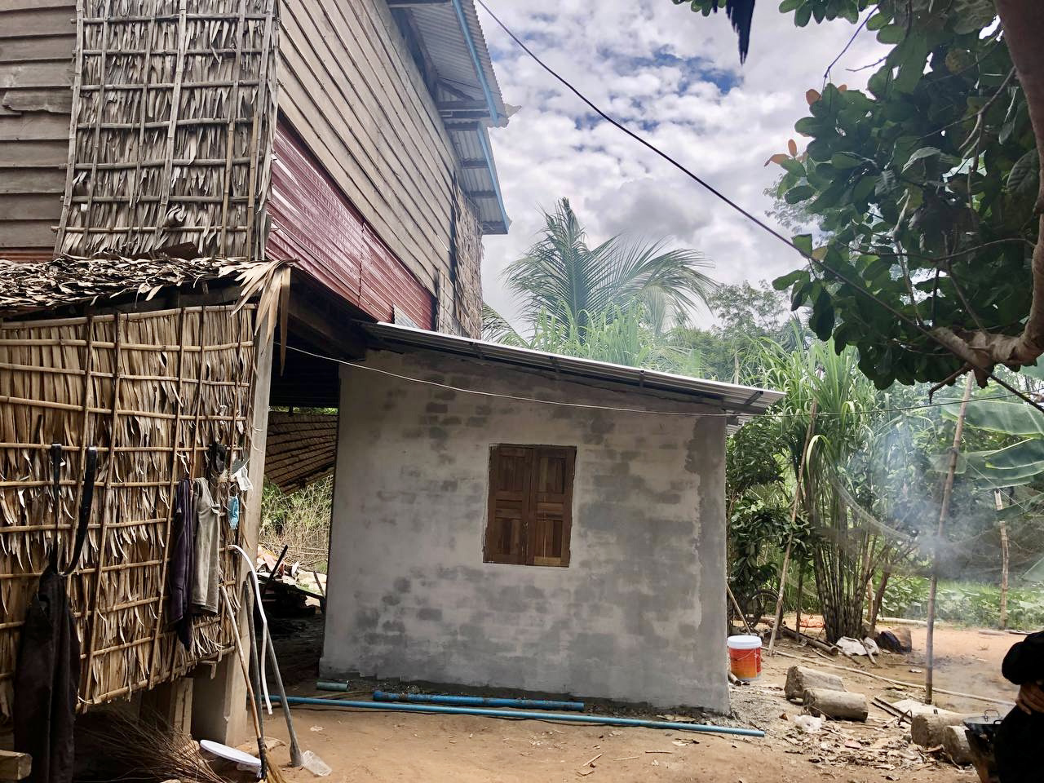  Free to Shine support – Room for disabled village person | 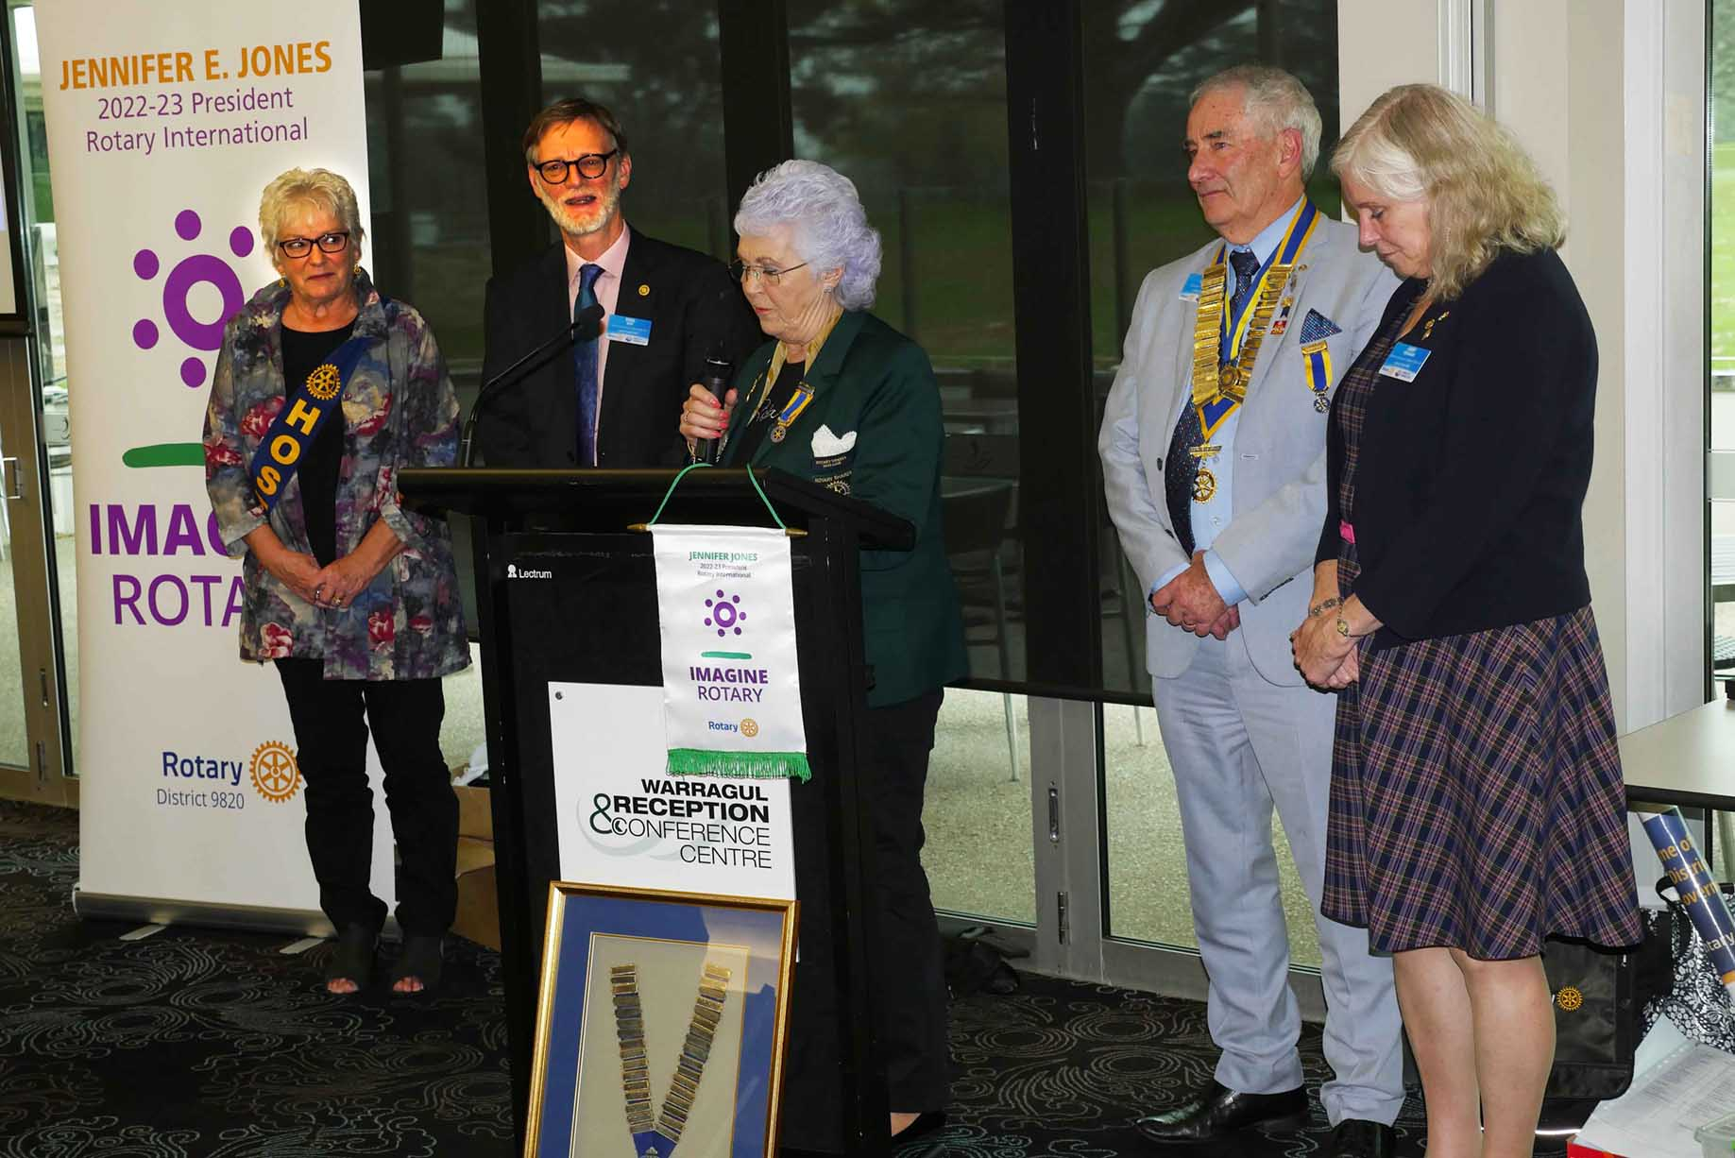  Janet conducting the District Changeover for DG Paul Mee  Judy about to eat cake!  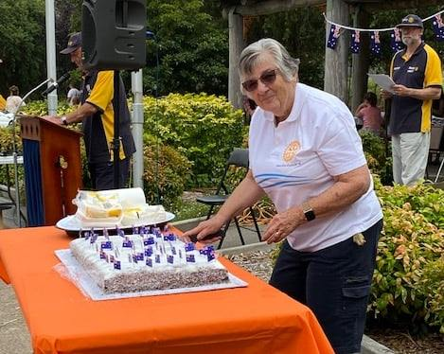  Patricia receiving her Citizenship.  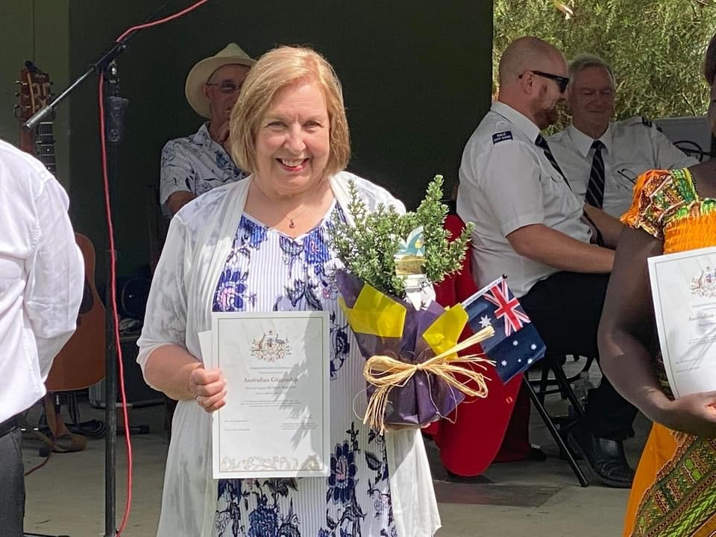

Training and Awareness Report
The aim of this activity is to increase Rotary knowledge and also other areas such as public image, membership and management activities in the Rotary context. I believe this has been achieved successfully through this program.

The topics covered were:

Leadership | Rotary World | Ethics & Vocation | Foundation I | Engaging members | Creating Service Projects
Rotary Opportunities | Effective Leadership Strategies | Attracting Members | Club Communications | Team Building | Foundation II: Targeted Service

Overall, there was a good participation rate by club members.

Brian Norris

Treasurer’s Report

 | Rotary eClub of Latitude 38
 | Financial Statements
 | Income and Expenditure Statement
 | Year Ended 30 June 2022
 | Income |  | $
 | Subscriptions – 2021 - 2022 |  | 2,805.00
 | Subscriptions – 2022 - 2023 |  | 1,815.00
 | Fundraising/Donations |  | 1,811.05
 | Uniform |  | 30.00
 | Interest |  | 0.71
 | Income Total |  | 6,461.76
 | Expenditure
 | Rotary International dues |  | 2,020.93
 | Rotary Down Under Subscriptions |  | 658.25
 | District 9820 levy |  | 1,664.26
 | Consumer Affairs |  | 60.10
 | Club Website – ClubRunner |  | 581.20
 | Domain Name |  | 36.00
 | Zoom Video Conferencing |  | 184.71
 | Secretary/Treasurer expenses |  | 0.00
 | Email Service |  | 44.27
 | RaffleLink setup |  | 0.00
 | Flowers |  | 60.00
 | Expenditure Total |  | 5,309.72
 | Donations Outgoing:
 | David Guitar 4 Vets |  | 160.00
 | Dignity Bags |  | 120.00
 | Cambodia - Free To Shine |  | 750.00
 | Vietnam Health Cards |  | 2010.00
 | Lift the Lid |  | 100.00
 | Ukraine Colouring Books |  | 99.06
 | Donations Total |  | 3,239.06
 | Expenses/Donations Total |  | 8,548.78
 | Surplus/Deficit |  | -2087.02
Rotary E-Club of Latitude 38
Balance Sheet
Year Ended 30 June 2022
Assets
Bank Account |  | 4,695.32
PayPal |  | 0.00
Total Assets |  | 4,695.32
Liabilities
Bank Account |  | 4,209.44
Project Account |  | 485.88
Accounts Payable |  | 0.00
Total Liabilities |  | 4,695.32

Michelle Young

Club Members in District Positions 2021/2022

Youth Exchange Chair Barry Rogers
Club Visioning Chair Brian Norris
Community and Vocational Service Chair Kerrie Schmidt
District Coordinator for Mentoring Brian Norris

Current Members – 30th June 2022
Don Crewe PHF (PP) | Barry Rogers
Grant Ellers (PP)(C) | Kerrie Schmidt (PP) (C)
Anthony Mayer | Judy van der Vlugt (PP)
PDG Janet McCahon (C) | Petra Showell
Ruth Mount (C) | Bill Zeldenryk (C)
PDG Brian Norris (PP)(C) | Michelle Young
Michelle Worsley | Patricia Murray-Walton
Pearl Findlay-James | Malcolm Findlay
Alfie King (PP) | Elli Adams

Total Membership – 18 (last year 22)

PDG = Past District Governor
(C) = Charter member
(PP) = Past President of a Rotary Club

Honorary Members

Sophanit Prin | Pete Showell
Past Presidents
2015/16 |  | Kerrie Schmidt
2016/17 |  | Kerrie Schmidt
2017/18 |  | Deanne Smith
2018/19 |  | Brian Norris
2019/20 |  | Grant Ellers
2020/21 |  | Jim Armstrong
2021/22 |  | Judy van de Vlugt
Rotary Foundation
Paul Harris Fellows
1997 |  | Ian Sayers (+4)
2001 |  | Kerrie Schmidt (+1)
2003 |  | Brian Norris (+2)
2005 |  | Janet McCahon (+1)
2007 |  | Bill Zeldenryk
2011 |  | Anthony Mayer (+1)
2020 |  | Don Crewe
Past Rotary International and District Officers
2007-08 | Janet McCahon, District Governor D9820
2009-10 | Brian Norris, District Governor D9820

