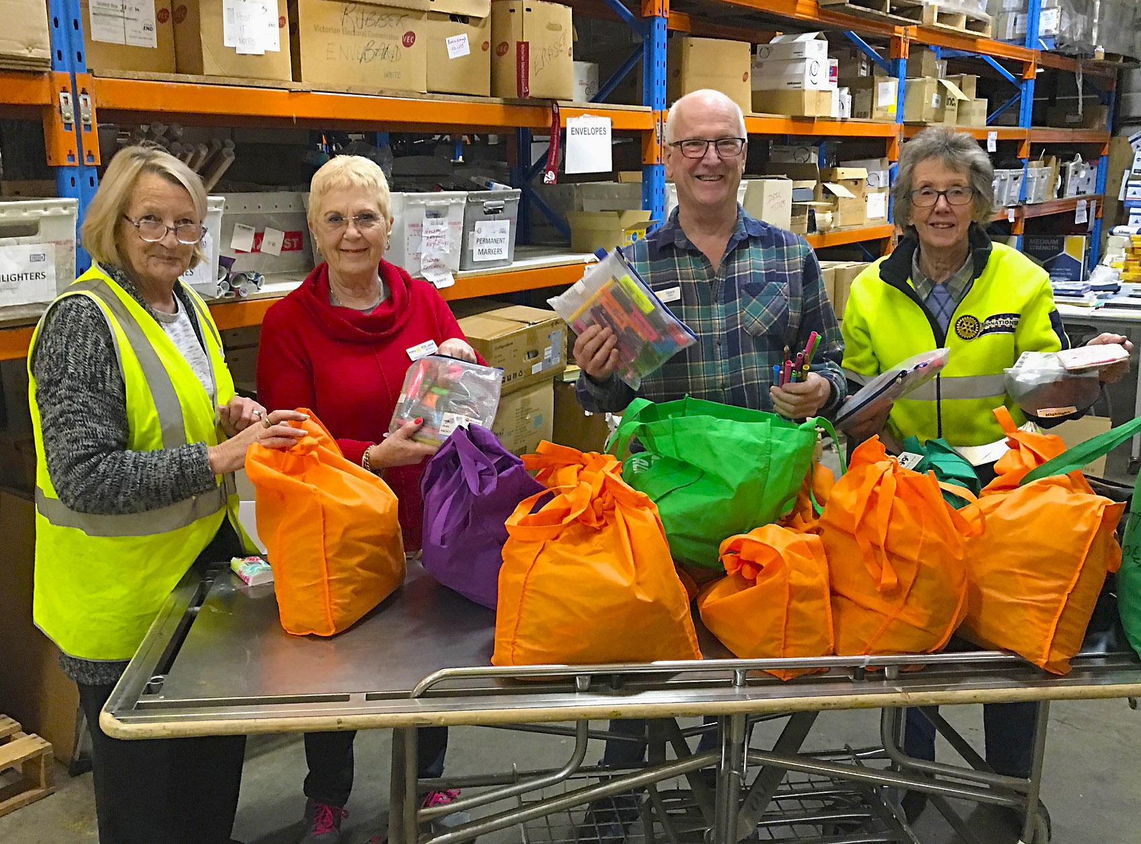  Sorting donations at the Donations-in-Kind warehouse in Sunshine  How do I join?  If you believe Rotary membership would complement your life and enable you to use your skills to help others’, then please contact us. There is an expression of interest form on our website at www.eclublatitude38.org.au Complete the form and email it to us today.  Then what happens?  Once we receive your expression of interest form, we will contact you. There’s no obligation. The call is to answer any questions you have, explain a bit more about Rotary and Latitude 38 so you’ll know that you’ll fit in. Our members are just like you – ordinary people doing amazing things.  ‘Latitude 38 is a fresh experience in Rotary’. Rob A |  |  | Contact Us  For further information contact:  Donald Crewe (President 2022_23)  Grant Ellers (Secretary)  Secretary_latitude38@Rotary9820.org.au  Visit our website  www.eclublatitude38.org,au  Find us on Facebook at:  https://www.facebook.com/  rotaryclublatitude38/  Chartered in Rotary District 9820, Victoria but otherwise borderless. |  |  | 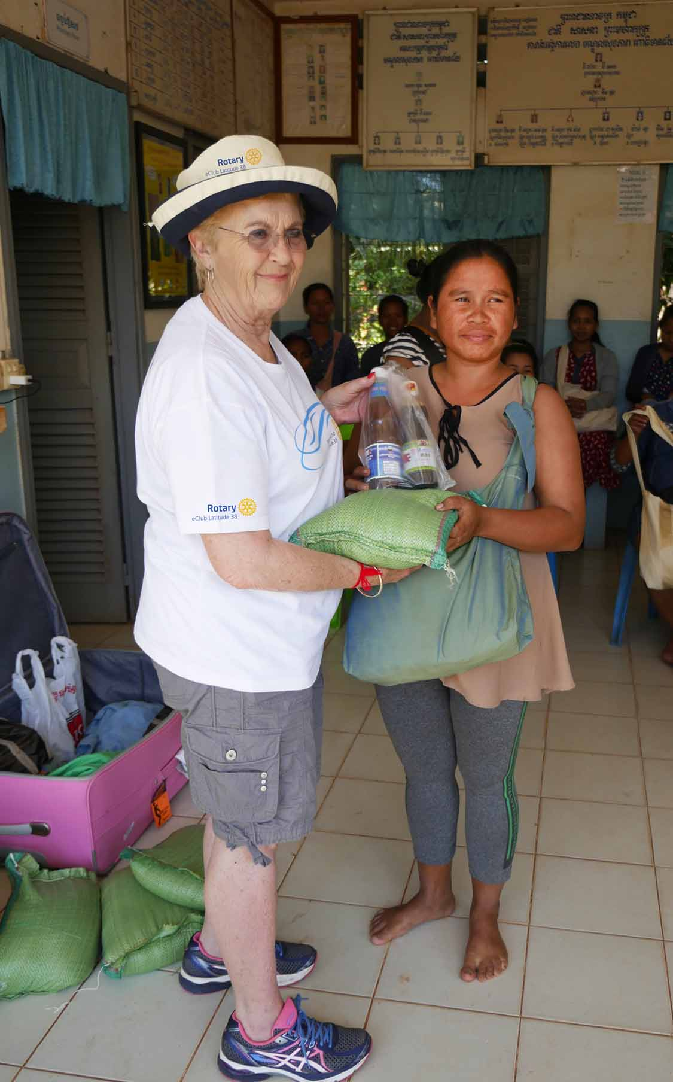  eClub member Janet donating rice and sauces to an expectant mum. Just one of many programs we have supported in Cambodia.  “Making Rotary affordable and Flexible for busy people”
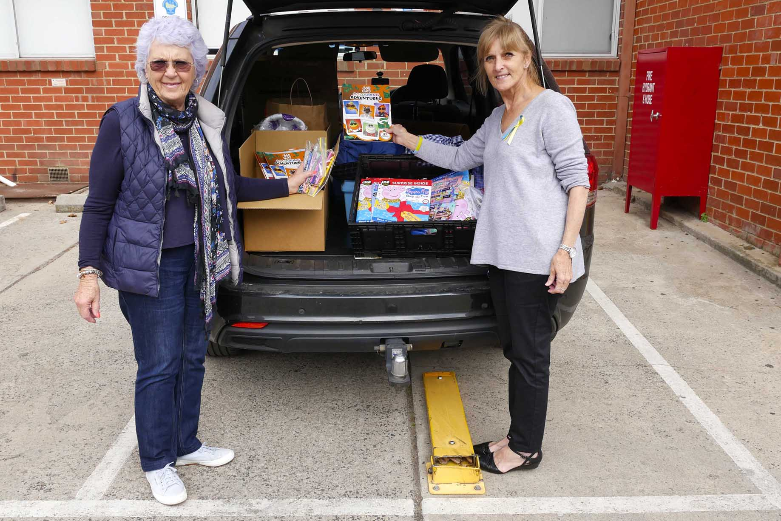  Donated children’s toys and clothing for arriving Ukrainian refugees being delivered to the Ukrainian Community Centre – Essendon.  What is Rotary?  Rotary is a community service organisation. Its members are ordinary people like you, who have joined together to create positive and lasting changes in our communities and the world around us.  How does Rotary work?  Members work individually and through their clubs to solve some of our communities' toughest challenges. Their efforts are supported by Rotary International and The Rotary Foundation which turns generous donations into grants that fund the work we and our joint venture partners do around the world. |  |  | What makes Rotary different?  Our capacity to leverage networks and how we see the priorities makes us different and effective. We see challenges in unique ways and apply our leadership and our expertise to find real solutions. We also act responsibly so that our passion and perseverance create meaningful change.  ‘Rotary is about giving a hand up’  Rob A.  Latitude 38 is a flexible style of Rotary Club  Flexible style Rotary clubs are ideal for people with busy lives and those on a budget. Like every Rotary club we carry out service projects and develop and use members’ vocational and personal skills to make a difference to others. It’s how we meet that makes us different. Latitude 38 members use technology to connect with each other and the world ensuring that Rotary is accessible, fun, flexible and affordable. |  |  | Latitude 38 is Rotary in Action  Rotarians get involved in a range of projects locally and internationally. Our members are helping others by:  - * Providing transport for isolated people;  - * Building and maintaining community gardens;  - * Feeding the hungry here and abroad;  - * Giving youth access to education;  - * Coordinating ‘Neighbourhood Watch’  * Supporting programs like Days for Girls, Helping Hands and Opportunity for Development through Art (ODA)  - * Delivering clothing, footwear and medical supplies to the needy.  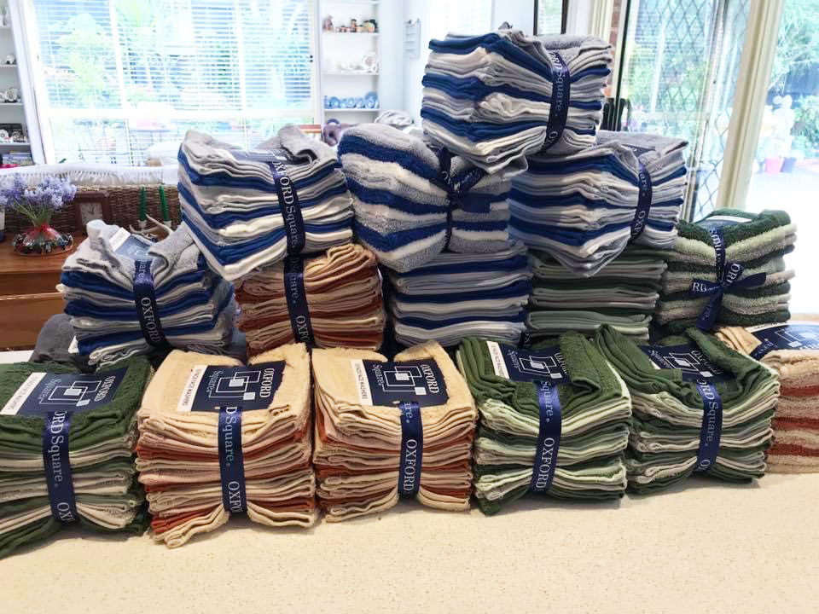  ‘What Latitude 38 members are involved in is amazing.’ Peter S.  Latitude 38 fundraising provided face towels for the End Trachoma project.

