Cycle Dindi 2017 - Family Registration Form
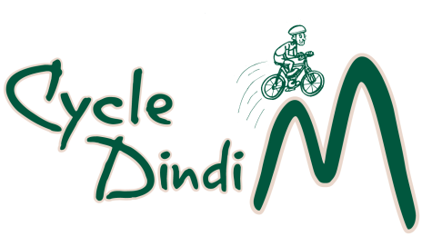
Family Surname
Individual adults
Individual children (school age)
Address
Suburb/Town & Post Code
Mobile phone number
Email
Special Dietary Needs
Emergency Contact Name and
Mobile Phone Number

Distance | Family | Tick
Yea/Alex- Molesworth & return  33/35 kms | $100
Yea-Alex return  Alex-Yea return  68 kms | $125
Payment Details (Tick Box)
Cheque (Payable to the Rotary Club of Yea) or money order

Direct deposit to Bendigo Bank BSB 633-000 Account No. 144545126
(RC of Yea Inc.) Please reference payment with name and ‘Cycle Dindi’.
Send cheque or money order and registration by post to PO Box 149 Yea 3717 or email entry to: cycledindi@gmail.com
Disclaimer: the participant (signed below) agrees that the Rotary Clubs of Alexandra and Yea will be neither liable or legally responsible for * any injuries sustained by the participant or * any loss or damage to property owned by, or in the possession of the participant.
By signing this form, we are agreeing to the conditions of entry.

Signature: _______________________________Date: _________________

