Cycle Dindi 2017 - Individual Registration Form
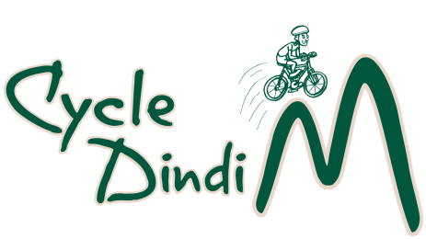

Name:
Address
Suburb/Town and Post Code
Mobile phone number
Email
Special Dietary Needs
Emergency Contact Name and
Mobile Phone Number

Distance | Adult | Tick | *Concession | Tick
Yea/Alex – Molesworth return  33/35 kms | $40 |  | $20
Yea- Alex return  Alex-Yea return  68 kms. | $50 |  | $20
*Concession applies to school aged participants
Payment Details (Tick Box)
Cheque (Payable to the Rotary Club of Yea) or money order
Direct Deposit to Bendigo Bank BSB 633-000 Account Number 144545126 (RC of Yea Inc.)
Please reference payment with name and ‘Cycle Dindi’.
Send cheque or money order and registration by post to PO Box 149 Yea 3717 or email entry to: cycledindi@gmail.com
Disclaimer: the participant (signed below) agrees that the Rotary Clubs of Alexandra and Yea will be neither, liable or legally responsible for * any injuries sustained by the participant or * any loss or damage to property owned by, or in the possession of the participant.
By signing this form, I am agreeing to the conditions of entry.

Signature: ________________________________Date: _________________

