#looselipsync

Entry Form and YouTube tutorial

For our online entry form, please go to https://form.jotform.com/90917021420143

In order to complete the form, you will need to have a share link from YouTube for your video. Directions are below:* if you have problems, feel free to contact eleanorgwelsh@gmail.com

You may pay either by mailing a check, or going to our online Square store
https://centreville-rotary-club.square.site/product/looselipsync/3?sbp=false

*If you have never uploaded to YouTube, don’t worry: it’s easy-peasy. Get the free YouTube app on your smart phone, and create an account for your organization (done in seconds! Well, minutes if you have a slow connection).

To upload your video, you just click on the image of the video camera, select the video you want, and click “Next.” Give your video a title and a short description, including the link to our contest webpage.

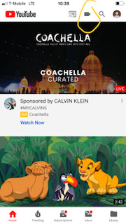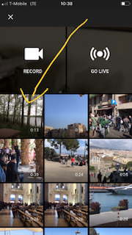

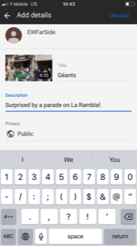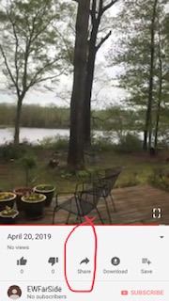
Click upload.
After the video is uploaded and “processed,” you will be able to get the share code to send on your application. If you want the most people to see your video, be sure to select “public” as your setting
