*Membership Application*

*Community Leaders Connecting to Make a Difference*



*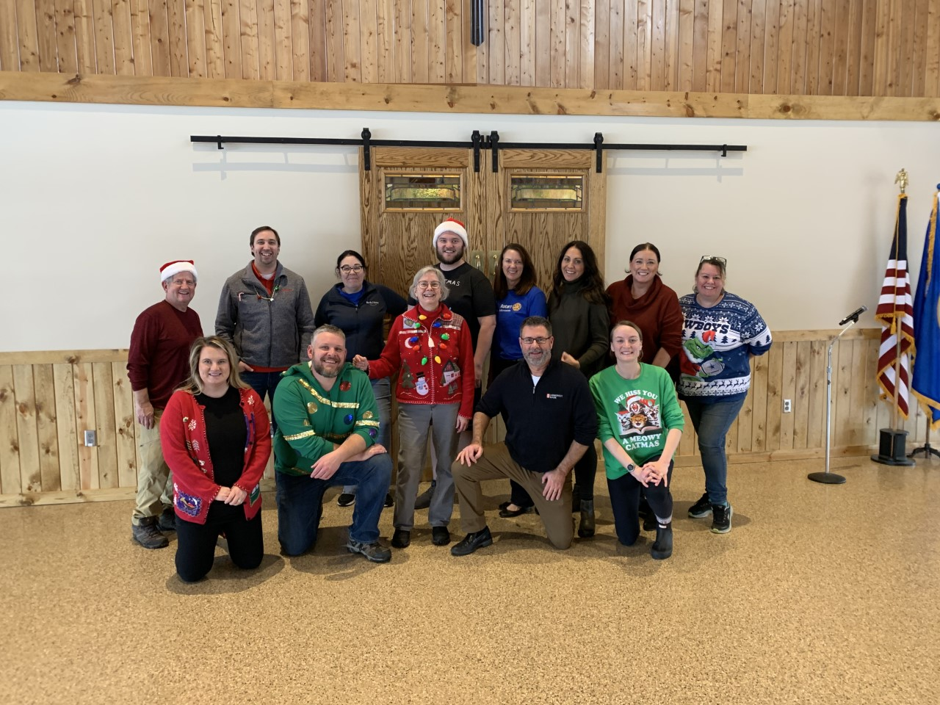Since our founding in 2002,*   
the Rotary Club of Farmington has been dedicated to making a difference in our community and in the world. Our members include some of Farmington’s most prominent business, professional and civic leaders. We gather at weekly meetings and other functions to fulfill our commitment to the Rotarian ideals of friendship, fellowship and service above self.

**What is Rotary?**

Rotary is a global network of 1.4 million neighbors, friends, leaders, and problem-solvers who see a world where people unite and take action to create lasting change – across the globe, in our communities, and in ourselves.

**What we do**

Rotary members believe that we have a shared responsibility to take action on our world’s most persistent issues. Internationally, our 46,000+ clubs work together to:

* Promote peace
* Fight disease
* Provide clean water, sanitation, and hygiene
* *A picture containing person, indoor, food

  Description automatically generated*Save mothers and children
* Support education
* Grow local economies
* Protect the environment

*What is the Farmington Rotary Club?*

We are a fun, welcoming, authentic club that unites with local businesses, community leaders and residents to provide services to better the community in which we work and live. We are People of Action.

*Local Community Service*

Our club focuses on expanding educational opportunities for youth by providing scholarships, mentoring FHS seniors through our STRIVE program, participating in adopt-a-highway cleanup, treating local seniors to an annual holiday luncheon and supporting numerous community programs and organizations.

*International Service*

Over the past 20+ years, Farmington Rotarians have funded clean water wells in Haiti, provided equipment for a medical laboratory at the Yendube Children's Hospital in the city of Dapaong in northern Togo, and renovated a library and provided books for an orphanage in Bolivia. We also annually support Polio Plus, Rotary’s signature project.

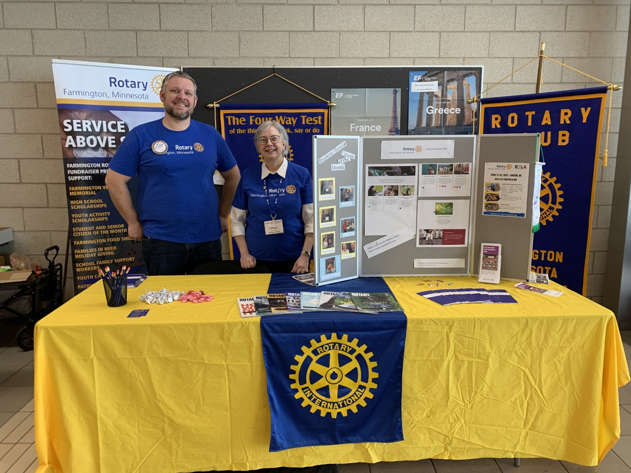

*Legacy and Vision*

Our members act selflessly and seek out service opportunities in our community and throughout the world. Through encouraging high ethical standards in all vocations, Farmington Rotary is the premier service organization in our community.

*To learn more about our current service projects, please visit:* ***www.farmingtonrotarymn.com***

*Joining The Rotary Club of Farmington*

Our club thrives on the active participation of community leaders who represent a wide variety of professions. As in all Rotary clubs, membership in the Farmington club is by invitation only*.*

*Membership Qualifications*

* Believe in the ideal of Service Above Self by fostering fellowship and friendship
* A business, professional or community leader – business or residence is located in the Farmington Area or serves the Farmington area
* Willing to provide your money, time and talents to further the club’s success

*Membership Benefits*

* The prestige of belonging to the premier service organization locally and internationally
* Fellowship and friendship with Farmington Area leaders committed to same ideals
* Variety of opportunities to serve your in community – and internationally
* Ongoing practical education, thought-provoking speakers, life changing experiences
* Networking with people who can help you become more successful

*Membership Commitments*

* Regular attendance at weekly luncheon meetings.
  1. Visiting other Rotary clubs, attending monthly committee meetings, or volunteering for service projects can make up missed meetings.
* Serve on a club committee.
* Provide time and talent on service projects in our community.
* Participate in raising funds for service projects. This may require soliciting sponsorships, selling admission and raffle tickets and volunteering time.
* Invite at least 2 potential Rotarians to a club meeting.
* Commit to the financial obligation of membership and agree to make timely payments:
  1. A one-time $50 initiation fee
  2. $175/quarter Lunch Package
  3. $50/quarter Basic Package
  4. Give to the Rotary Foundation every year; suggested amount is $100 per year.

*Membership Process*

1. *Complete the application and give it to your sponsoring member, along with a check for the $50 initiation fee.*
2. *Sponsoring member then endorses your application and submits it to the club secretary.*
3. *Board of Directors will review your application within two weeks [at their monthly board meeting?].*
4. *Upon acceptance, you will be welcomed at the next meeting by the president of the club.*
5. *The membership chair will assign a mentor for you.*
6. *You choose a committee assignment.*
7. *You give a classification talk to the club at a weekly meeting.*

**ROTARY CLUB OF FARMINGTON**

*WHY JOIN ROTARY?*

*In case you need more reasons…*

1. **Friendship:** In an increasingly complex world, Rotary provides one of the most basic human needs - friendship and fellowship. It is one of two reasons why Rotary was founded in 1905.

2. **Business Development:** The second original reason for Rotary's beginning is promoting business development. Everyone needs to network. Rotary consists of a cross-section of the business community. Our members come from all walks of life. Rotarians help each other and collectively help others.

3. **Personal Growth and Development:** Membership in Rotary continues one’s growth and education in human relations and personal development.

4. **Leadership Development:** Rotary is an organization of leaders and successful people. Members improve leadership skills - such as learning how to motivate, influence and lead others while serving the community.

5. **Citizenship in the Community:** Membership in a Rotary club makes one a better community citizen. The Farmington Rotary club consists of active community leaders who share the goal of making our community even better.

6. **Continuing Education:** Each program at Rotary is designed to keep the membership up-to-date about what is happening in the community, nation and world. Each meeting provides an opportunity to engage with stimulating speakers on a broad range of timely topics.

7. **Fun:** Rotary is fun, a lot of fun. Each meeting is fun. The club service projects are fun. Social activities are fun.

8. **Public Speaking Skills:** Many individuals who joined Rotary were uncomfortable speaking in public. Rotary develops confidence and skill in public speaking and the opportunity to practice and perfect these skills.

9. **Citizenship in the World:** Every Rotarian in any of the 29,000 clubs in 194 nations wears a pin that says “Rotary International.” There are few places on the globe that do not have a Rotary club. Every Rotarian is welcome – even encouraged – to attend meetings anywhere in the world. It is an amazing experience to feel the common bonds and values of Rotary with people from all cultures throughout the world.

10. **Assistance when Traveling:** Because there are Rotary clubs everywhere, many a traveling Rotarian in need of a doctor, lawyer, dentist, hotel, or advice while traveling has found assistance through Rotary.

11. **Entertainment:** Every Rotary club and district has parties and activities that provide diversion in one’s business life. Rotary holds conferences, conventions, assemblies and institutes that provide entertainment, information, education and service.

12. **The Development of Social Skills:** Rotarians develop people skills every week at various events and functions. Rotary is for people who like people.

13. **Family Programs:** Rotary provides one of the world’s largest international youth exchange programs including high school and college experiences for future Rotarians. Rotary also provides opportunities for spouse involvement and a host of activities, which strengthen families.

14. **Vocational Skills:** Every Rotarian is expected to participate in the growth and development of his or her own profession or vocation, and to teach youth about one’s career or vocation. Rotary helps make us all more effective at our chosen career.

15. **Ethical Development:** Rotarians practice the Four-Way Test in business and personal relationships.

16. **Cultural Awareness:** Around the world, practically every religion, country, culture, race, creed, political persuasion, language, color and ethnic identity is found in Rotary. It is a cross section of the world’s most prominent leaders from every background. Rotarians become aware of their cultures and learn to love and work with people everywhere. They become better citizens of their countries in the process.

17. **Prestige:** Rotary members are leaders of business, the arts, government, sports, military, religion and all disciplines. Rotary is the oldest and most prestigious service club in the world. Its ranks include executives, managers and professionals – people who make decisions and influence policy throughout the world.

18. **Nice People:** Rotarians above all are nice people – the nicest people on the face of the earth. They are important people who follow the policy of, “It is nice to be important but it is more important to be nice.”

19. **The Absence of an “Official Creed”:** Rotary has no secret handshake, no secret policy, no official creed, no secret meetings or rituals. It is an open society of men and women who simply believe in helping others.

20. **The Opportunity to Serve:** Rotary is a service club. Its’ business is humankind. Its’ product is service. Rotarians provide service to both local and international communities. This is perhaps the best reason for becoming a Rotarian; the chance to do something for somebody else and to experience the self-fulfillment that comes in the process. It is a richly rewarding experience.

***“He profits most who serves best.”***  
***Richard D. King***  
***Rotary International President 2001-02***

** Rotary Club of Farmington Membership Application**

|  |  |  |  |  |  |  |  |
| --- | --- | --- | --- | --- | --- | --- | --- |
| Name | | | | | Nickname | | |
|  | | | | |  | | |
| Business/Firm/Organization | | Position/Title | | | | | |
|  | |  | | | | | |
| Business Address | | City, State, Zip | | | | | |
|  | |  | | | | | |
| Business Phone | | Business Fax | | | | | |
|  | |  | | | | | |
| Occupation/Profession | Years in Profession | Years in Farmington | | | | Previous Cities/States | |
|  |  |  | | | |  | |
| Residence Address | | City, State, Zip | | | | | |
|  | |  | | | | | |
| Residence Phone | | Cell Phone | | | | | |
|  | |  | | | | | |
| E-Mail | | Preferred Mailing Address | | | | | |
|  | | Business |  | | | Residence |  |
| Previous Rotary Club Memberships  Club(s) & Member ID Numbers | | | | Dates: | | | |
| 1) | | | |  | | | |
| 2) | | | |  | | | |
| Date of Birth: | Spouse’s Name: | | | | | | |
|  |  | | | | | | |
| Hometown: | University/College(s): | | | Degree(s): | | | |
|  |  | | |  | | | |
| Community Activities: | | | | | | | |
|  | | | | | | | |
| Interests: (i.e. Golf, Reading, etc.) | | Family ties to Rotary? | | | | | |
|  | | | | | | | |
| **Rotarian Sponsor’s Name:** | | | | | | | |

**CERTIFICATION OF MEMBERSHIP**

**Eligibility for membership in the Rotary Club of Farmington requires the following:**

1. Proposed member is business, professional or community leader with their primary business or residence located in the Farmington area.
2. Proposed member believes in the ideal of “Service Above Self” by fostering fellowship and friendship.
3. Proposed member is willing to provide their time and talents to further the club’s success.

**As the proposed member, I attest to the following:**

1. I am eligible for membership in the Rotary Club of Farmington as stated above.
2. I have attended at least two meetings as a guest of the Rotary Club of Farmington.
3. I accept the attendance requirements. I understand make-up options that are available to me.
4. I agree to participate in the club’s service projects and understand the service responsibilities.
5. I agree to participate in growing the membership of the club by inviting guests to club meetings.
6. I accept the financial obligation of membership including initiation fees, quarterly dues including meals costs and agree to make payments timely.

Financial Obligations include:

* + 1. Initiation Fee: $50 – Non-refundable and payable at time my application is submitted.
    2. Quarterly Dues:
       1. Lunch package: $175 – Payable quarterly. Covers Rotary International, District 5960 and Rotary Club of Farmington dues and meal costs.
       2. Basic Package: $50 – Payable quarterly. Covers Rotary International, District 5960 and Rotary Club of Farmington dues.

1. I agree to the suggested minimum annual contribution to the Rotary Foundation of $100.
2. I agree to actively participate in all fundraising activities.

**Prospective New Member**

I certify I am aware of the obligations of membership as set forth above and the conditions of membership as explained within the club’s constitution and bylaws. I hereby wish to be considered for membership in the Rotary Club of Farmington.

In addition, I understand that the Rotary Club of Farmington is committed to protecting the welfare and safety of all youth, and before participating in any youth related activity, I shall be required to submit to a background check.

Signature Date

**Sponsor/Proposer**

I certify that the person I am proposing is eligible for membership and is aware of the responsibilities of Rotary regarding service, financial support and attendance.

Signature Date

Thank you for your interest in joining the Rotary Club of Farmington.

Rotary Club of Farmington, P.O. Box 175, Farmington, MN 55024

Established May 2020