Back Ground.

There are many people in our community who are immobilised or severely restricted in their movements, either temporarily or permanently due to advancing age, illness or disease.

Often they are confined to wheel chairs and can easily become house bound, as whilst wheel chairs are convenient for indoor use, they are not very versatile out doors and usually require a carer to accompany the operator which denies them their independence.

In recent times the electric scooter has been developed to be easily operated and to a reliable standard. Many people have now found new freedom and independence with dignity being able to get out and about under their own steam, off to the shops, post office, church, clubs or to visit friends and participate in normal social activities.

The scooters are quite expensive and generally only those people with sufficient means have access to them. Scooters are available from rental companies and some government funded community organisations can make them available, but only for the most extreme cases.

There are many people in our local community who can derive great benefit from a scooter but find when they reach this stage of ill health or age they can not afford to purchase one or could not justify the purchase as it might only be used for a short period due to further deteriorating health, or the inevitable.

It is this group of people within our community who can benefit most from the Rotary Scooters project.

Rotary Scooters (motorised chairs)

The Rotary Club of Tauranga maintains a pool of electric scooters which it leases for an annual fee of one dollar each to eligible disabled people who might otherwise be virtually house bound, hopefully to improve the quality of their lives and provide assistance to their families.

The beneficiaries are required to sign a lease agreement, to undertake to keep the scooter in good repair, to indemnify the club from all damages and to surrender it back to the Club when the time comes that they no longer use it on a regular basis.

The scooters are standard models suited for general use but some modifications can be made if warranted and are reversible.

Applicants

Nominations are called for from Club Members, Community Support organisations such as Hospice, Welfare Groups such as Salvation Army, Retirement Villages and Nursing Homes.

Preferred applicants will be the most deserving cases and will generally be;
- Of sufficient mental and physical faculties to derive significant benefit from a scooter.
- Of insufficient financial ability (including family) to purchase or rent a scooter.
- Not entitled to such a benefit from a Government agency.

This project is ongoing and is a major Community Service initiative.
Scooters Project
Application Form
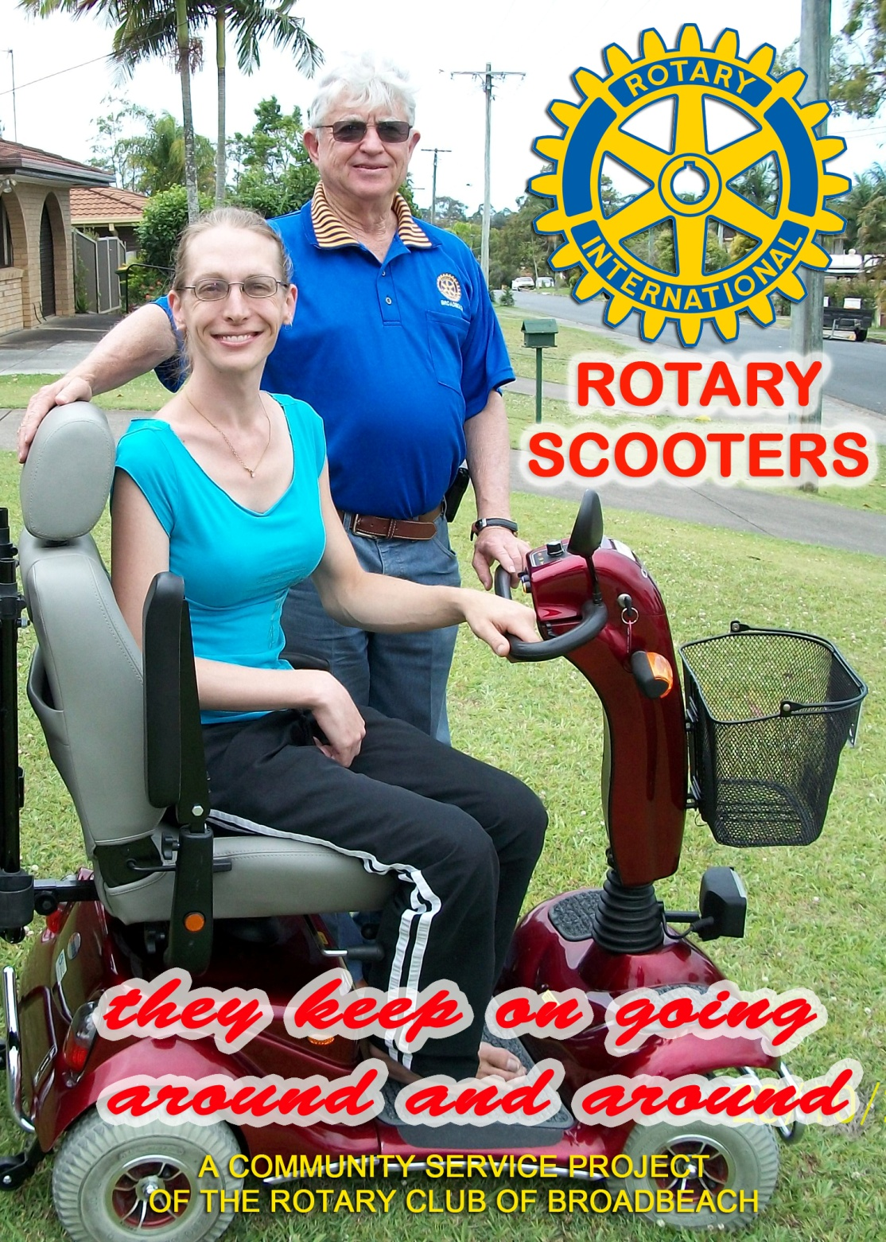

Full Name

Address
Code Phone

Age Disability

Doctors Name Phone

Address
Code
If loaned a scooter, how often would it be used and for what purpose? (e.g. daily/shopping)

Other comments to support this application

Signature of Applicant ______Date

Signature of Proposer Date

Committee Chair Date

The Rotary Club of Tauranga PO Box 609
TAURANGA 3140

