Home page for www.rotarytaurangaam.club. Press member logon. 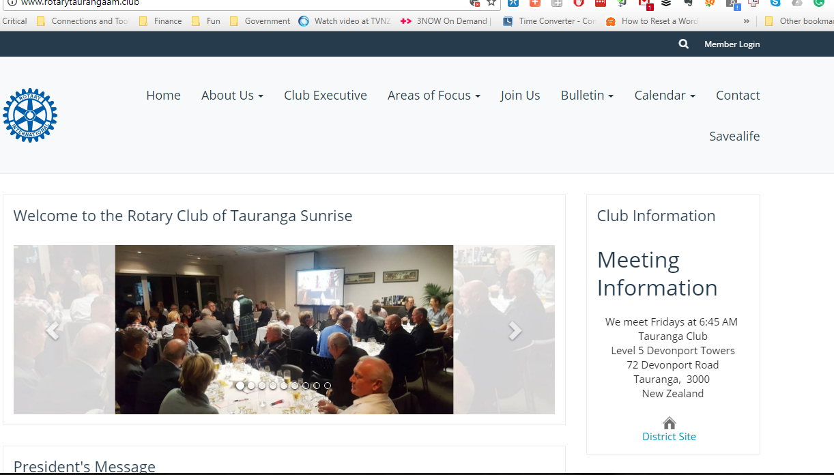
Most of the club has a logon name that is their full name.12121. If you can't remember your password, use the email address that you receive the Bulletin at and request a new one. Otherwise write to secretary@rotarytaurangaam.club. Many of us have changed our logon name
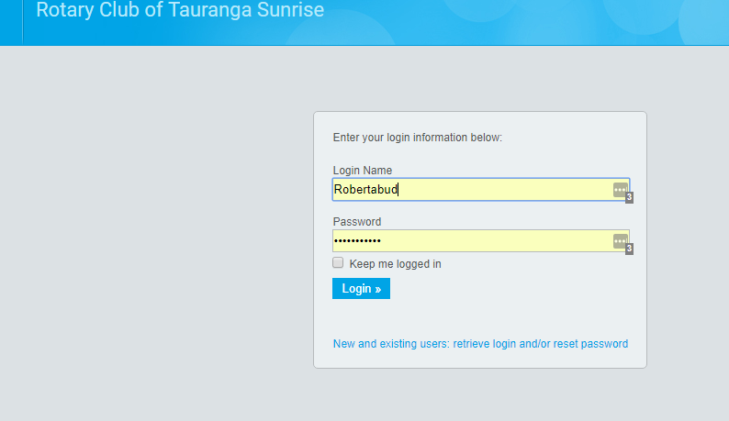
Once you are logged in the black bar changes. Click membership area
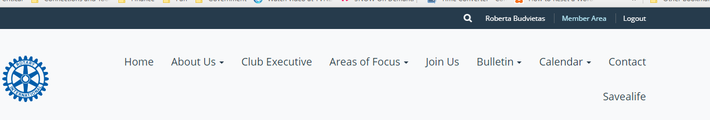
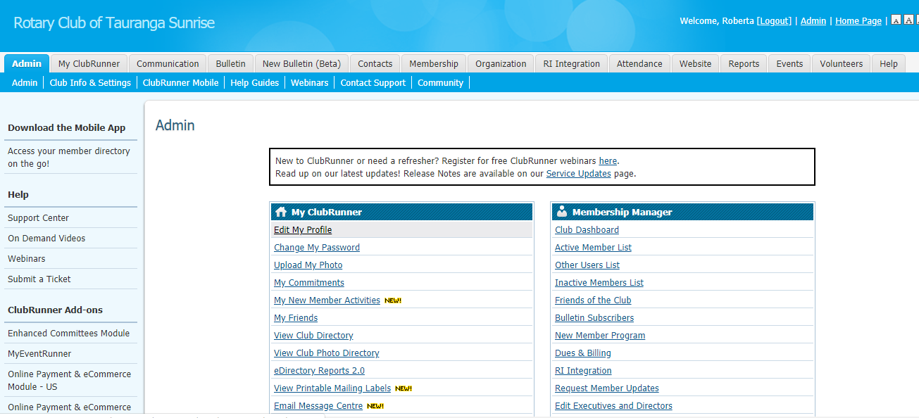
On this screen you can now do many things but to change your profile click edit my profile
This takes you to a screen that shows the information you can enter. The privacy tab restricts who can see what about your profile. Please ensure your picture, contact details especially your phone number and classification are entered
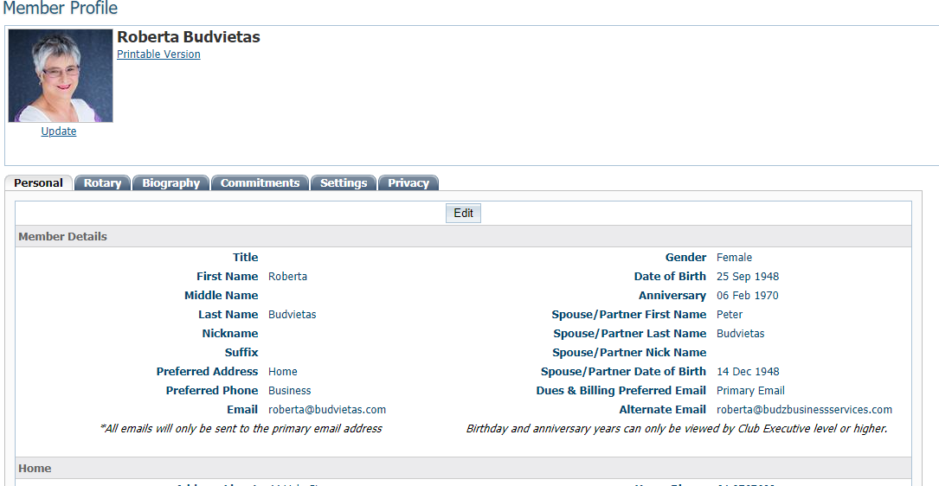
The details you enter in your profile will help other members understand your talents as well as being able to contact you when necessary.
Download the Clubrunner app to your phone and once you log in to it you have the club on call.

