Newsletter of the





Guest Speaker Ninni Helenius
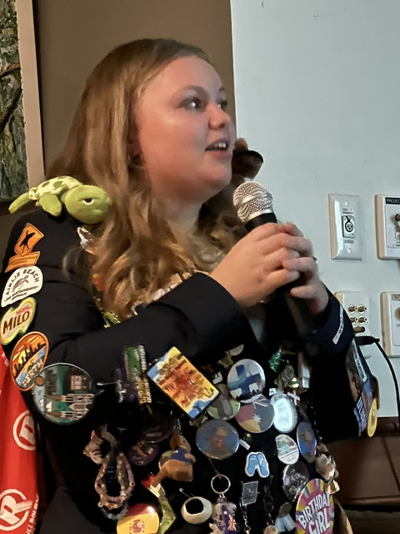

Rotary Club of Mansfield Inc.

27th May, (Part 2) 2026

Youth Services Month

National Song: All

Loyal Toast: Australia and its People

Rotary Grace: For good food, for good fellowship and the opportunity to serve through Rotary – we give thanks.

THIS WEEK - Duty Roster
Cashier:
Chairperson:
NEXT BOARD MEETING:
12th August 5:30pm at Delatite Hotel.
Bob’s Blog
We had a good attendance on the meeting of the 27th May. Our speaker was our Exchange Student Ninni Helenius who told us about her year in Mansfield.
Thank you to all the guests who attended including her host families, partners, exchange students and district committee members from Benalla.
We are now on meetings break over winter. Our next meeting will be on the 12th August.
I hope all members and travellers have a safe, enjoyable and warm winter.

Bob Prosser
Past President

Last Meeting: 27th May, 2026

Ninni said that before she left Finland, she was independent girl who lived with her grandmother.

Ninni has travelled all over Victoria and most of Australia including Albury, Canberra, Perth and Adelaide. On the Safari she visited Darwin, Uluru, Kings Canyon Kakadu and Litchfield, Airlie Beach and The Great Barrier Reef.

Ninni stayed with the Alexander’s for three months until Christmas. While there she went snow skiing, played board games and did a lot of cooking.

She then moved to the Vasey’s farm for two months over summer. Ninni really enjoyed farm life where she got in a lot of practice opening and closing gates along with cooking and baking.

Liz Bannister looked after Ninni for the next two months. With Liz she went to the Art Show, saw waterfalls that she had never seen before and did some hikes and bike rides.

Then onto the Mahoney’s for two months. There she has two little sisters to watch movies with. Ninni went to the Australian Open with other exchange students and to Orientation days where she met the new students.

To round off the year she went to the School Formal, one day after coming home from Safari. She also went on a hot air balloon flight. Ninni has developed a great group of friends at Mansfield along with all the other exchange students.

What Ninni Learnt about Australia
Indigenous culture important
Sport is a huge part of life
Nature is extreme and beautiful
Australians are very laid back but extremely friendly
School culture is different; calling teachers by their last name
Drop bears

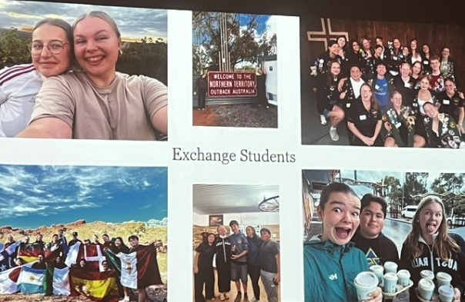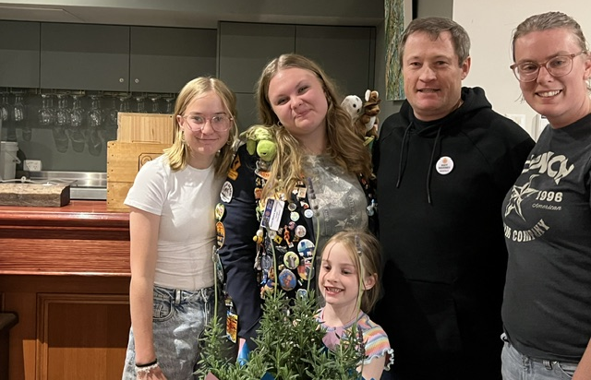

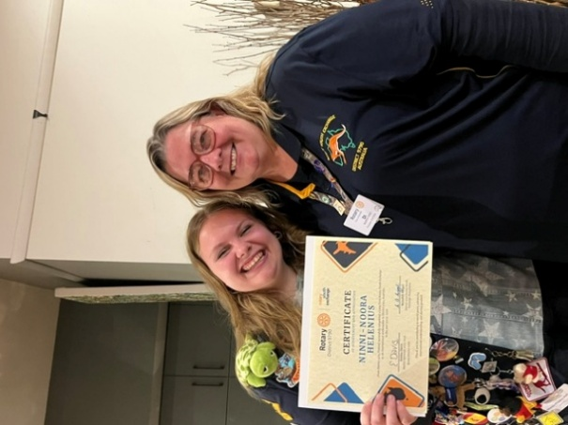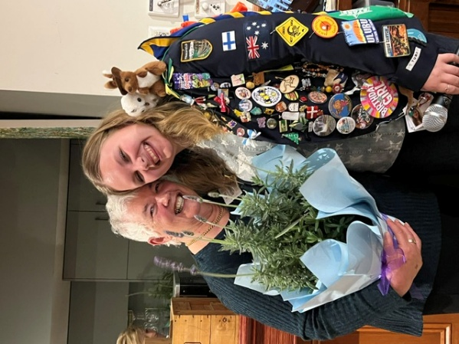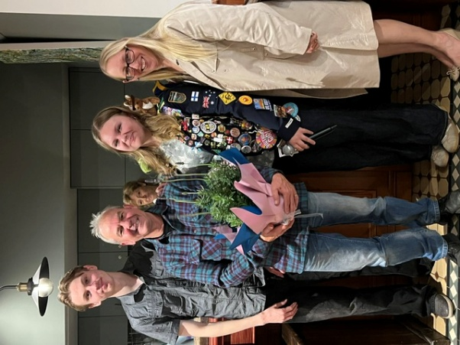
Birthdays over winter:
Bob Prosser 6th June
Stuart Bett 18th June
Stephanie Hart 22nd August
Exchange Students:

Ninni Helenius;

Ninni gave her talk last meeting but what surprised her the most about Australia was;
How friendly strangers are
The strong multicultural mix
How big the distances actually are
How early everything closes and how early they open
How many different accents there are
Birds
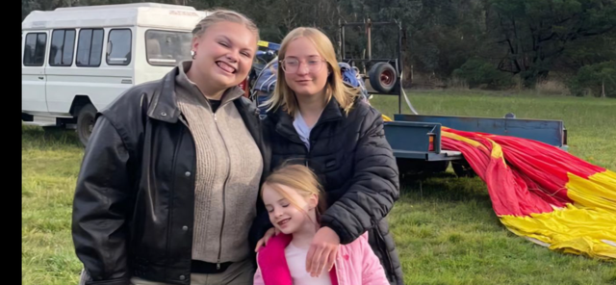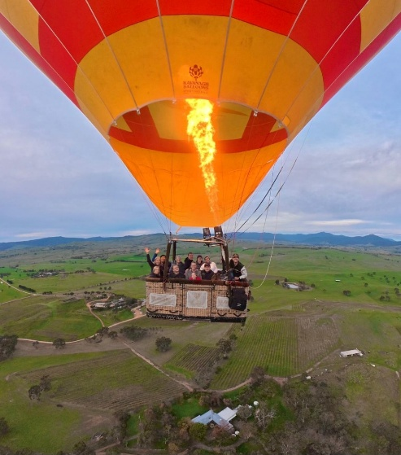

Erin Mahoney;

Erin competed in a Japanese language competition with exchange students where she did well and came third. It was so such fun talking and practicing with the other exchange students.

She went out to dinner with her Japanese class. She also went to another track and field competition and it also happened to be her birthday at the competion.

A few days later was a big festival in Kanazawa that she participated in and wear super pretty kimonos. It was fun learning Japanese culture in such a fun way.

She also had fun celebrating her 16th birthday with some class friends.

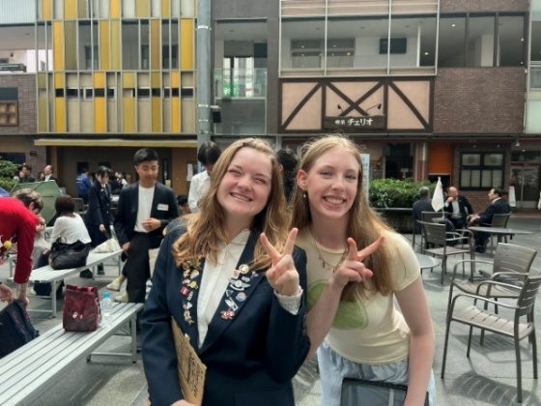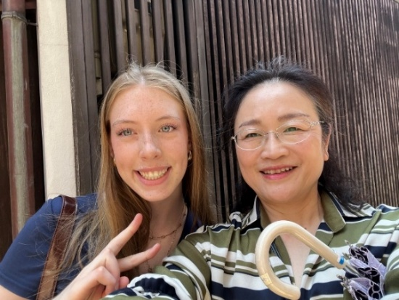

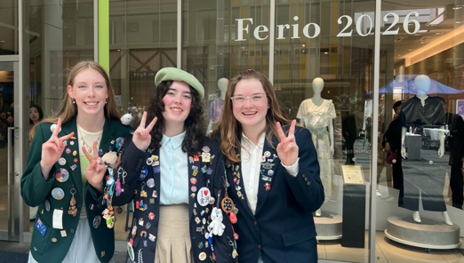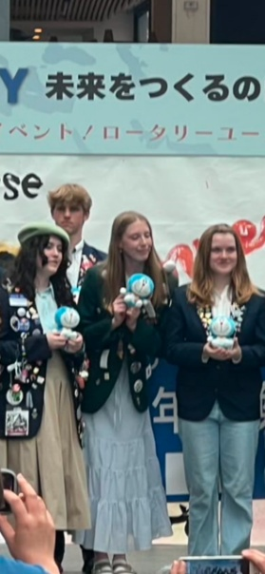

International;

Denise has had an interesting trip so far. The Rotary club has not had a meeting this month, so I have been unable to have a conversation with them. I have contacted their new President and am expecting a phone conversation with her in the next few days to work out the partnership we need, in order to apply for a global grant. Wayne and I delivered warm clothing and blankets to Thanh's charity, see photos

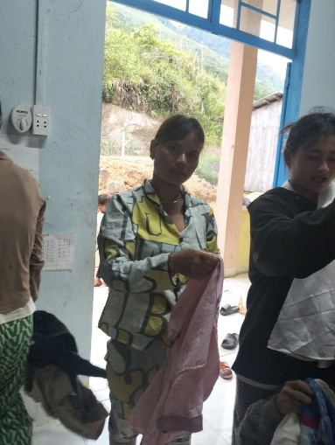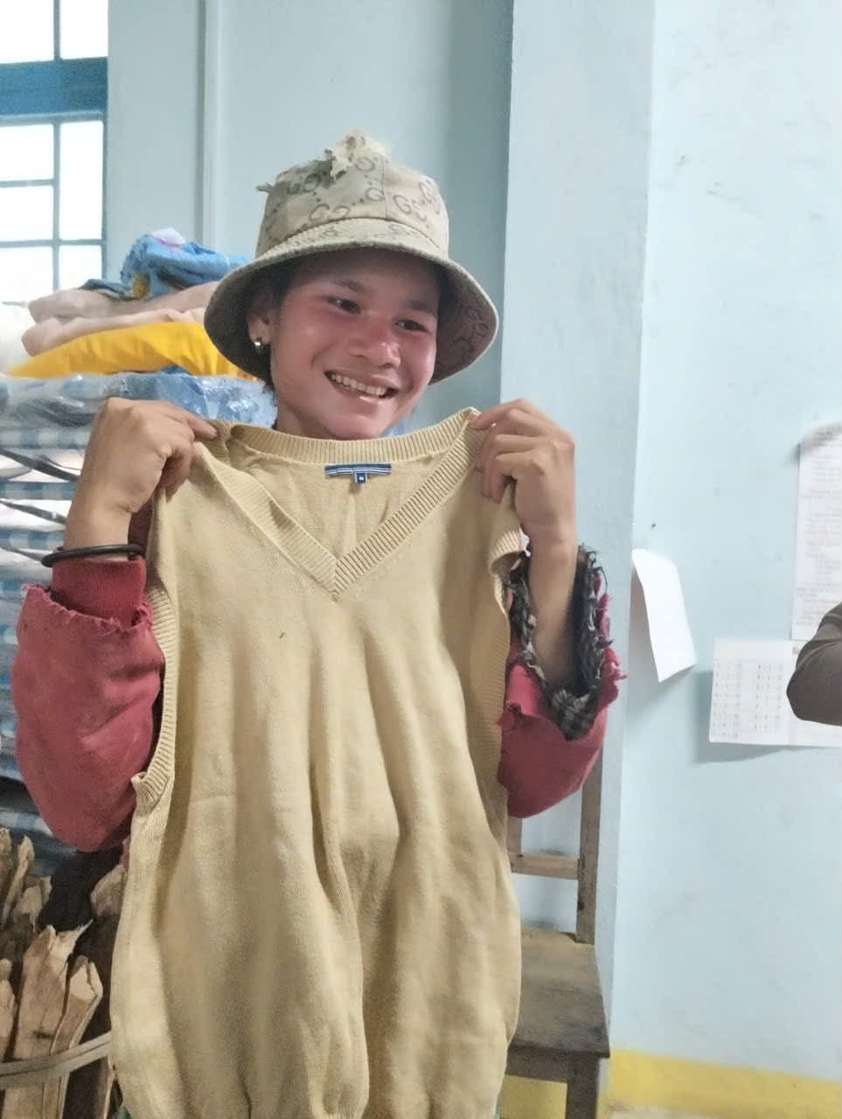

Thought for the Week; YOU DON’T HAVE TO BE GREAT TO START,
BUT YOU HAVE TO START TO BE GREAT.
Travellers;
Our President Stephanie and Peter are on the world cruise. They have visited Cape Town in South Africa and now heading for Mindelo, Cabo Verde.
Denise Skinner is currently in Vietnam where she delivered cloths to underprivileged children and visiting the Rotary Club of Da Nang.
Bob Prosser is currently on the sunshine cost visiting his new one month old niece.
Club Programme;
No Meetings During Winter;
Due to the lack of members being around during winter the Board made the decision to Cancel meetings from and including the 10th June through to the 1st meeting in August.
Meetings will commence again on the 12th August.
Up Coming Events;
June 22nd – Ninni will depart Australia by QANTAS Flight AY5022 at 10:15am
July 18th – Bonnie Doon CFA – BBQ for comedy night
August 12th – Our Rotary Meetings resume at the Delatite Hotel
September 23rd – Guest Speaker - Stephen Whiteside – Book “The View From Point Lookout”
October 24th – guest speaker - Love Your Sister – Samuel Johnson

