Newsletter of the





Guest Speaker David Mayne – Bendigo Bank
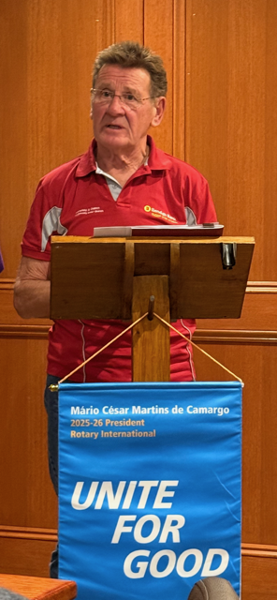

Rotary Club of Mansfield Inc.

27th May 2026

Youth Services Month

National Song: All

Loyal Toast: Australia and its People

Rotary Grace: For good food, for good fellowship and the opportunity to serve through Rotary – we give thanks.

THIS WEEK - Duty Roster
Cashier: Maurie
Chairperson: Robyn
NEXT BOARD MEETING:
12th August 5:30pm at Delatite Hotel.
Bob’s Blog
What a great meeting we had when we were joined by the Rotary Recreational Vehicle Club. They had over thirty of their members attend. Leanie was Sergeant, who said it was the first time he fined guests, in other words the Recreational Club, he did a great job doing it. Thanks for standing in at the last minute.
On Saturday the 16th May we cooked and served a two dinner for them at the caravan park.
Thanks to Robyn for the potato salad and tomatoes, Kelly for preparing food, Laurie, Shane and myself for getting the trailer ready and cooking. We all served the food, in the dark, but the club thanked us and said the food was above their expectations. Thanks to you all for attending.
Bob Prosser
Past President
Last Meeting: 13th May

We were Joined by over thirty members of the Recreational Vehicle Fellowship of Rotarians. They all arrived early, at 6pm, so it was luck both Robyn and Bob were in attendance to welcome them at that time. We had a great meeting of fellowship and laughter.

The Club as over 300 members Australia wide with 130 members from all over Victoria. They travel to a destination for about four days together and some continue to look around the surrounding area. Next year they have a Muster in the south of WA.

Our guest speaker was David Mayne from the Bendigo Bank in Mansfield. David is a volunteer Director of the Bank and has been in Mansfield for 10 years after growing up in Bendigo as one of eight siblings. His family also hosted a Rotary Youth Exchange student back in 1962.

The Bank is the life blood of a community; Mansfield branch is a franchise and opened 18 years ago. Over these years it has supported 75 groups in the Mansfield community with funding grants including the Mansfield football club and the Station Precinct. It gave the New Museum a grant of $35,000.

The Mansfield Branch has 300 shareholders and is a Public Company. David mentioned that 80% of profit goes back to the community. In the 18 years in existence, it has given over $2 million back in grants. Last year they gave back about $120k.

The Community Bank is a fantastic model of Banking. Across Victoria 40 Banks got together and fund three full-time teachers in the Children’s Prison in Parkville.

Nationally the Bendigo Bank gave back to communities $50 million, so go and support them by opening an account to help support Mansfield.

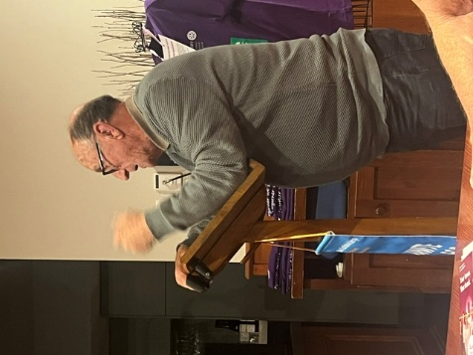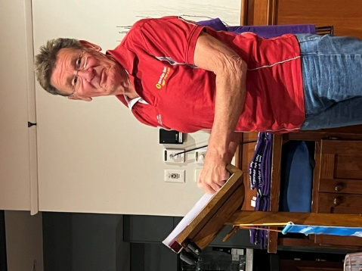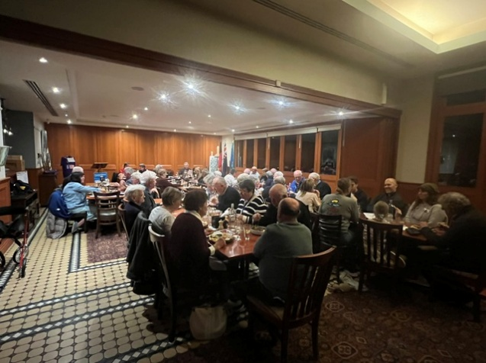
Recreational Vehicle Club President, David Mayne and general meeting.

This Meeting; 27th May 2026
PARTNERS NIGHT;
This is a partner’s night with a special guest speaker, Our Finish Exchange Student Ninni. She will give us a wrap up of her fabulous year in Mansfield Australia.
Come along and enjoy the meeting and fellowship and hear about her adventures in Central Australia.
Birthdays this Month:
Liz Bannister 3rd May
BBQ for The Rotary Recreational Vehicle Club at the Caravan Park;

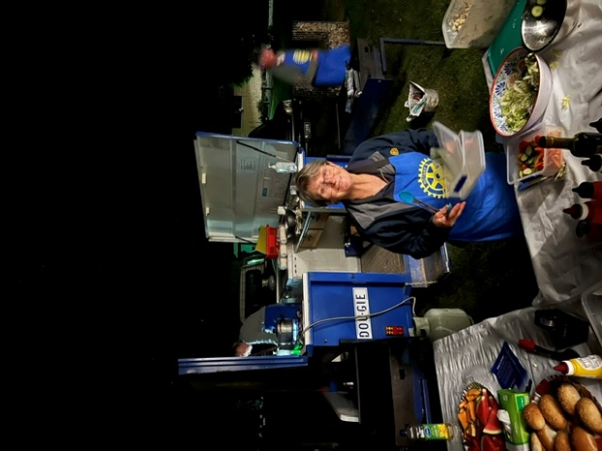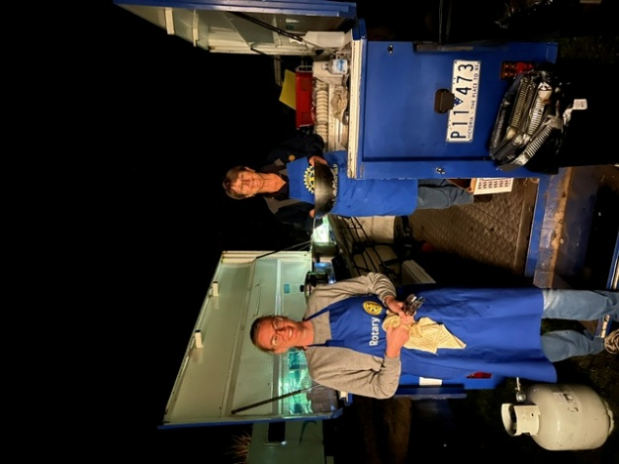

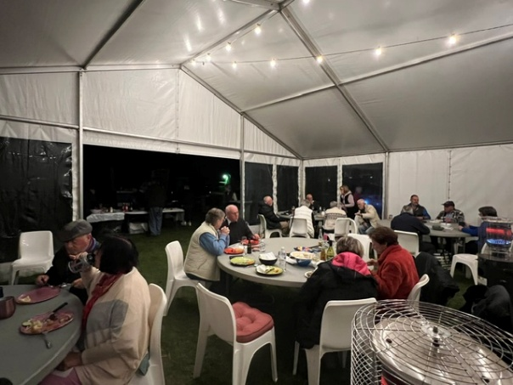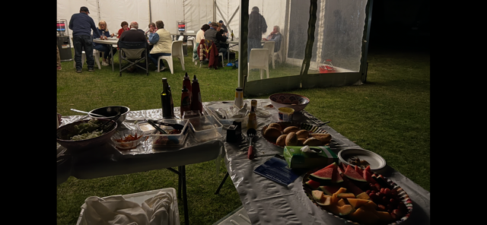

Exchange Students:

Ninni Helenius;

I’ve been now in the Northern Territory for 9 full days. Our trip started from Darwin where we spent couple pf days. From there we started our driving. Sometimes our days have just been full or driving and other time we’ve been sitting in the car only for couple of hours. We have seen so many incredible things and places like yesterday we saw Kata Tjuta and sunset in Uluru and in the beginning of the trip the Wangi Falls. This trip has been so fun and I can’t wait what it still has to offer us!

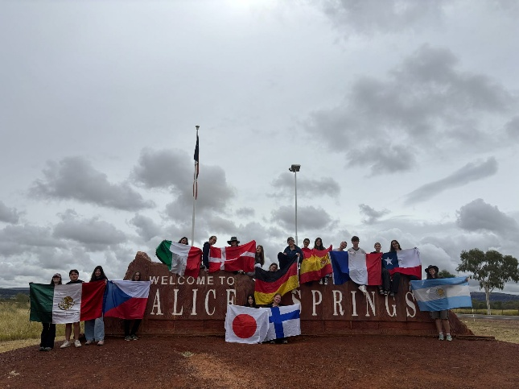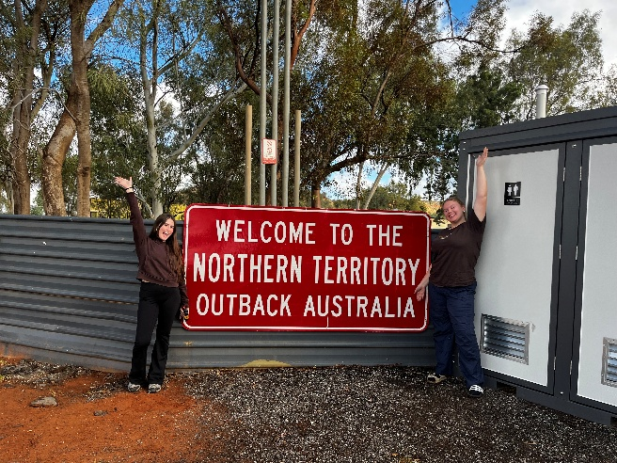

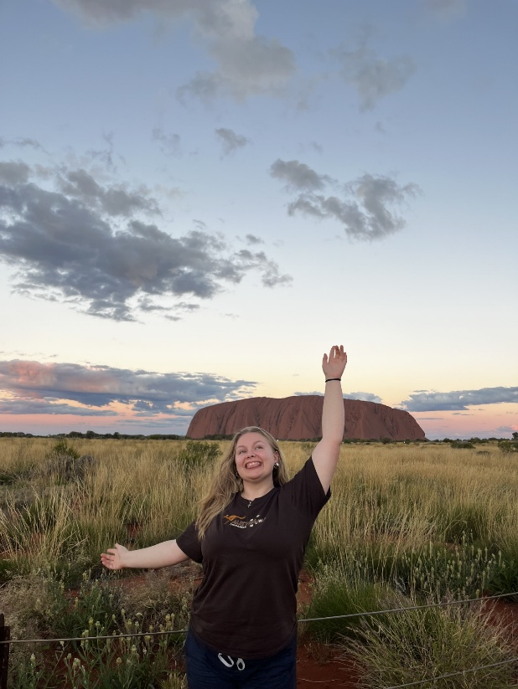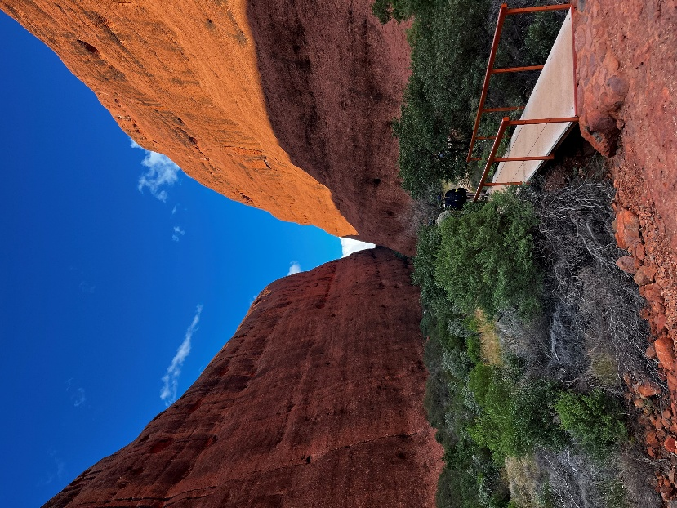

Erin Mahoney;

Erin visited the Kazuemachi District, just south of where she is living. It’s riverside and has rows of feudal-era wooden machiya buildings and teahouses where geishas play music

Erin with other Exchange Students living In Kanazawa. She travelled into the city and visited a Karaoke venue

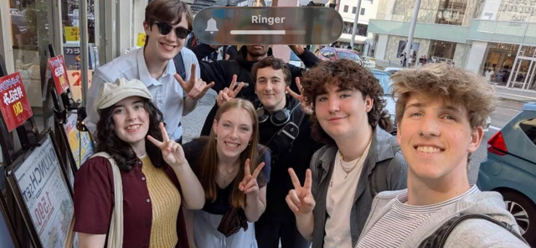

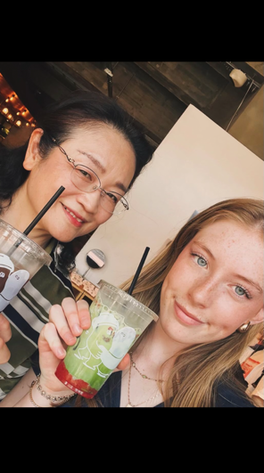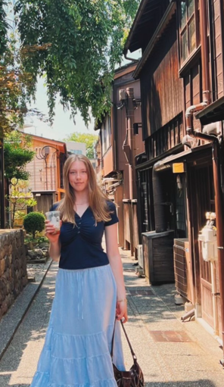

RAFFLE;

Raffle of the three bottles of Peppin Ridge wine was won by a member of The Recreational Club – The Jackpot of $100 was not won.

Thought;

Since a politician never believes what he says, he is surprised when others believe him.

Politicians are the same all over. They promise to build a bridge even when there is no river.
Thought for the Week; DON’T JUDGE PEOPLE BY THEIR RELATIVES

Travellers;
Our President Stephanie and Peter are on the world cruise. They left Sydney and spent some time in Fremantle where Steph caught up with her daughter for lunch. They then departed for Port Louis, Mauritius. Steph is spending some of the time on the ship playing bridge.
Club Programme;
No Meetings During Winter;
Due to the lack of members being around during winter the Board made the decision to Cancel meetings from and including the 10th June through to the 1st meeting in August. Meetings will commence again on the 12th August.
Up Coming Events;
May 27th – Partners Night with our Exchange Student Ninni Helenius giving her farewell talk
May 28th – Women’s Health Conversation 5-6pm at MACE
June 22nd – Ninni will depart Australia by QANTAS Flight AY5022 at 10:15am
August 12th – Our Rotary Meetings resume at the Delatite Hotel
October 24th – Love your Sister – Samuel Johnson guest speaker

A LETTER TO RC MANSFIELD FROM OUR EXCHANGE STUDENT ERIN MAHONEY

Dear Mansfield Rotary, 17TH May 2026
Thank you so so much for everything this club as given to me, my exchange in Japan has already taught me so much more than I ever asked for! It has given me so many opportunities I will never forget. I’m so lucky to have these experiences that I would not have had if it wasn’t for this exchange.
Living here in Kanazawa has given me the freedom to become more open minded and independent. Over the past 5 months my Japanese has thoroughly improved! I’m also happy to report that I am learning more and more each day about the culture and daily life of Japan. Through the challenges and experiences that have come with exchange I have also had the chance to learn more about myself and become more confident in myself. I’m meeting new people and doing something new every day.
One of my most valuable parts of this exchange has to be the friendships and connections I have already made. I love the moments where I feel at home in Japan, like when I’m with my class friends and we are drawing all kinds of adorable doodles on the class blackboard, or at a track and field competition with the other managers, playing games in the shade and timing the players. It’s also always so much fun just going out for dinner for a catch up. All these moments will stay with me for a long time!
I sincerely cannot thank Mansfield Rotary enough for this. I am incredibly grateful that you believe in me and gave me all of this. I know for a fact that these lessons, memories, and experiences will last me a lifetime. None of it would have been possible without Rotary.
Thank you again for your kindness and support.
Kind regards,
Erin Mahoney

