  - Cycle Dindi 2021 - Registration Form
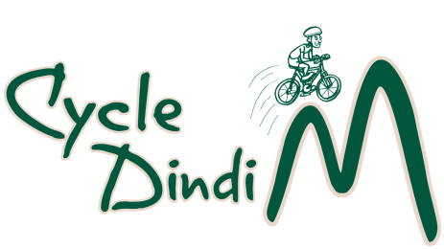

Name:
Address
Suburb/Town & Post Code
Mobile phone number
Email
Special Dietary Needs
Emergency Contact | Mob.
Please circle option
Options & Distances | Adult | Senior | Concession
Long Ride  Yea to Bonnie Doon (return) 121 Km  Bonnie Doon to Yea (return) 121 Km  Bonnie Doon to Cathkin (return) 80 Km | $50 | $40 | $10
Short Ride  Yea to Cathkin (return) 42 Km  Yea to Alexandra (return) 61 Km  Alexandra to Yea (return) 61 Km  Alexandra to Cathkin (return) 26 Km | $40 | $30 | $10

Concession applies to school aged participants Seniors: Holders of Seniors’ cards
Under school age: free.
Payment Details (Tick Box)
Credit/Debit card payment at trybooking.com (Cycle Dindi 21)

Direct Deposit to Bendigo Bank BSB 633-000 Account Number 161857420.
Account Title: - Cycle Dindi
Please reference payment with name and ride option.
Registration by post to PO Box 149 Yea 3717 or email entry to: cycledindi21@gmail.com
Release and Indemnity Cycle Dindi 21

The Rotary Clubs of Yea and Alexandra...................................................................................................................................... Inc. (“Rotary)

- I .................................................................................... of .......................................................................................

..............................................................................in the State of ............................................ am aware and acknowledge that
Cycle Dindi 2021...........................................................involves inherent risks, including the risk of injury to life or death and damage to property and in undertaking such activities, I do so at my own risk.

2. I am also aware that it is a condition of participation in .Cycle Dindi 2021 that Rotary, its officers and employees, agents and volunteers are released by me from all liability howsoever arising from injury or damage to both property and person howsoever caused (whether fatal or otherwise) arising out of my participation in the Event whether or not such injury or damage is due to any negligent act, breach of duty, default and/or omission on the part of Rotary, its officers and employees, agents or

3. I indemnify Rotary, its officers and employees, agents and volunteers against all loss, damage and expenses (including legal costs on a solicitor and own client basis) arising out of or in connection with any claims, actions, proceedings or demands of any kind arising directly or indirectly as a consequence of my participation in the Event.

4. I acknowledge and agree that my participation in the Event is as a consequence of my own free will and desire and that I have read and understood the above warning, release and indemnity.

5. I warrant that I am 18 years of age or older and am lawfully able to enter into this above release and indemnity or, in the event that I am a minor, I have the permission of my legal guardian to participate in the Event and that my legal guardian has agreed to adhere to the terms of the indemnity below.

Signature ……………………….............................................................................

Dated this day of 2021

Photo Release Form
I hereby grant permission to use photographs and/or videos of me taken during the event on 17th April 2021 in publications, news releases, online and in other communications in promotion of the event by Cycle Dindi and its partners.
Signature ..................................................................................................................

How did you hear about Cycle Dindi? ............................................................................................

