

THE BAY NEWS

Issue 2
1
/0
9
/26 v
2

Rotary International President 2026-2027 - Olayinka H. Babalola (Nigeria)
District 9510 Governor 2026-2027 - Tim Mee (Rotary Club of Morialta)
Community Leader 2026-2027 - Linda Sweeney (Rotary Club of Seaford)

Vision Statement for the  Rotary Club of Holdfast Bay  We are people of action who come together to make positive and lasting change in communities at home and abroad | The Rotary Five-Way Test  Of the things we think, say or do:  - Is it the truth?  - Is it fair to all concerned?  - Will it build goodwill and better friendship?  - Will it be beneficial to all concerned?  - Is it FUN?

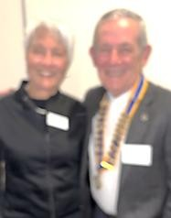
Rotary Club of Holdfast Bay President 2026-2027– Bill May (Anne)

Message from President Bill……………

The Rotary Club of Holdfast Bay donated $2,400 in August and this FY (July & August) donated $4800, mainly to local organisations.

Messages from District Governor Tim Mee
Barcelona Convention – 5 day low Registration rate period opens soon!
Registration fees for the 2027 Rotary International Convention in Barcelona ( 26 June to 30 June 2027) are now available at Registration fees including the deadlines.
Registrations will open on 17 September for a 5-day low-rate promotional period. There will not be the usual December deadline, and the first deadline after the promotional period is 31 March 2027. The event code for Barcelona will be IC27.

Please note that while the fee structure and deadlines are now available, neither online registration nor the registration form will be available until registration opens on 17 September.

District 9510 will be appointing a District RI Convention Promotions Chair for Barcelona shortly. If you are interested in being part of the Barcelona team next year, please contact District Governor Tim Mee Dg26-27@rotary9510.org
RYLA Dinner on Thursday 8 October Supporting our Youth programs - Registrations are now open for the RYLA (Rotary Youth Leadership Awards) Dinner at the Marche Club, 51 Gorge Road, Paradise.
Registration Link Trybooking. https://www.trybooking.com/DNUVW
Full details of RYLA Dinner on Page12 of the Rotary Classifieds (September edition)
Club Excellence Awards announced (2025-26 Rotary Year)
Congratulations to the following nine clubs in District 9510 for achieving the Rotary Club
Excellence Award in 2025-26. The Rotary Clubs of Adelaide, Gawler Light, Lightsview, Magill Sunrise, Murray Bridge, Port Lincoln, Regency Park, St Peters and Whyalla, have demonstrated a commitment to achieving their goals, ultimately strengthening Rotary and shaping our future.

Please encourage your club to enter its goals for 2026-27 in Rotary Club Central and your club could be recognised next year. Link to RC Central Goals

The Rotary stand at the Royal Adelaide Show attracted large crowds to the Jubilee Pavilion, (stand E21) as 90 volunteers over 108 shifts, sparked conversations and captured interests via a quick QR survey. Visitors were invited to spin the prize wheel, earning everything, from RC Mitcham and Edwardstown bookshop vouchers, to RC Burnside breakfast burgers, RC Lightsview popcorn, Bunnings BBQ treats, and cross marketing with RC Mount Barker through their kindly donated donut vouchers. This strategy ensured people connected twice with Rotary. With more than 300 people already registering interest to learn more about Rotary, our Rotary Community Leaders will soon share this 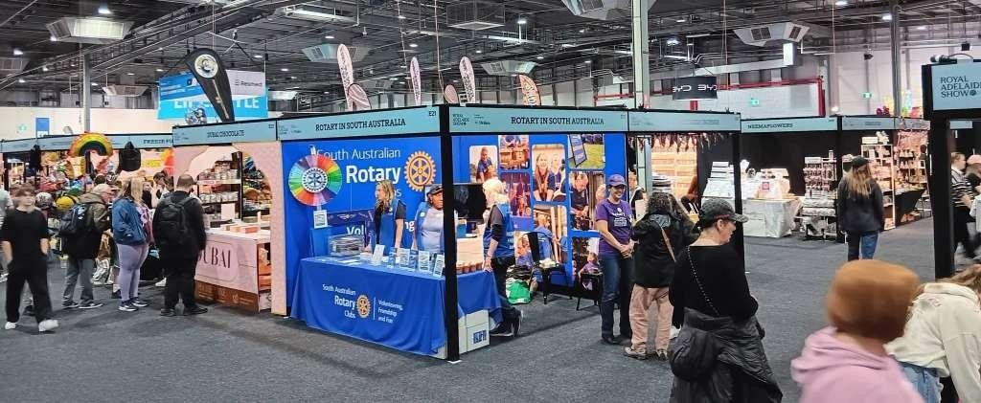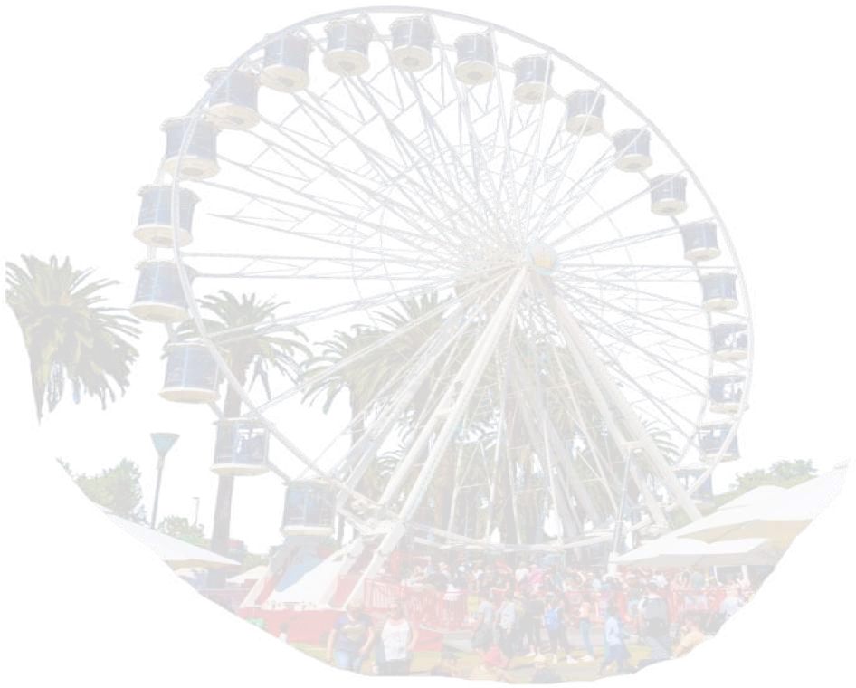data with clubs so you can create engaging ways to welcome potential members.

September is Education and Literacy Month—a time to celebrate how
reading, writing, and learning opens doors. Around the world, Rotary is strengthening education through projects such as the Guatemala Literacy Project, which supports more than 170 schools with textbooks, computer labs, teacher training, and early childhood centre upgrades in Cape Town’s Phillippi Township.
Rotary’s impact also reaches Honduras, rural Taiwan, Belize, and beyond—modernising schools, expanding science education, rebuilding literacy skills, and supporting clubs through BELRAG (Basic education and Literacy Rotary Action Group) with projects such as mobile libraries, literacy programs, and youth digital skills training. As we mark this month, let’s keep championing learning locally and globally, knowing every child, teacher, classroom, and book supported helps build a more hopeful future. Yes, as member of Rotary we are creating lasting impact globally, through education and literacy thanks to the members of this club and similar clubs all over the world!


People who have Created Lasting Impact
Introducing, Nelson Mandela a profile of a person who Created Lasting Impact.
Presented by Evelyn McCloy - meeting 7/09/26
Good evening, everyone and thank you for joining us again. As part of our theme this year, Create Lasting Impact, we’re exploring people whose actions didn’t just change their own communities, but reshaped the world in ways that endure today.
Tonight, we turn to one of the most powerful examples of moral courage and leadership in modern history: Nelson Mandela.
Mandela’s story is not simply about politics. It is about humanity. It is about dignity. It is about the belief that even in the face of overwhelming injustice, one person’s determination can transform a nation. To understand his impact, we need to begin with the world he was born into.

Nelson Rolihlahla Mandela was born in 1918 in rural South Africa, part of the Madiba clan of the Xhosa people. His early life was shaped by traditional leadership, community values, and stories of resistance. These influences planted the seeds of a lifelong commitment to justice.
As a young man, Mandela studied at the University of Fort Hare and later at the University of the Witwatersrand. He became involved in student activism and soon joined the African National Congress, where he helped form the Youth League. He believed that change required courage, organisation, and the willingness to stand up to injustice.
At that time, South Africa was governed by the apartheid system — a rigid structure of racial segregation and oppression. Black South Africans were denied basic rights, freedom of movement, political representation, and equality under the law. Mandela recognised that this system could not be reformed; it had to be dismantled.
Throughout the 1950s and early 1960s, Mandela became a leading voice in the antiapartheid movement. He organised peaceful protests, defended victims of discriminatory laws, and spoke out against injustice. But as the government intensified its repression, Mandela and his colleagues faced a difficult truth: peaceful resistance alone was no longer enough.
In 1962, Mandela was arrested. Two years later, he was sentenced to life imprisonment for sabotage and conspiracy against the state. He would spend 27 years behind bars — 18 of them on Robben Island.
Those years could have broken him. Instead, they shaped him.
Mandela used his imprisonment to deepen his understanding of leadership, justice, and reconciliation. He studied, he reflected, and he prepared for the day when South Africa would need a unifying voice. His moral authority grew, not despite his imprisonment, but because of it. Around the world, he became a symbol of resistance and hope.
When Mandela was finally released on 11 February 1990, the world watched with anticipation. South Africa stood at a crossroads. Decades of oppression had left deep wounds, mistrust, and fear. Many expected anger or revenge.
But Mandela chose a different path.
He believed that lasting impact required reconciliation, not retaliation. He worked with President F.W. de Klerk to dismantle apartheid and build a democratic South Africa. Their efforts earned them the 1993 Nobel Peace Prize.

In 1994, Mandela became South Africa’s first Black president. His leadership during those years was defined by unity, dignity, and forgiveness. He understood that healing a nation required more than political change — it required moral change.
He famously said, “Resentment is like drinking poison and then hoping it will kill your enemies.” Mandela refused to drink that poison. Instead, he built bridges.
He established the Truth and Reconciliation Commission, allowing victims and perpetrators to confront the past openly. He promoted education, equality, and opportunity. He stepped down after one term, reinforcing the importance of democratic principles.
After leaving office, Mandela continued humanitarian work through the Nelson Mandela Foundation, focusing on HIV/AIDS awareness, poverty reduction, and education. Even in retirement, he remained a global symbol of justice and compassion.
Mandela passed away in 2013 at the age of 95. But his impact endures — not only in South Africa, but across the world.
So why does Mandela matter to us, here in Rotary?
Because his life embodies the values we strive to uphold: Peace and conflict resolution.
Supporting those in need. Promoting dignity and equality. Building stronger communities.
Mandela showed that lasting impact is not created through anger or division, but through courage, empathy, and the willingness to forgive. He demonstrated that leadership is not about power — it is about service.
As we reflect on his life, we are reminded that creating lasting impact often requires us to confront difficult truths, to listen deeply, and to act with integrity. Mandela’s story encourages us to look at our own community and ask: Where can we build bridges? Where can we promote understanding? Where can we help create a more just and compassionate world?
Nelson Mandela didn’t simply change South Africa. He changed the global conversation about justice, reconciliation, and humanity.
May his example inspire us in our Rotary work this year. May we strive, as he did, to create lasting impact — not through grand gestures, but through consistent, courageous service.
Thank you.
Evelyn

And don’t forget in October

Rotary Club of Coromandel Valley
GIANT PLANT SALE
WAITE STREET RESERVE BLACKWOOD

SATURDAY 24TH OCTOBER 8.30 – 1.30

HUGE VARIETY, GREAT PRICES, FROM $5.00

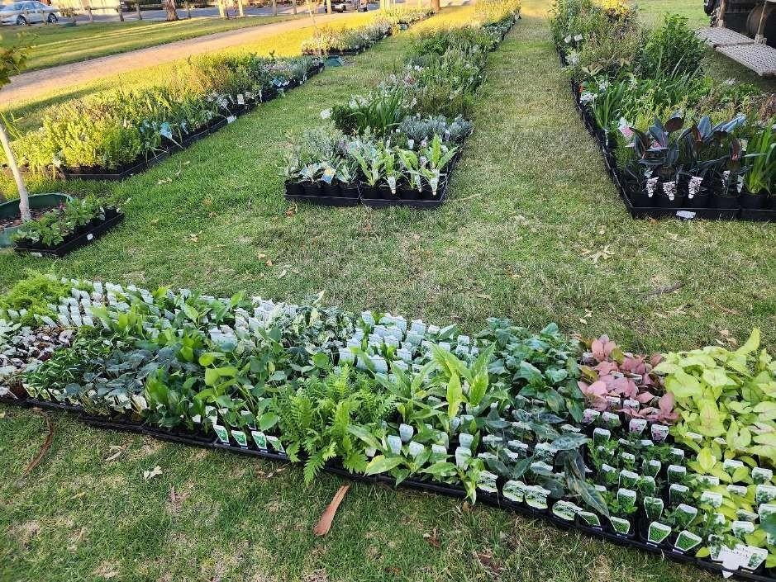

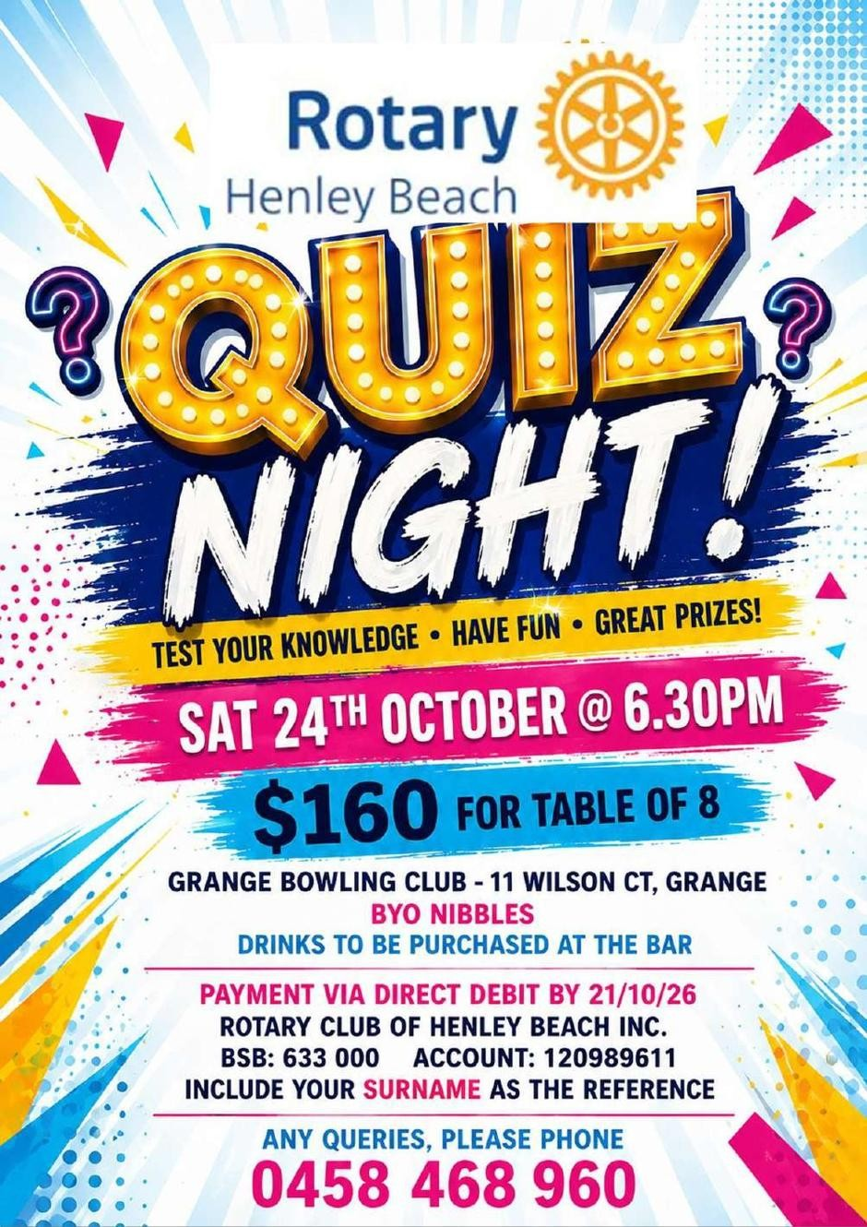

ROTARY INFORMATION

  OCTOBER |   Anniversary  31st Brenton Tiver |     4th Roger Wicks Congratulations on a Special Birthday Roger!  19th Marilyn Tiver  20th Marilyn Armstrong  27th Eva Martin  27th Meryl Pocock  28th Garry Veroude |   Wedding Anniversary  14th John & Lorraine Douglas  21st Simon & Jo Hall


NOTICE BOARD


- Kibby Coffee Morning every Wednesday 10am – 11am Members, Partners and Guests WELCOME! $2 Gold Coin Donation per person

- Book Exchange – available at Kibby every Wednesday 10am – 11am Please bring current books in good condition for Book Exc


GUEST SPEAKERS – OCTOBER 2026

Meeting 5 October - NO MEETING, PUBLIC HOLIDAY

Meeting 19 October - Calperum Station, Health of the River,
Ian Coat

,

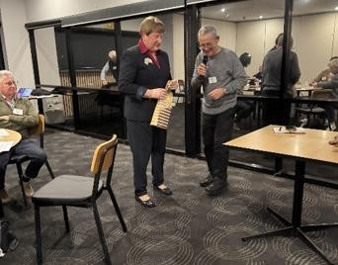
At the Club Meeting on 7 September, Barbara Wheatcroft, Chair of Australia Rotary Health was our Guest speaker. Below is a follow-up from Barbara reinforcing the current activities of ARH.

Left: Barbara pictured with President Bill after her presentation

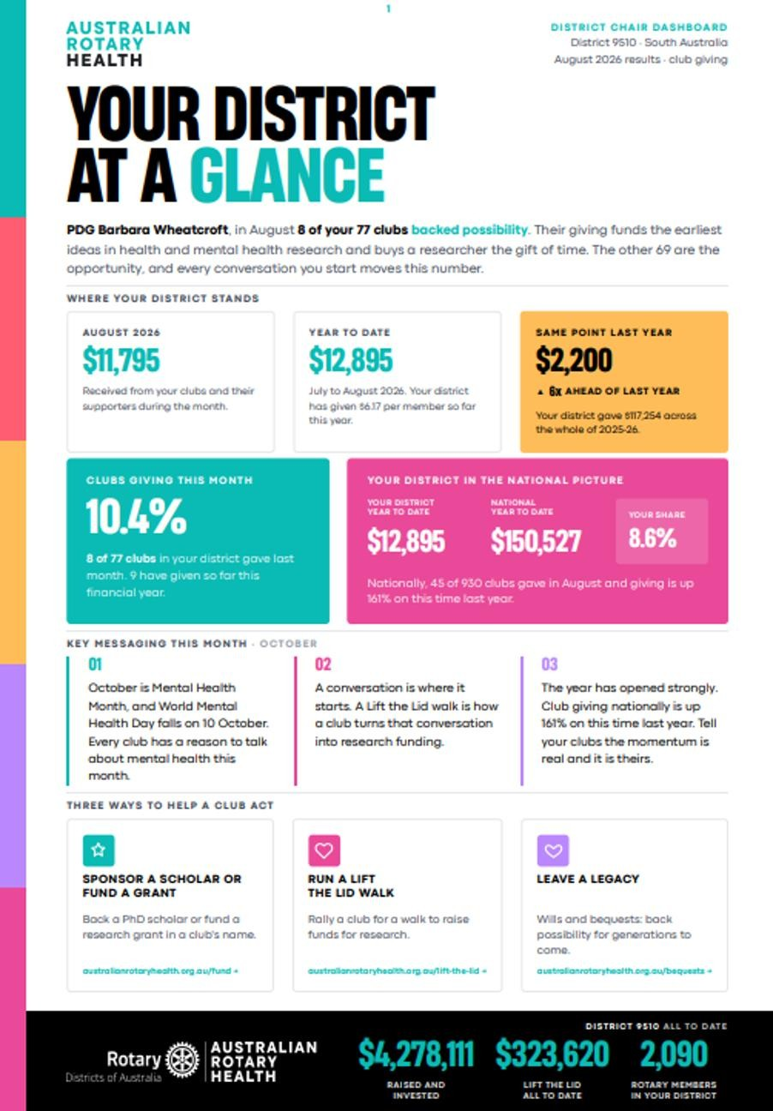
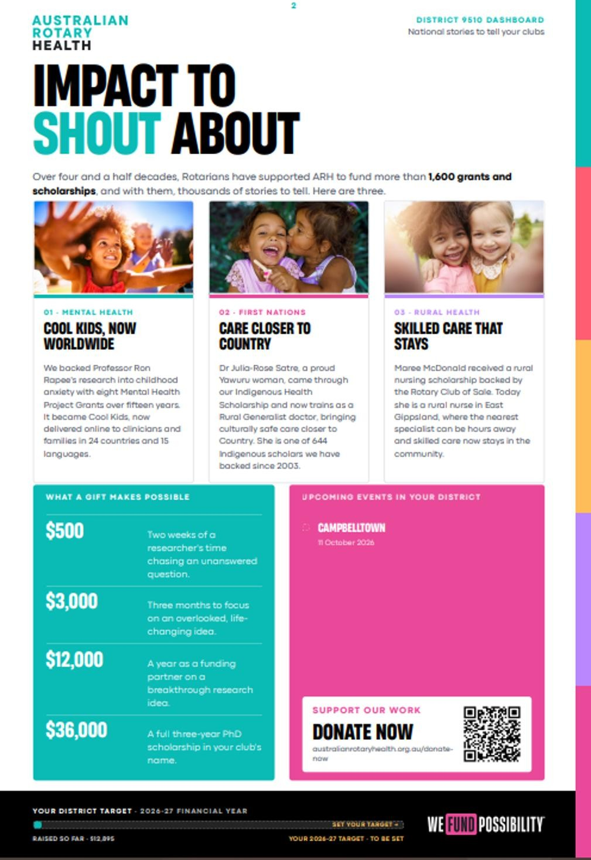

COMMITTEE UPDATE

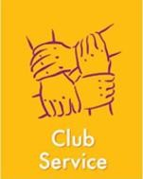

Club Service - Brenton Tiver
Next Bunnings Friday 25th September.
The rosters for future dates will be circulated at Meetings and Kibby Coffee Mornings. WE NEED YOUR HELP!


Community Service – Jeannette Bennett/Val Delbridge
Mary’s Kitchen – see Roster section in the Bulletin.

Christmas Food Drive - the dates for our Christmas Food Drive at Brighton Central are November 13 & 14 – Members please put these dates in your diary.

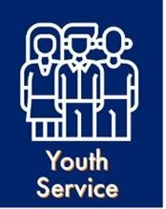
Youth Service – Anne Day
Health of the River Forum. This event happened from 14th to 18th September and the club sponsored student Maarley from Coromandel Valley.

Rotary Youth Sailing Challenge - The One and All will depart on 27th September for a 5-day voyage around Kangaroo Island.

National Youth Science Forum -The board has agreed to send a second student, Kate from Seacombe Gardens, to the forum next January.

We will invite these students to present at the club and tell us about their adventures.

SOCIAL UPDATE



Around the Club………
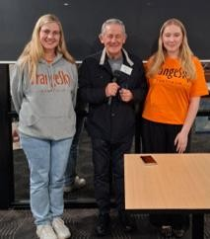
Guest Speakers at Club Meeting on 21-09-26 from Orange Sky –
Lis &Maechela, Pictured right with President Bill
Orange Sky provides laundry facilities for the homeless across Australia. Both Ladies volunteer for the organisation and told Members all about this wonderful project.

CLUB UPDATE

  DIARY DATES | DATE | TIME | PROGRAM | VENUE
 | 26 Sep | 1pm | AFL Grand Final BYO Drinks | Kibby Shed
 | 5 Oct |  | NO MEETING – PUBLIC HOLIDAY
 | 19 Oct | 4.30pm | Board Meeting-prior to Club Meeting | Club Marion
 | 19 Oct | 6.pm for  6.30pm | Club Meeting – Guest Speaker TBA | Club Marion
 | 2 Nov | 6.pm for  6.30pm | Club Meeting – MELBOURNE CUP    PARTNERS NIGHT Come and join in the fun and wear that SPECIAL Hat! | Club Marion

  Furniture  Attendance  Vision Statement  Toast Australia  Sergeant  Chair/ MC  4 Way Test | 5/10/26  Club Meeting | 19/10/26  Club Meeting | 2/11/26  Club Meeting  Melbourne Cup
 | NO MEETING | Brenton & Marilyn Tiver | Brenton & Marilyn Tiver
 | PUBLIC HOLIDAY | G.Lang/H.Janzon | B.Manson/E.Martin
 |  | Barry Manson | Bill May
 |  | Lynne Sheridan | Judy Shipp
 |  | Roger Wicks | Roger Wicks
 |  | Bill May | Bill May
 |  | ALL | ALL

  Mary’s  Kitchen  Kibby  Avenue | Tuesday 20/10/26 @ 4.45pm | Tuesday 17/11/26 @ 4.45pm
Bump In/Bump Out | Jeannette Bennett/Val Delbridge All Welcome - For Coffee & Chat | Jeannette Bennett/ Val Delbridge All Welcome - For Coffee & Chat

  Bump In 8.15am  Captain/Cook  Order  Collect  Bump Out 4.00pm  Kibby Crew 4.15pm PLEASE NOTE: | Friday 25/09/26 8.15am-10.00am 10.00am-12noon | Friday 25/09/26  12noon-2.00pm 2.00pm-4.00pm
 | Bill May, Greg Lang
 | Bill May Simon Hall | John Douglas Brenton Tiver
 | Lynne Sheridan Sue Petrou | Anne Day Roy Armstrong
 | Peter Gapp Bruce Grimm | Rob Hill Marilyn Tiver
 |  | Brenton Tiver, Marilyn Tiver
 |  | Val Delbridge, Jeannette Bennett
 | MUST WEAR ENCLOSED SHOES | SHIFTS 1 & 4 - ARE REQUIRED To help with Bump In & Bump Out


CLUB BOARD 2026-2027

President: Bill May
Past President: PDG Roy Armstrong OTHER POSITIONS:
President Elect: David Patton Bulletin: Lorraine Douglas
Treasurer: Borys Potiuch Web Master: Simon Hall
Treasurer Assistant: Barry Manson Social Media: S. Hall/E. McCloy
Secretary: Eva Martin Almoner: Judy Shipp
Club Service: Brenton Tiver Public Officer: Barry Manson
International Service: PDG Roy Armstrong
Youth Service: Anne Day
Membership & Public Image: Roger Wicks
Community Service: Jeannette Bennett /Val Delbridge
Fundraising: Judy Shipp

MEETING DETAILS  Club Marion, 262 Sturt Road, Marion SA 5043  1st & 3rd Mondays of the month 6pm for 6:30pm Guests and Apologies phone Judy Shipp  08 8377 2358 or 0418 814 080 By Sunday evening prior   | ROTARY CLUB HOLDFAST BAY  PO Box 167, Glenelg SA 5045  Website: https://rotaryholdfastbay.org/  Email: holdfastbay.rotary.sec@gmail.com  Bulletin Editor: Lorraine Douglas  Email: johlor@gmail.com

