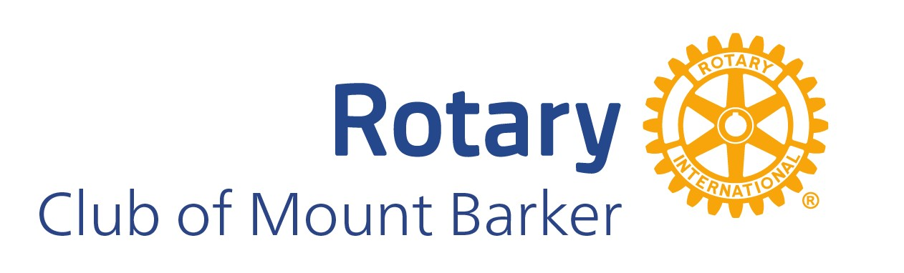

ROTARY CLUB OF MOUNT BARKER
2025 COMMUNITY GRANTS

The Rotary Club of Mount Barker is a local community based service club, affiliated with Rotary International. We comprise dedicated community members, volunteering their time to raise funds to spend in our local community, nationally and internationally. Rotarians are ordinary people, who generously work together to aid those in need.

Over the past years, we have participated in and contributed to a wide variety of activities:
- The club’s famous donut van at various festivals and events, including the Royal Adelaide Show and the Lights of Lobethal
- Barbecues throughout the local community
- Assistance at local events, including the Mount Barker Australia Day celebration, ANZAC Day and Hungry No More (at Mount Barker Uniting Church)
- Funding youth projects such as Operation Flinders and Kick Start for Kids
- Sponsoring young people in leadership development and career networking
- Relocating playgrounds no longer needed by Councils to villages in developing nations
- Saying NO to Domestic Violence and promoting world peace
- Significant Rotary charities and projects such as Australian Indigenous Health, the Rotary Foundations, End Polio and Rotary Overseas Medical Aid.

The Club would like to hear from local not for profit, sporting and environmental groups, as well as individuals with community projects, that could be supported by the Rotary Club of Mount Barker (RCMB).

Applications for the 2025 Rotary Club of Mount Barker Community Grants are now open.

Please use the attached Application Form to tell us about a great community project we could support. Grants are up to $1,000 per application. If you are successful, you will be asked to attend and address a meeting of the Rotary Club of Mount Barker on June 16th 2025.

Applications close at 5pm on Friday May 16th 2025. Please carefully read the Terms and Conditions (Declaration) attached to the application form.

2025 ROTARY CLUB OF MOUNT BARKER COMMUNITY GRANTS

APPLICATION FORM

One-off project grants up to $1,000

1. ORGANISATION DETAILS
1. 1 Incorporated Organisation:
Location Address:

Postal Address:

ABN GST registered? (please circle) YES/ NO

1. 2 ORGANISATION CHAIRPERSON:
Title:
First Name: Jason

Surname:

Position:

Phone:

Email:

1. 3 APPLICANT ORGANISATION: Use only if not incorporated.
Name of Applicant Organisation:

Location Address:

Postal Address:

1.4 PROJECT CONTACT PERSON:

Title:

First Name:

Surname:

Position:

Phone:
Email:

2. PROJECT DETAILS:

2.1 Name of Project:

2.2 Start Date: | End Date:
2.3 Project Description:
Note: If successful, in June 2025 your organisation will be invited to attend a Rotary meeting to accept the funding and provide a short presentation on your project.

2.4 Project Summary: Provide an overall summary statement for your project.

Please carefully read the Declaration, Terms and Conditions on the following pages.

3. DECLARATION

3.1 Agreement to conditions of funding

The Rotary Club of Mount Barker Community Grant Program is designed to generate awareness within the general public of the availability of funds or funding from the Rotary Club of Mount Barker, The members of the Rotary Club of Mount Barker work hard to raise this money and the Rotary Club of Mount Barker Community Grant Program will help us effectively deal with the large numbers of requests that we receive for support each year.

This is designed to be a funding model that does not guarantee or offer funds on a recurring basis.

The pool amount is set at $15,000 to be divided at the discretion of the community grant committee of the Rotary Club of Mount Barker. Larger amounts will be considered, however proposals offering part funding of your proposal will also be viewed, with a considerable bias. All decisions made by the club are considered final.

The purpose of the Rotary Club of Mount Barker Community Grant Program is to offer not for profit community organisations, clubs, individuals, cultural & environmental groups & associations funding for their needs and/or projects in the Mount Barker Council district.

The Rotary Club of Mount Barker does not intend or condone the use of this community grant program to be used for monetary profit, but insist that it is used by the above mentioned, not for profit organisations/ individuals, to achieve their goals.

Applicants seeking community grant funding must ensure that the project meets with all federal/ state laws, and also meets local council guidelines. Please check relevant websites.

Successful applicants must use the allocated funds within the financial year that they are allocated, unless specifically agreed to by the Rotary Club of Mount Barker.

3.2 Limitations

The Rotary Club of Mount Barker will not consider, nor approve applications whose primary purpose is to promote religious beliefs, political beliefs, individual or sporting prizes, projects already completed, and especially events/ requests that contravene the guiding principles of Rotary, the 4 way test as below:
- Is it the TRUTH?
- Is it FAIR to all concerned?
- Will it build GOODWILL and BETTER FRIENDSHIPS?
- Will it be BENEFICIAL to all concerned?

3.3 Assessment Criteria

All applications for a Rotary Club of Mount Barker community grant will be assessed on the following:

- Adherence to Rotary’s core values, as underlined in the 4 way test
- Benefits to the community
- Demonstrated community support for a project and/or activities planned
- Measurability of outcomes

3.4 How are the Rotary Club of Mount Barker Community Grants assessed?

The Rotary Club of Mount Barker Community Grant assessment panel, consisting of four members appointed by the board of directors of the Rotary Club of Mount Barker, undertakes the role of assessing all applications, based on the before mentioned assessment criteria.

The Rotary Club of Mount Barker Community Grant assessment panel will recommend those projects and/or activities that most meet the values and expectations, underlined in the assessment criteria, and present these to the board of directors of the Rotary Club of Mount Barker for final approval.

If your application is successful, you will be notified in writing by the club, and it is expected that you will attend a Rotary Club of Mount Barker meeting to outline your project before the project/ activity, AND after said project/activity to deliver an outcome report. Failure to do so will be taken into consideration for future applications/ requests for grants.

If you are not successful, the club will be in contact to let you know why you were not successful and advise how you may wish to apply again in the future, to gain a better chance of approval.

All grants MUST be spent in the manner in which they were granted, within 12 months. Any unspent monies must be advised to & returned to the Rotary Club of Mount Barker.

3.5 Recognising the Rotary Club of Mount Barker’s Contribution

One of the conditions of receiving funding through the Rotary Club of Mount Barker Community grant program is that the recipients recognise the support/ contribution of the Rotary Club of Mount Barker.

This can be achieved by the following methods:

- Include the Rotary emblem on any printed materials (Proof to be approved by RCMB)
- Acknowledge the support/funding of the Rotary Club of Mount Barker n any press releases, articles, media, or outline programs
- Attend our meeting and present to the members the aspirations and/or results of our grant
- Invite and/or acknowledge members of the Rotary Club of Mount Barker at your event
- Recognise the contribution of the Rotary Club of Mount Barker with on-site signage (Proof to be approved by RCMB)

The Rotary Club of Mount Barker also retain the right to use and/or promote any photos or promotional material on our website and social media platforms.

3.6 Signatories This application must be signed by 2 persons authorized by the organisation.

At least one signatory must be an Executive member of the Board or Management Committee.

We declare that the information supplied is true and accurate to the best of our knowledge.

We also acknowledge that this one-off project does not involve ongoing funding.
1) Name: | Signature:
Position: | Date:
2) Name: | Signature:
Position: | Date:

Applications close: Friday May 16th 2025 at 5.00pm

Please either email to secretary.rotarymtbarker@gmx.com

Or Post to:

Rotary Club of Mount Barker PO Box 111, Mount Barker SA 5251

Object of Rotary

The Object of Rotary is to encourage and foster the ideal of service as a basis of worthy enterprise and, in particular, to encourage and foster:

FIRST. The development of acquaintance as an opportunity for service;

SECOND. High ethical standards in business and professions; the recognition of the worthiness of all useful occupations; and the dignifying of each Rotarian's occupation as an opportunity to serve society;

THIRD. The application of the ideal of service in each Rotarian's personal, business, and community life;

FOURTH. The advancement of international understanding, goodwill, and peace through a world fellowship of business and professional persons united in the ideal of service.

