Rotary Club of Auckland Harbourside & Education First Trust – Joint Dictionary in Fiji Project
Rotary Club of Auckland Harbourside in partnership with Education First Trust commenced Rotary Dictionary distribution project in Fiji in 2015. After an educational needs analysis, it was identified there was a huge need with improving literacy particularly English language and numeracy in low decile and many rural schools in Fiji. These students lacked teaching aid that would assist in improving their understanding of English language. It was recognised that Rotary Usborne Illustrated English Dictionary was an ideal tool to assist with English learning and may assist with other subjects.
First distribution started in 2015. In 5 years until 2019, we have distributed total of 4,650 dictionaries to 233 schools in Fiji covering areas in Nadi, Lautoka, Ba, Tavua, Rakiraki, Nausori, Nadroga, Navosa, Sigatoka in Viti Levu Fiji and Labasa in Vanua Levu Fiji. Members and Trustees have travelled to Fiji to personally deliver these dictionaries to the students, also donating dictionaries to school libraries and Education District offices.
These Rotary Dictionaries have been extremely effective as a learning tool. Feedback from some Teachers confirmed marked improvement in English since introduction. Some remote rural Schools have opted to retain these dictionaries in School Libraries making them available to all the students in the School. In most cases dictionaries were distributed to individual students and are the first book they own as a “Gift of Learning”.
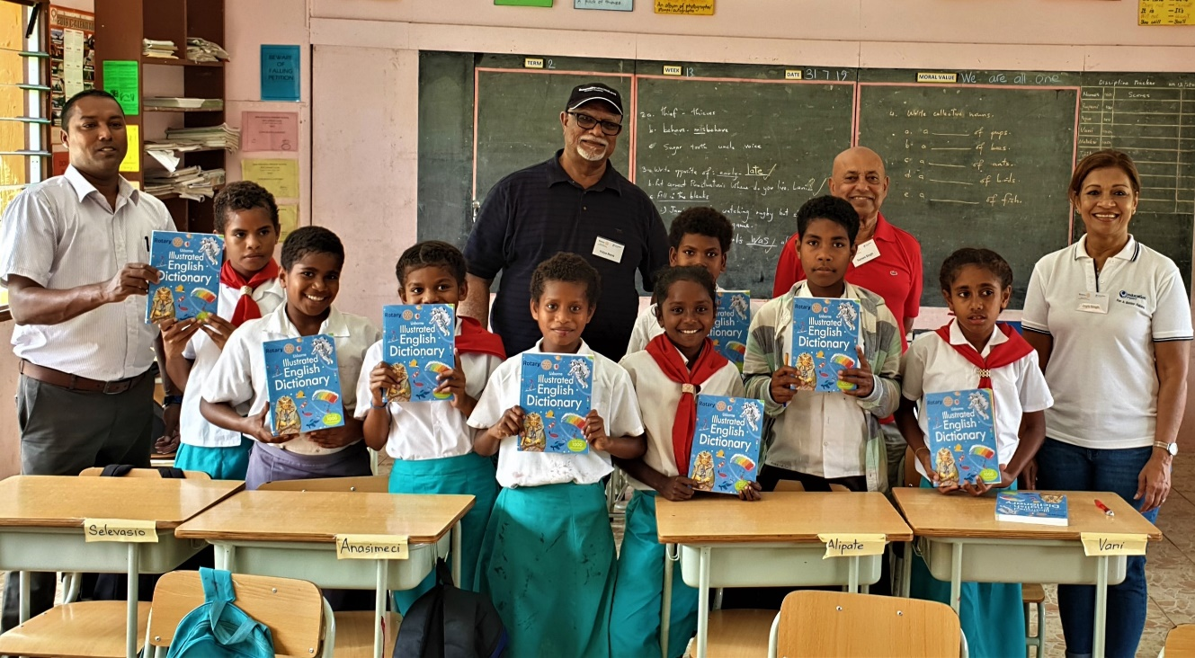

Rotary Dictionary distribution to Southern Cross Campus - Junior School, Auckland
Rotary Club of Auckland Harbourside has been distributing dictionaries to Year 4 students at this low decile Junior school annually for the past 10 years. Around 90 children each year have been given their own dictionary with their name written and they get to keep it! In most cases this is their first educational book.
The joy of seeing the delightful twinkle in their eyes on receiving the dictionary, tells it all. This annual occasion is one of our club's most rewarding projects. We are grateful to Bill and Lorna Trust for initiating this opportunity. We also acknowledge Syd Young Trust, along with other donors for the funding that makes this project so worthwhile.
