Trip to Myanmar in 2013
Our 12 days travel in 2013 took us through Yangon, Naypidaw the new Capital of Myanmar build in the early 2000’s; Mandalay; Bagan and Inle Lake. The whole trip was organized by a fellow colleague a Burmese who came to Singapore more than 20 years ago to escape the military junta and had long to return to Yangon to set up his own business to take on the challenge of rebuilding his country economy. When the chance came along, he decided to uproot and return to Myanmar in 2012. He was responsible for planning and arranging all logistic and hotel accommodation as well as local tours for us.

The big draw was the chance to see a country where the 21st-century world has barely intruded. In 2013, Myanmar was still relatively untouched and there was a strong sense of significant change in the air. It's a place where Buddhism is still a way of life and its home to many old colonial relic and buildings which were being restored and turned into hotels and museum.

Though Myanmar now claims an elected civilian government, it is hardly a country which is free from oppression. The military is still very involved in the country’s economy but the big difference is that the Burmese people are now more positive and hopeful that the massive changes in political system they have witnessed over the past four years cannot be reversed. The new democratically elected government lead by, Aung San Suu Kyi bring with it hope and opportunities; access to the worldwide web, including sites critical of the government; and the arrival of planeloads of Western tourists with dollars to enrich their communities.

Following the recent lifting of Western sanctions, Myanmar has become a magnet for tourists. It has some wondrous sights:
- A thousand temples scattered across the countryside in Bagan;
- The leg-rowers and floating gardens of Inle Lake, and
- The majestic rivers - the Irrawaddy and the Chindwin River- navigable into the furthest reaches of the country.

Chronic temple fatigue is a big danger for the first-time visitor. So plan your itinerary to go beyond the main tourist areas. Spend time in the traditional street markets, teak villages, teahouses and small-town markets getting to know some of the most endearing people you will meet anywhere in the world
1st Stop - Yangon (formerly Rangoon), the country's largest city, is home to bustling markets, numerous parks and lakes, and the towering, gilded Shwedagon Pagoda, which contains Buddhist relics and dates to the 6th century. A mixture of British colonial architecture, modern high rises and gilded Buddhist pagodas define its skyline. Its famed Shwedagon Paya, a huge, shimmering pagoda complex, draws thousands of pilgrims annually. It’s gold exterior is best appreciated in the early morning and dawn where sun rise and sunset has a mesmerising impact. The city's other notable religious sites include the Botataung and Sule pagodas, both housing Buddhist relics. One unique market worth visiting is the covered market of Bogyoke Aung San. It is packed with stalls selling traditional lacquerware, antiques, wood carvings and textiles (including the sarong like longyi (traditional wear for many Burmese). The Circular Railway, a commuter train departing from the landmark Yangon Central Station, provides views of a variety of urban and rural landscapes.
The following photos capture the vibrancy of Yangon city:
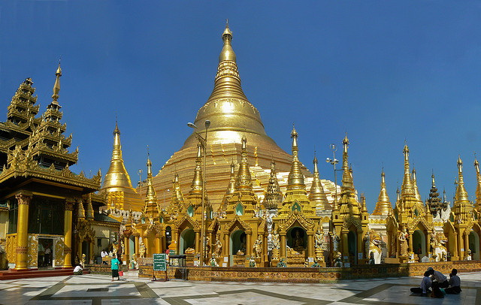
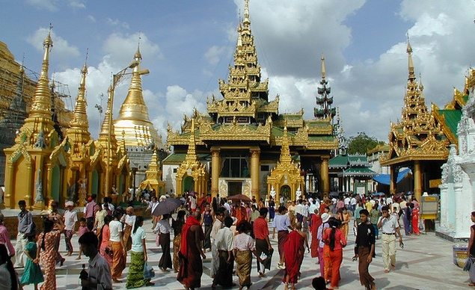
Shwedagon Pagoda early in the morning

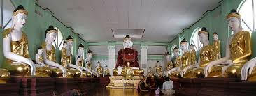
Inside Shwedagon Pagoda
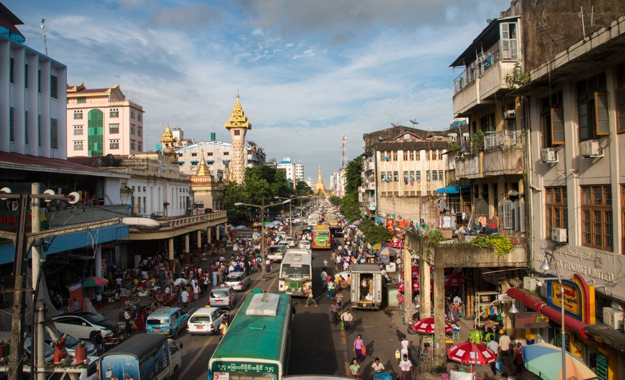
One of the main streets in Yangon
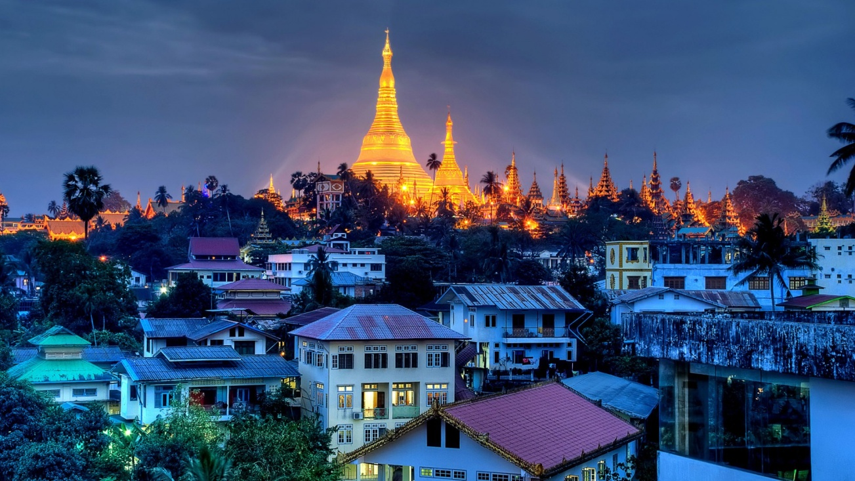
View of Yangon City from hotel room with Pagoda in the background
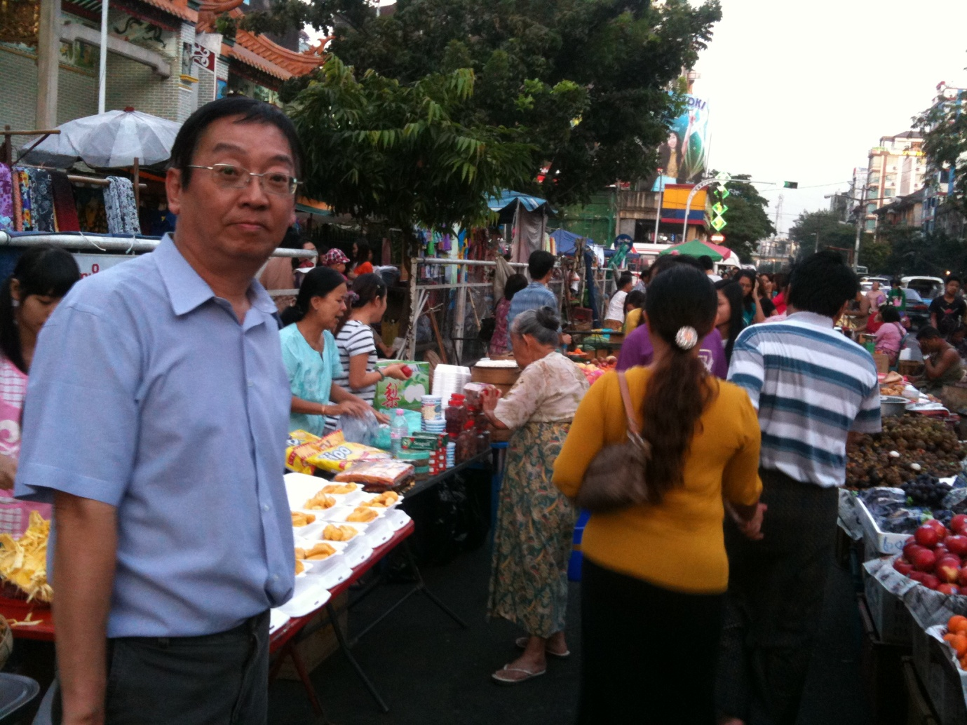
Shopping in one of the night market
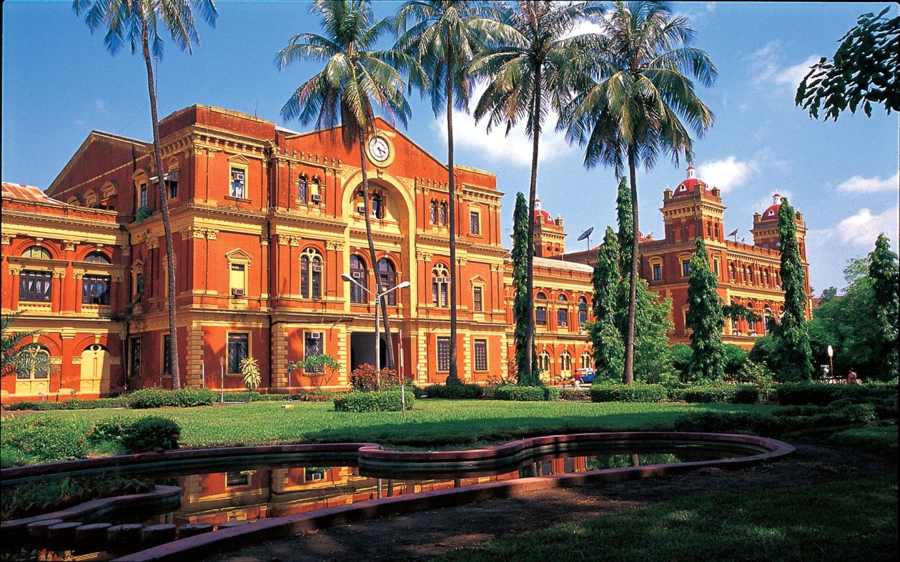
An old colonial building converted to York Hotel at Yangon
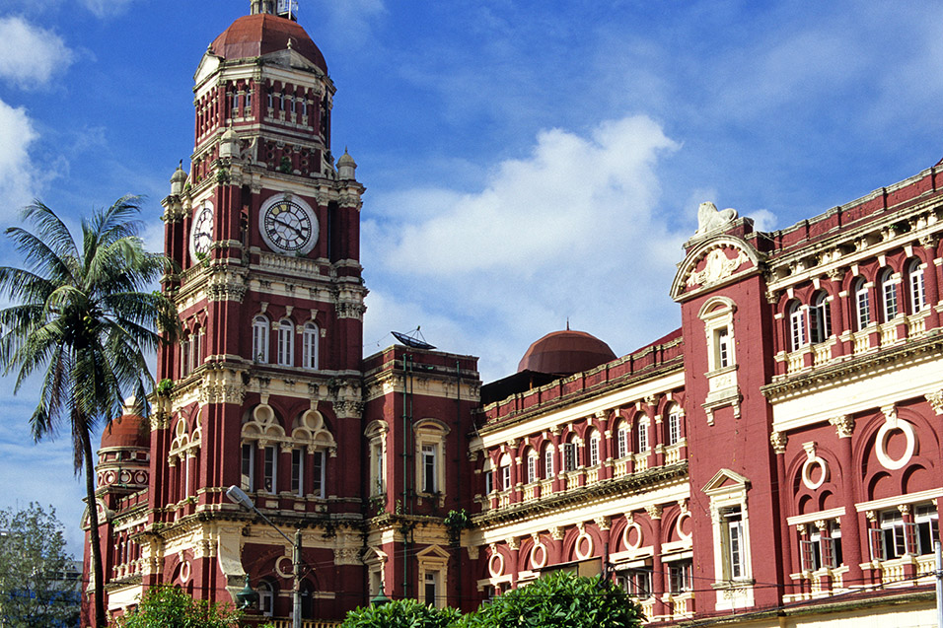
Yangon Supreme Court –another old colonial building put to good use
2nd Stop - Naypyidaw, was officially declared as the new capital of Myanmar in 2006. It is the administrative capital of the country and was created out of a green field site approximately 320km north of Yangon, the previous capital. The purpose-built city of Naypyidaw can be considered a bizarre city as it boasts 20-lane highways with very few cars using them, golf courses, fast Wi-Fi and reliable electricity. The only thing it doesn’t seem to have is people. Driving through Naypyidaw, it could be easy to forget that you’re in the middle of one of south-east Asia’s poorest countries. We drove pass a seemingly endless series of giant detached buildings, villa-style hotels and shopping malls look stunning, all painted in soft pastel colours: light pink, baby blue, beige. The roads are newly paved and lined with flowers and carefully pruned shrubbery. Meticulously landscaped roundabouts boast large sculptures of flowers – quite unreal.
When we were there in 2014, part of this planned city was still under construction.
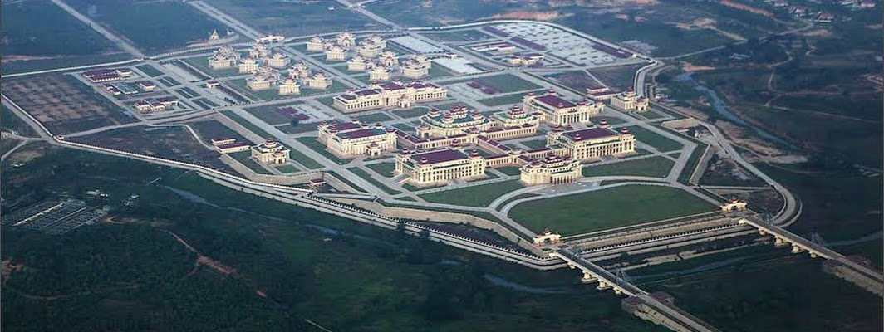
Government complex in Naypyidaw as seen from the air

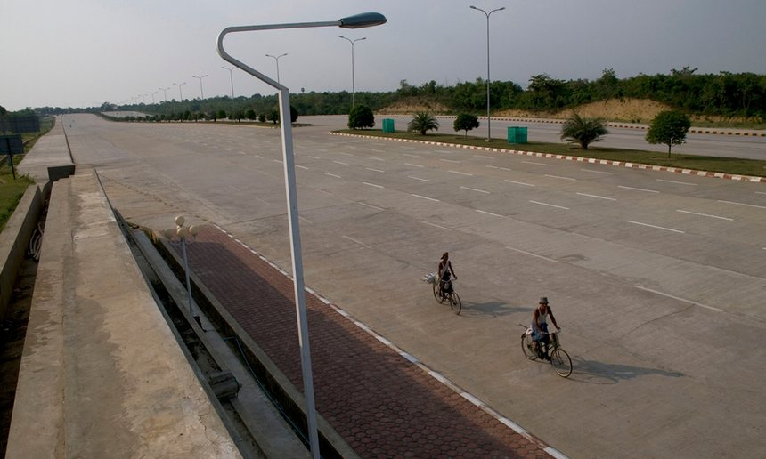
A 14-lane highway in the centre of Naypyidaw
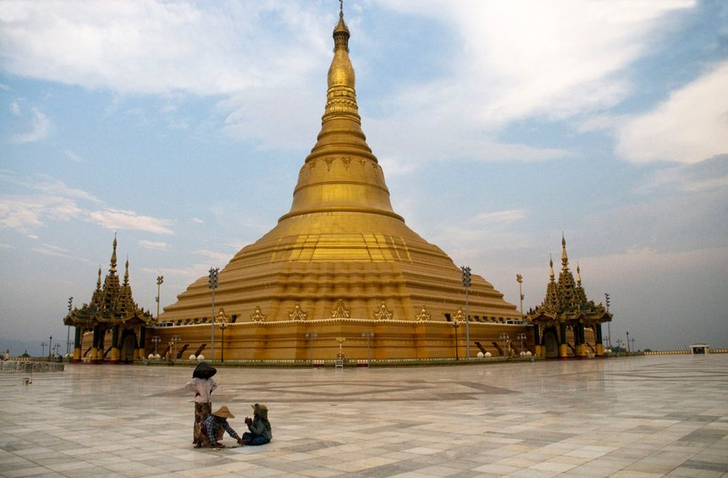
The Uppatasanti pagoda is a replica of the famous Shwedagon pagoda in Rangoon. Unlike the original, this one is hollow

Mandalay, which is about 716km north of Yangon is the second-largest city and the last royal capital of Myanmar. Located 716km north of Yangon which is estimated to have a population of 1.5 Million.. We flew into the city on Day4 of our tour. Mandalay is the economic centre of Upper Myanmar and considered the centre of Burmese culture. In recent years, there has been a continuing influx of Chinese immigrants, mostly from Yunnan, China leading to some resentment by the local community. This has reshaped the city's ethnic makeup and increased the dominance of the Chinese migrants in the local economy. Despite Naypyidaw's recent rise, Mandalay remains Upper Burma's main commercial, educational and health center. Mandalay is the former royal capital in northern Myanmar on the Irrawaddy River. In its center is the restored Mandalay Palace from the Konbaung Dynasty, surrounded by a moat. Another tourist attraction is Mandalay Hill which provides views of the city from its summit. The summit is reached by covered stairway. Tourists flock to this hill and stayed until sunset just to capture the amazing view of the evening sunset. At its foot, the Kuthodaw Pagoda houses hundreds of Buddhist-scripture-inscribed marble slabs. These photos are some of the main tourist attraction s in the city

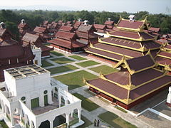
Mandalay Palace from watch Tower
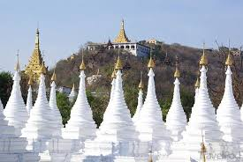
Kuthodaw Pagoda at the foot of Mandalay Hill

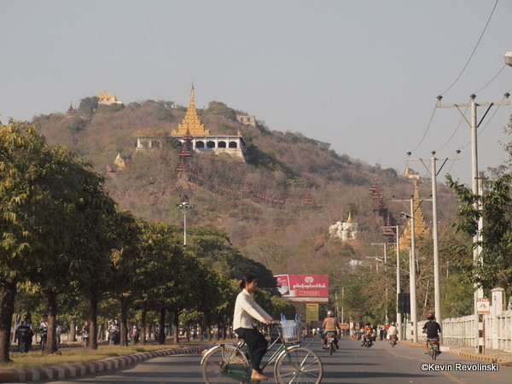
Photo of Mandalay Hill
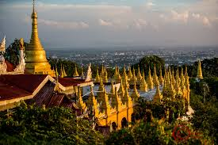
Another Photo of Mandalay Hill

The rural landscape around the small town of Inwa, also to the south, contains ruins and stupas (sphere-like Buddhist structures). A visit to Inwa is a fascinating trip back in time, allowing you to explore the remains of an ancient city full of old watch towers, city walls, monasteries, and more temples that feel a world away from the hustle and bustle of Mandalay.
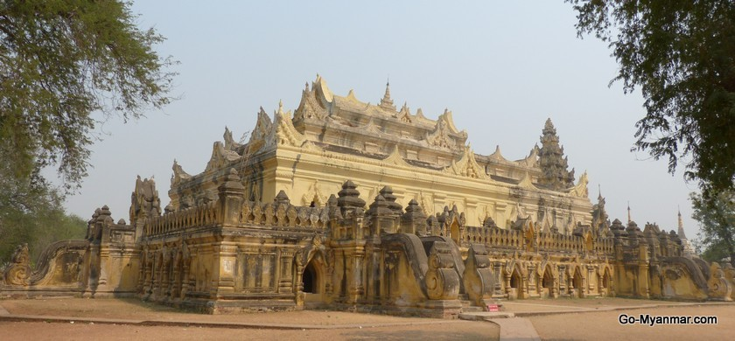

Bagan was our next stop. Bagan, located on the banks of the Irrawaddy River, is home to the largest and densest concentration of Buddhist temples, pagodas, stupas and ruins in the world with many dating from the 11th and 12th centuries. One can suffer from chronic temple fatigue after a visit to Bagan.
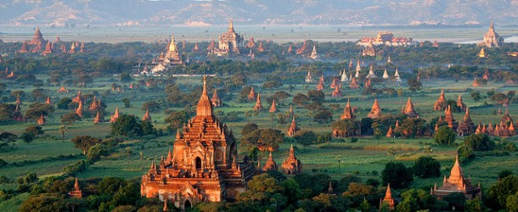

Bagan in central Burma is one of the world’s greatest archaeological sites, The setting is sublime as evident by the attached photos. Most of the archaeological sites are superbly preserved or have been restored by Unesco, Many contain frescoes and carvings and statues of Buddha, big and small. Only a handful of the m ore spectacular sites are regularly visited. The most spectacular time to see the temples is when the sun dramatically rises and falls over the plain at dawn or dusk. There are several ways to explore Bagan and we had the benefit of going up in hot air balloon which all us to have the most spectacular view of temples is to head to the sky for a hot air balloon trip as it offers a unique view of the plain and temples.

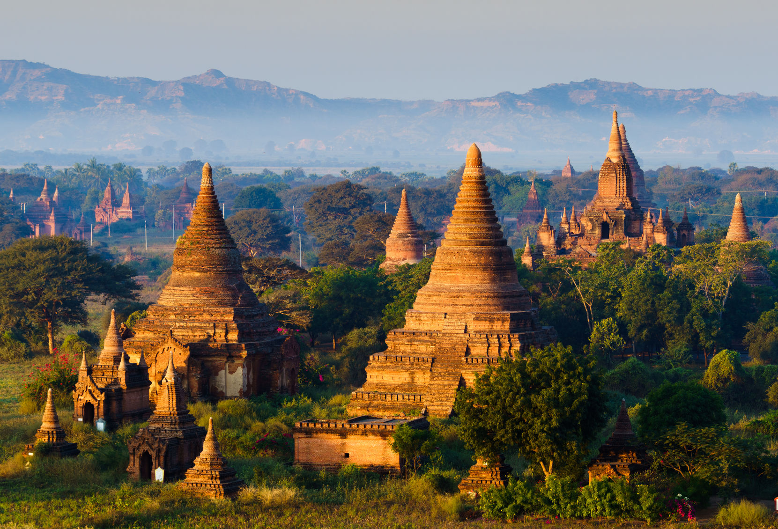
Photos showing the spectacular views of Bagan and its surrounding plain from the air
From Bagan we took a local flight to Inle Lake. When we reach the airport we were informed that a similar flight the previous day crash and the pilot and all passengers perish. Since we were already there, we took the decision to continue with our travel plans and hopped into a Cherokee propellor plane –we reach Inle Lake safely.

Inle Lake, is famous for its floating villages and gardens and the unique way of life of the local people, with their living communities based entirely on the water. The villages and towns that dot across the lake, have houses and buildings that are built on stilts and fishermen steer their one-man boats with a characteristic rowing style which involve the fisherman wrapping one leg around their oar.
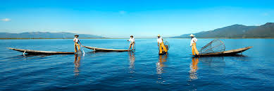
There is a lot to see on Inle Lake and in the villages that surround it, so, unless you stay in the area for 3 days or more, you need to be selective about what you want to see and do. Boat drivers, who also act as tour guides, will advise you on many of the best sights on the lake and its shores, but highlights of our visit are shows in the photo attached.
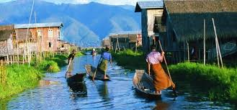
Typical canal and houses along the canal and mode of transport

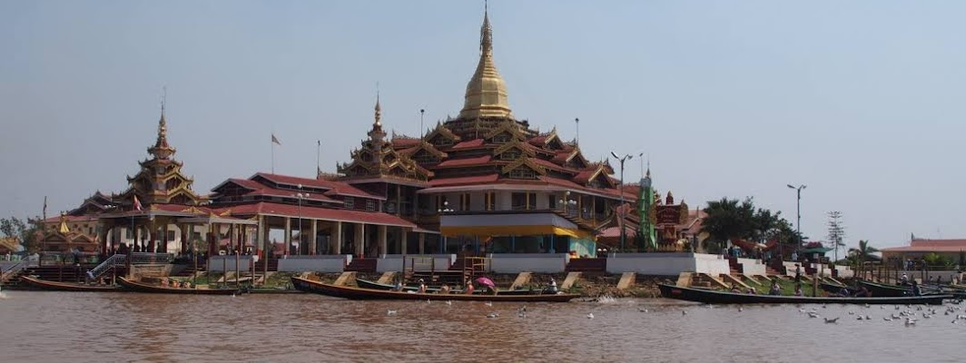
Ywama village and the Phaung Daw Oo Pagoda
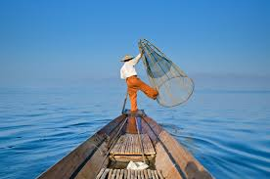
Fisherman fishing
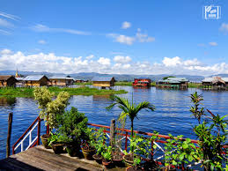
Lake View from hotel room balcony
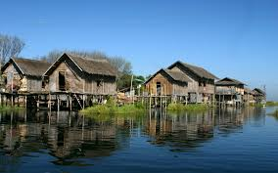
No trip to Inle Lake is complete without a visit to a Long neck Karen Hill tribe. We were lucky enough to be able to see the unique culture of this tribe al people.
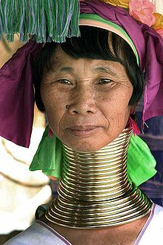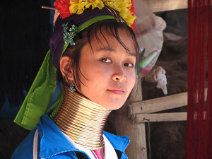
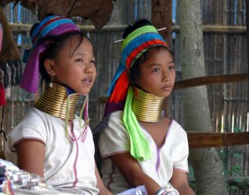
Karen Long neck Hill tribe people

