Local Trust’s and Howick Rotary’s Joint Effort to Support Food Parcels During Covid 19
The Rotary Club of Howick Community Trust and club members have joined forces with the Thomas Brydon Trust to help local organizations provide food parcels to needy families in the Howick area.
Throughout the nation the demand for food parcels and assistance has grown substantially under the lockdown provisions of the Covid 19 pandemic and this has also flown through to our own community. Many people are under considerable financial stress and have to resort to food parcels to feed themselves and their families. This will continue even under level 2 with reduced working hours and redundancies in the coming weeks.
Faced with this situation Howick Rotary decided that it needed to get in behind three local organizations and provide some much-needed funding. The local organizations are the Salvation Army, Stand Children’s Services and All Saints Anglican Church. Each of these organizations are set up to deliver food parcels and other assistance to needy families in the area.
The club decided to donate $5000 from its own Community Trust and sought and gained the assistance of the Thomas Brydon Trust of a further $5000. The Thomas Brydon Trust whilst independent of the Rotary organization has a strong association with it as it was founded by Tom Brydon in 1981 with two fellow Rotarians. Tom was president of Howick Rotary in 1969/70. The current trustees are all Rotarians.
In addition to providing support through the trusts Howick Rotary has challenged its members to make individual or family donations on a matching grant basis. For each dollar donated by club members the club’s Community Trust will match it with an additional donation. These donations will be made direct to the Salvation Army through the Make a Donation button on its web site or to the club’s Community Trust by internet banking (bank account 03 0166 0435725 00). The Club has organized with the Salvation Army to track the donations so the matching can be achieved. It is hoped to raise another $6000 through the “Challenge”. The club also challenges other organizations and the Howick community to join the “Challenge”.
All three organizations are thrilled to receive the support.
Joanne Wardle, Pastor of the Salvation Army in Howick is “thrilled with this amazingly generous donation. We have not experienced anything like it before and I would like to thank Rotary for the vision and drive they have demonstrated to help the local community”.

Rev Scott Malcolm commented “The All Saints Anglican Church Parish Council would like to thank the Rotary Club of Howick for it’s very generous and thoughtful donation of $2000 to our Foodbank. We can assure Rotary and its members that the funds will be used in the local Howick Pakuranga district and will be for the benefit of the children, women and families of this area.”

Pene Frost Stand’s Regional Manager said “The donation received from the Rotary Club of Howick, has enabled the Stand Children's Services Team to continue to provide genuine support to children and families in the local area. Providing food parcels, blankets and warm pajamas for children and their families during these challenging times, is a very real way of showing compassion, care and service to those families affected by the constraints and demands created by Covid-19. The deprivation we are experiencing in some families is unimaginable to many of us. Thank you, Rotary, you are making a very real contribution to creating a difference in the lives of these families.”
Mike Abercrombie current President of Howick Rotary said “the club has provided significant support in the area over across a vast number of projects over its almost 60 years and we are very proud to once again assist those families in need in the Howick community in what is one of the most challenging periods of our history”.
Allan Riley Chairman of the Thomas Brydon Trust said " Covid-19 has highlighted the financial distress existing amongst our 'new refugees' - Kiwi's. They may be our workmates, friends or neighbours. The Thomas Brydon Trust is pleased to support them alongside Howick Rotarians and the local Salvation Army teams."
If you are interested in knowing more about what Rotary does in the community call Ian Fox 021662 896 or visit the web site www.howickrotary.org.nz
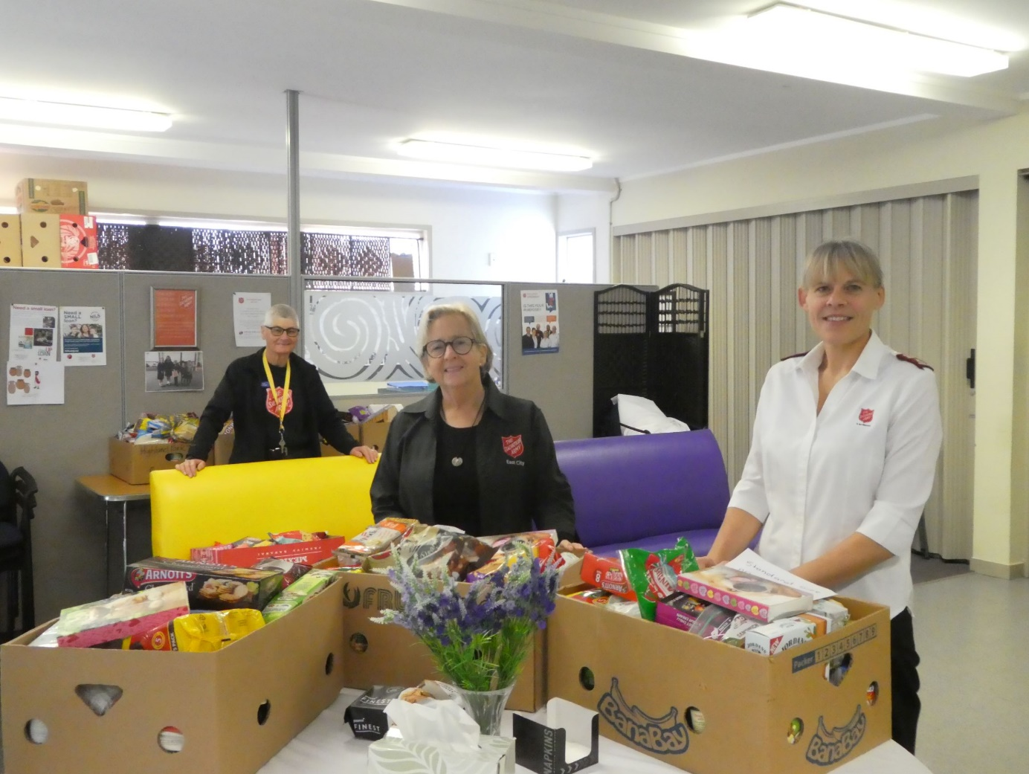
Salvation Army Pastor Joanne Wardle along with Rosemary Davies, Community Ministries Manager and Lyn Fischer Volunteer preparing Food Parcel at their centre in Moore Street.
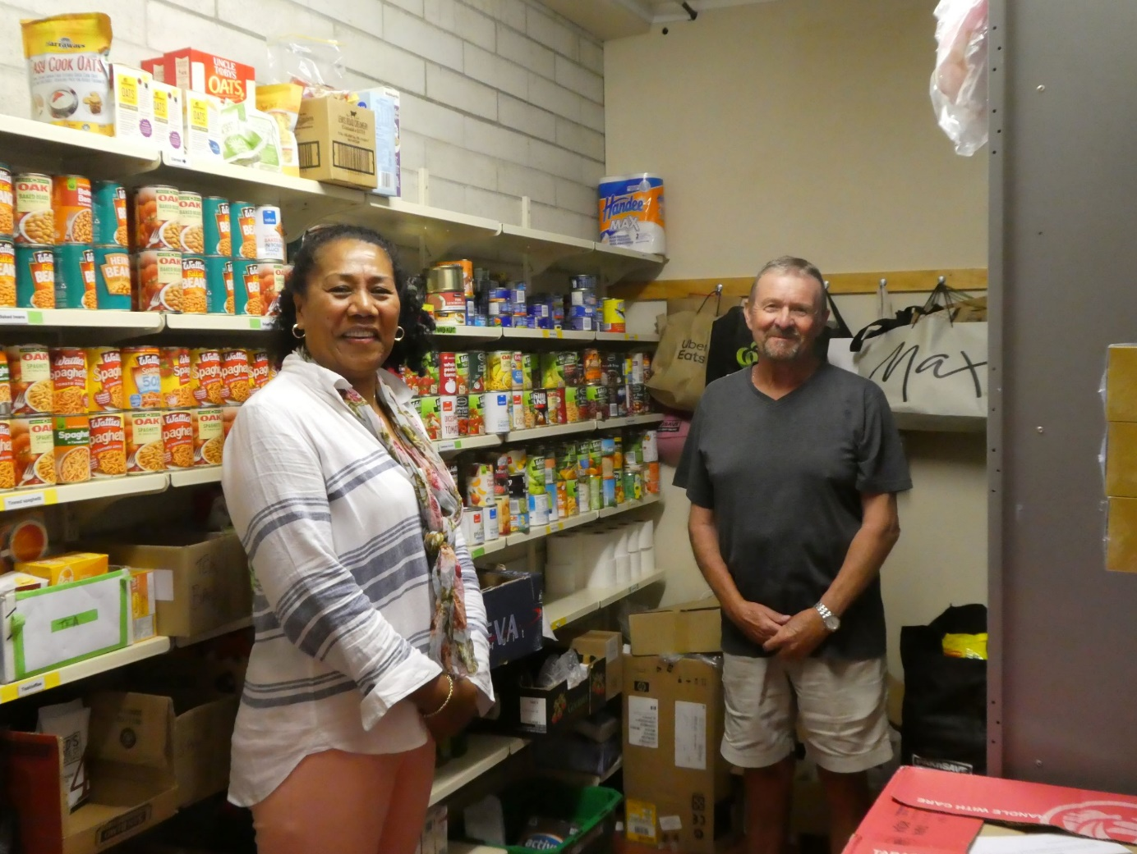
Lole Turner All Saints Anglican Church Foodbank Coordinator with Howick Rotary President (suitably social distanced) in All Saints Foodbank Store.
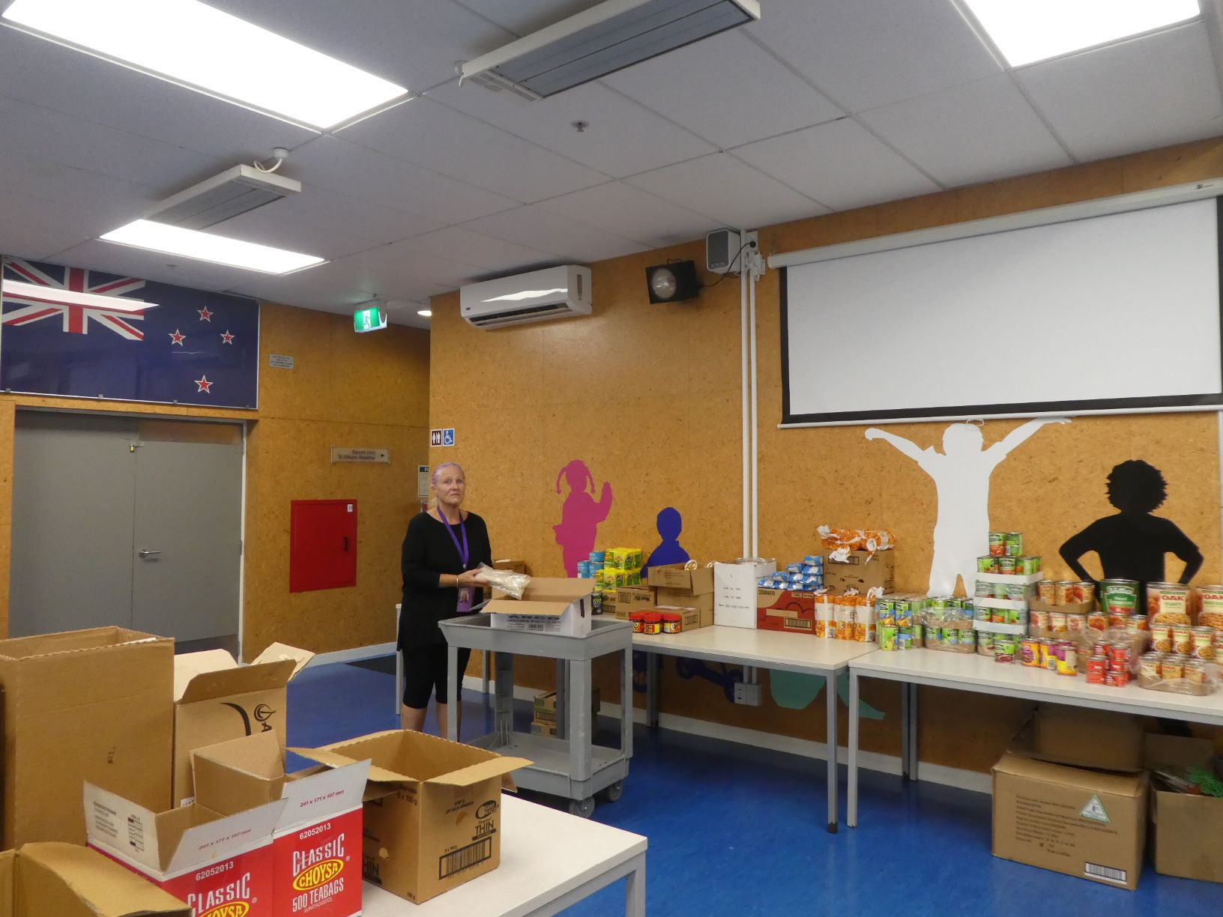
Pene Frost Regional Manager of Stand Children’s Services in their Food Parcel area of their premises at Half Moon Bay.

