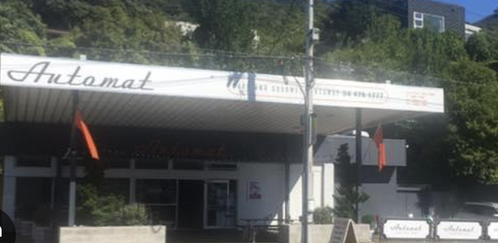

ROTARY CLUB OF WELLINGTON NORTH
LUNCHEON MEETING THURSDAY 7th SEPTEMBER 12.15pm

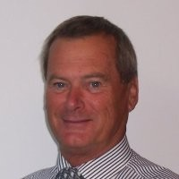
FROM THE PRESIDENT
Our meeting next Thursday at the Automat will be a fellowship luncheon, with no external speaker, when we can discuss club issues including the comments of District Governor Wayne Gordon last Thursday night.

He was complimentary of our various projects and outlined some interesting approaches taken by other clubs. We all seem to be facing the same challenges, but even given all that, he spoke of the transformative approach taken down in South Canterbury where a membership drive produced some dramatic new enrolments.

It was also useful for us to reflect that far from being moribund we are actually quite effective in a range of areas, including of course the upcoming Rotary Khandallah fair.

One new item the Board has suggested we could add into most meetings is a 5-minute slot called “Who Am I” where members talk about where they have come from and what they have done so far. I will kick off with the first such talk. 5 minutes, max.
President Steve

The menu will be available on the day as usual. As we're trying to avoid too much bureaucracy RSVP’s are not required.
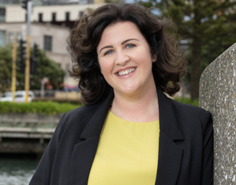
ADVANCE NOTICE
The Sept evening meeting on 21 Sept will be Em Lewis, Executive director of the Nikau Foundation speaking about trends in philanthropy in the Wellington region. It will be the usual pizza, salad and drink evening. $15

NOTE TO READERS
With the cessation of publication of The Bulletin, and until a replacement is decided, flyers such as this will be sent out a week before the next luncheon or evening meeting. Please forward any notices for publication, 10 days prior to a meeting, to mrps6T@gmail.com

