Benjamin Baker
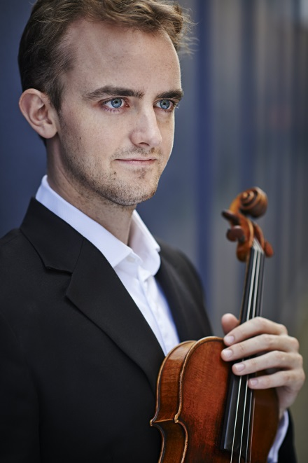
Born in 1990 in Wellington, Benjamin moved, with his family, to the UK in 1998 to study at the Yehudi Menuhin School, on the recommendation of Nigel Kennedy. Benjamin studied at the Yehudi Menuhin School and the Royal College of Music where he was awarded the prestigious Queen Elizabeth the Queen Mother Rose Bowl. In 2013 he won 1st Prize and the audience prize at the Windsor Festival International Violin Competition, and was selected for representation by Young Classical Artists Trust.
The following year Benjamin gave recitals throughout Europe including Wigmore Hall, The Sage Gateshead, Pedrera Hall Barcelona, St. John’s Smith Square, the Pärnu, Aegean Arts, Cheltenham, Northern Chords, East Neuk & Buxton Festivals, and appeared as soloist with the Royal New Zealand Ballet Company. In 2015 Benjamin released his first CD for Champs Hill Records which immediately went to No.22 in the Classical Charts and was featured on Classic FM.
As a soloist he has appeared with the Philharmonia Orchestra several times, performed the Britten and Sibelius Concertos with the Haydn Chamber Orchestra, Brahms and Tchaikovsky with the Cardiff Philharmonic Orchestra and Shostakovich Concerto No.1 with the Fulham Symphony Orchestra. He has also appeared with the London Mozart Players, Orchestra Wellington, Royal Philharmonic Concert Orchestra, Joven Orquesta de Salamanca, Orpheus Sinfonia and Bath Philharmonia at major venues including the Royal Albert Hall, the Bath and Gstaad Festivals.
Benjamin has appeared as soloist and director in Paris and attended IMS Prussia Cove and performed the Beethoven Concerto with Sinfonia Cymru and the Amadeus Orchestra.
Since winning 1st Prize at the 2016 Young Concert Artists International Auditions in New York and 3rd in the Michael Hill Competition in 2017, Ben has established an even stronger international presence. He received critical acclaim for his debut at the Merkin Concert Hall in New York, recitals at the Kennedy Center in Washington DC, Festipiele Mecklenburg-Vorpommern and in China.
He performs regularly at Wigmore Hall, including in the Beethoven celebrations. He has appeared as soloist with the Scottish Chamber Orchestra at East Neuk Festival, Beethoven’s Concerto with the English Chamber Orchestra, Mozart with the Royal Philharmonic Orchestra, and recorded as soloist with the BBC and Royal Philharmonic Orchestras.
A hectic 2019 saw Ben playing in Lebanon – in the Al Bustan Festival, Ireland, Australia – where he play in the Sanguine Estate Music Festival, New Zealand, Colombia, Argentina, Venezuela, Albania, Siberia and several times to the USA, including in New York, Chicago, Baltimore, Pennsylvania, Colorado and California.
On 18 January this year, he played in a very special concert in London. The wonderful conductor Jonathan Bloxham and Ben put together a chamber orchestra to perform works by Mozart and Brahms at the Royal Over-seas League. The concert was in aid of Concern Worldwide’s “Free From Hunger” Campaign. See his website benbakervolin.co.uk for even more of his exceptionally impressive accomplishments to date – and he is only just 29!
Ben has been invited to be soloist with the Christchurch Symphony Orchestra playing the Sibelius Violin Concerto in a special leap year day concert on 29 February.
Wanting to say ‘thank you’ to his many long supporters in New Zealand, Ben is giving a Dinner Concert, [title name needed] with Justine McCormack and a special friend, accompanied by Julie Coulson. He will also further a new enterprise for Chamber Music in NZ based in Queenstown.
He was very grateful to have be awarded Honorary Membership of the Rotary Club of Port Nicholson for his commitment to children’s charities and for the highly valued support of the Club.
For further details contact Ben’s NZ Agent, Dawn Sanders M: 027 283 6016, E: Action-Sanders@xtra.co.nz

