ClubRunner Member profile - uploading your photograph
You are encouraged to upload a passport-sized photograph to your ClubRunner Member profile. This will help to connect newer members with others, putting a face to a name.
Firstly, make sure you have an electronic copy of a portrait photograph of yourself.
- Log into ClubRunner:
  - https://www.crsadmin.com/gen/Login.aspx?
  - User name: first name.last name.13146
  - Password: 13146
- Click on My ClubRunner and My Profile
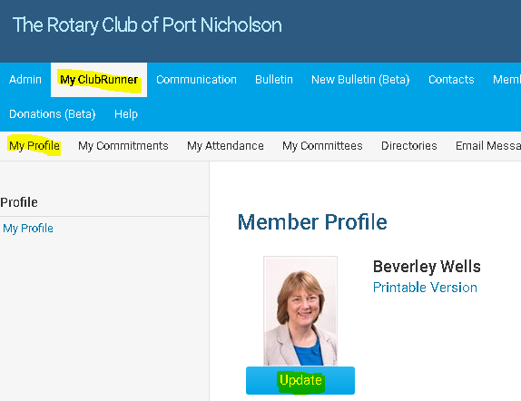
- Click on Update
- You will see the following screen.
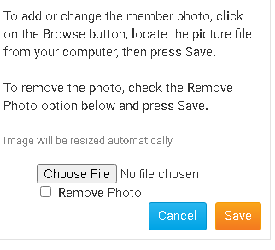
- Click on Choose file and select your photograph. Click Save.

