Fork and Brewer

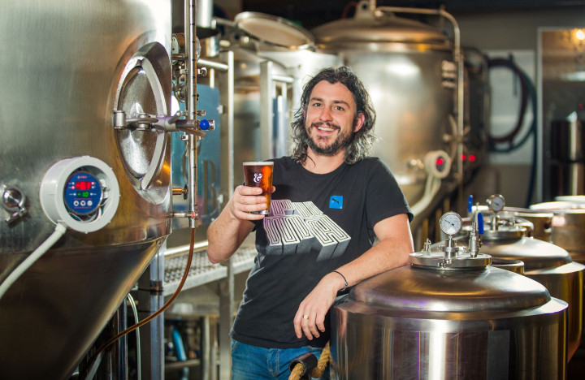

Kelly Ryan is the renowned Head Brewer of current Champion Small New Zealand Brewery, Fork & Brewer. Under his brewing stewardship, Fork has made history as the only independent New Zealand brewery to win successive Brewers Guild of New Zealand Champion Brewery titles, winning in both 2018 and 2019 (thanks to the global pandemic, Fork & Brewer gets to hold that title for 2020-21 too!). He single-handedly brews the 41 beers available on Fork & Brewer's 42 taps (the 42nd tap pours cider), which we strongly suspect is an unofficial world record, as it is virtually unheard of for a single brewer to undertake. We also strongly suspect Fork & Brewer has the most taps of beer in New Zealand.
Kelly is also a seasoned and sought-after beer judge, having judged multiple local and international beer competitions since 2007, from the New World Beer & Cider Awards and the World Beer Cup, and building a reputation for his meticulous sensory prowess and poetic descriptors.
A trained food scientist and microbiologist, graduating with first class honours from Otago University, Kelly began his brewing career in 2001 as a trainee brewer at Tui Brewery, then went on to work at UK breweries, Fyne Ales in Scotland and Thornbridge Brewery for four years.
On returning to New Zealand, Kelly worked for Epic Brewing Company in Auckland and Good George in Hamilton (hired to set up the brewery), before settling in Wellington in 2014 to work at brewpub, Fork & Brewer. It is with this extensive experience that Kelly has been able to perfect his craft, produce award-winning beers and gain an international reputation as one of the top brewers in New Zealand (as evidenced by his industry-bestowed nickname, Brewjesus).

