Rotary Club of Port Nicholson Goalsetters Awards Presentation

Kahui Tihore and Melissa Dol were presented with their Goalsetter Awards at a breakfast which took place on Monday 10 August 2020 at the InterContinental Hotel. The guest speaker was the Hon Grant Robertson who presented the awards to Kahui and Melissa. Around 170 business people and Rotary members attended.

Hannah Gibson also received an award but was unable to attend the breakfast. Hannah was presented with her award the previous week at the club's Rotary meeting.
Also, at the breakfast Mark Dunajtschik was presented with a PHF for his incredible donation of $50m to the Wellington Children's Hospital.

Kahui and Melissa with Hon Grant Robertson
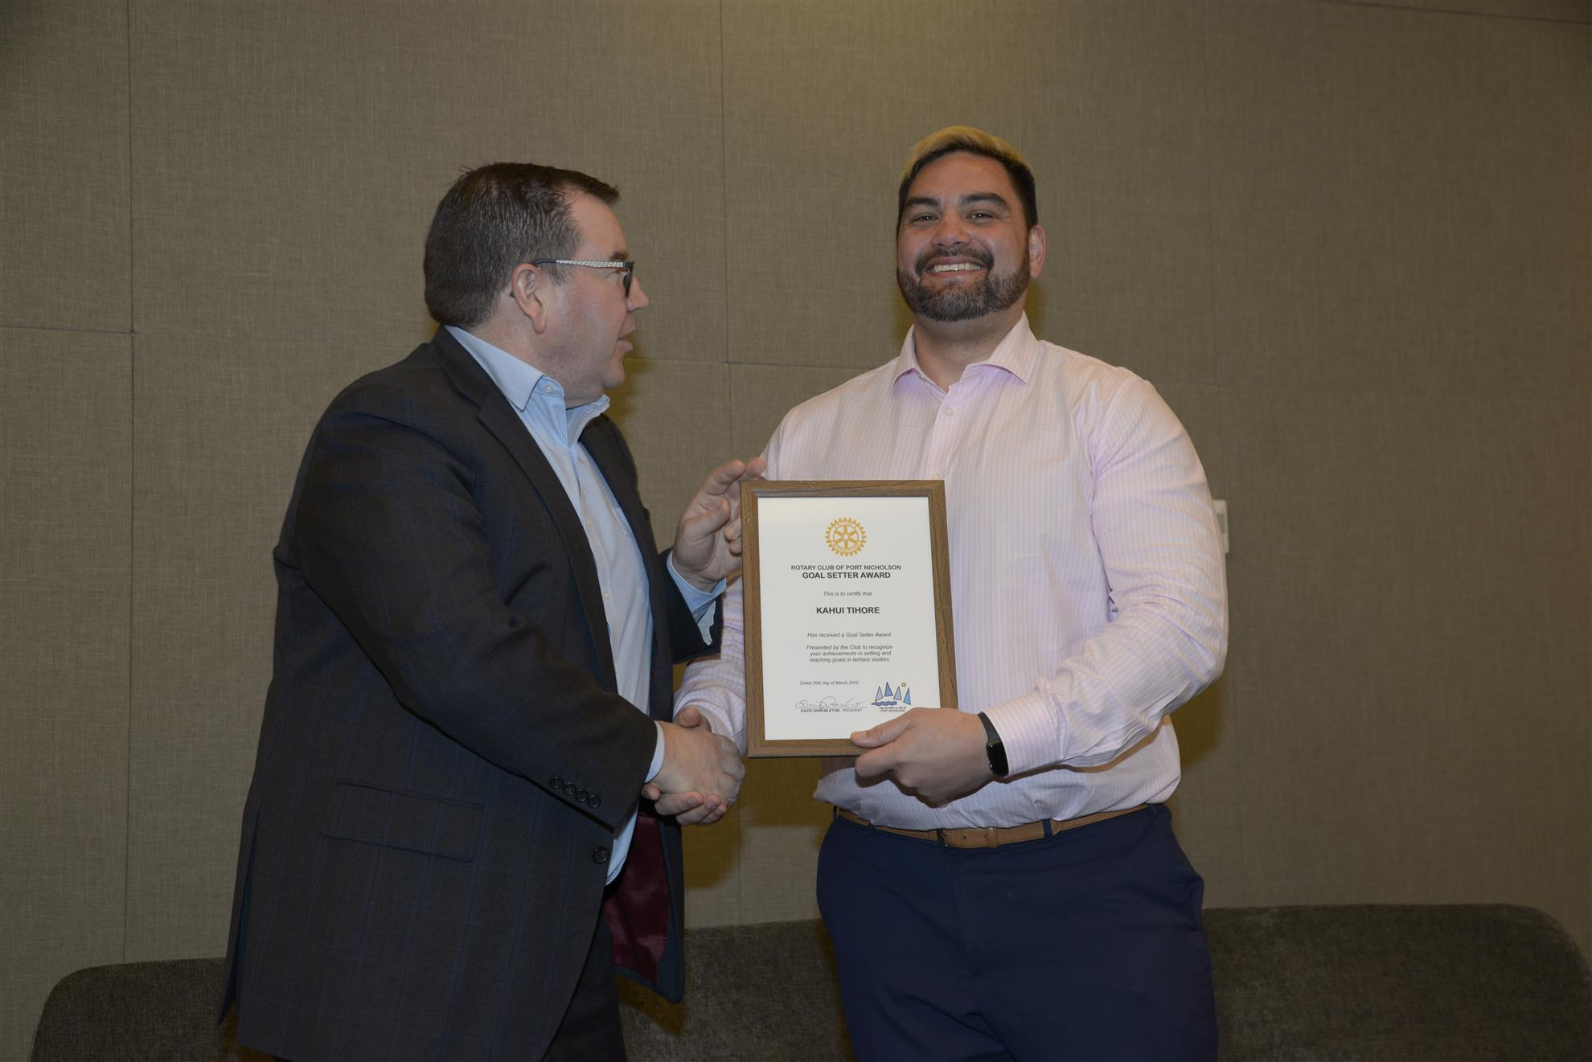
Kahui and Hon Grant Robertson
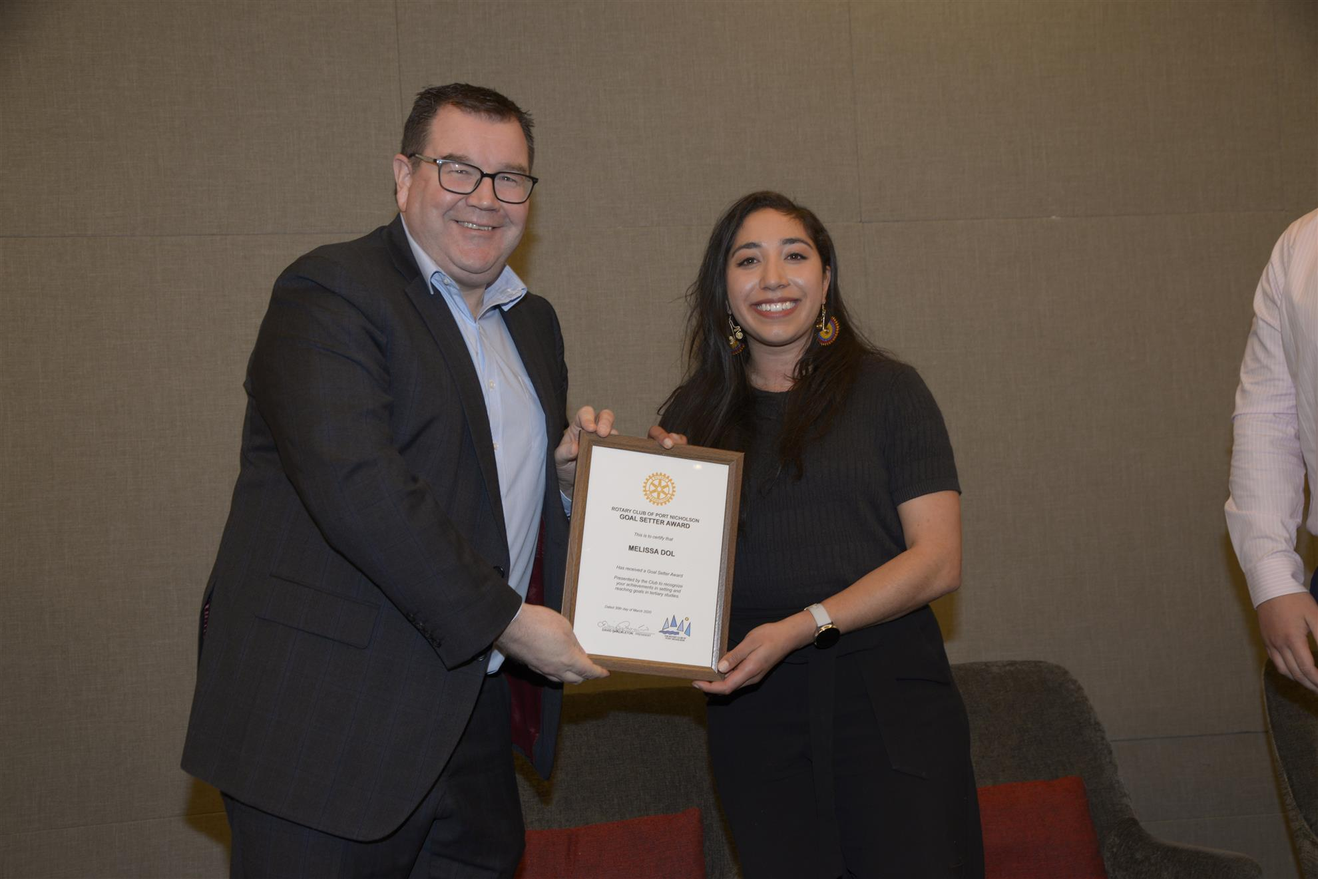
Melissa and Hon Grant Robertson
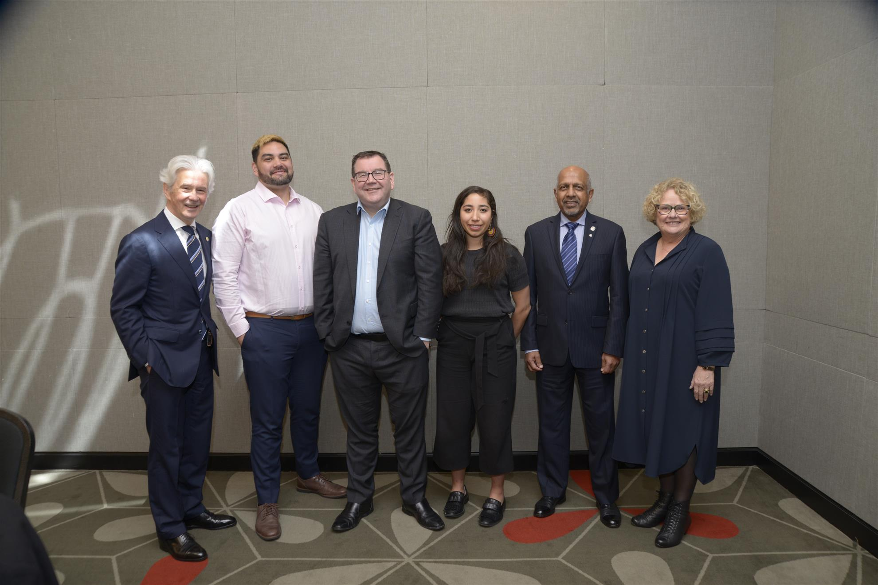
Past President David Shackleton, Kahui, Hon Grant Robertson, Melissa, President Mike Selvadurai, and MC for the function our own Jane Paterson
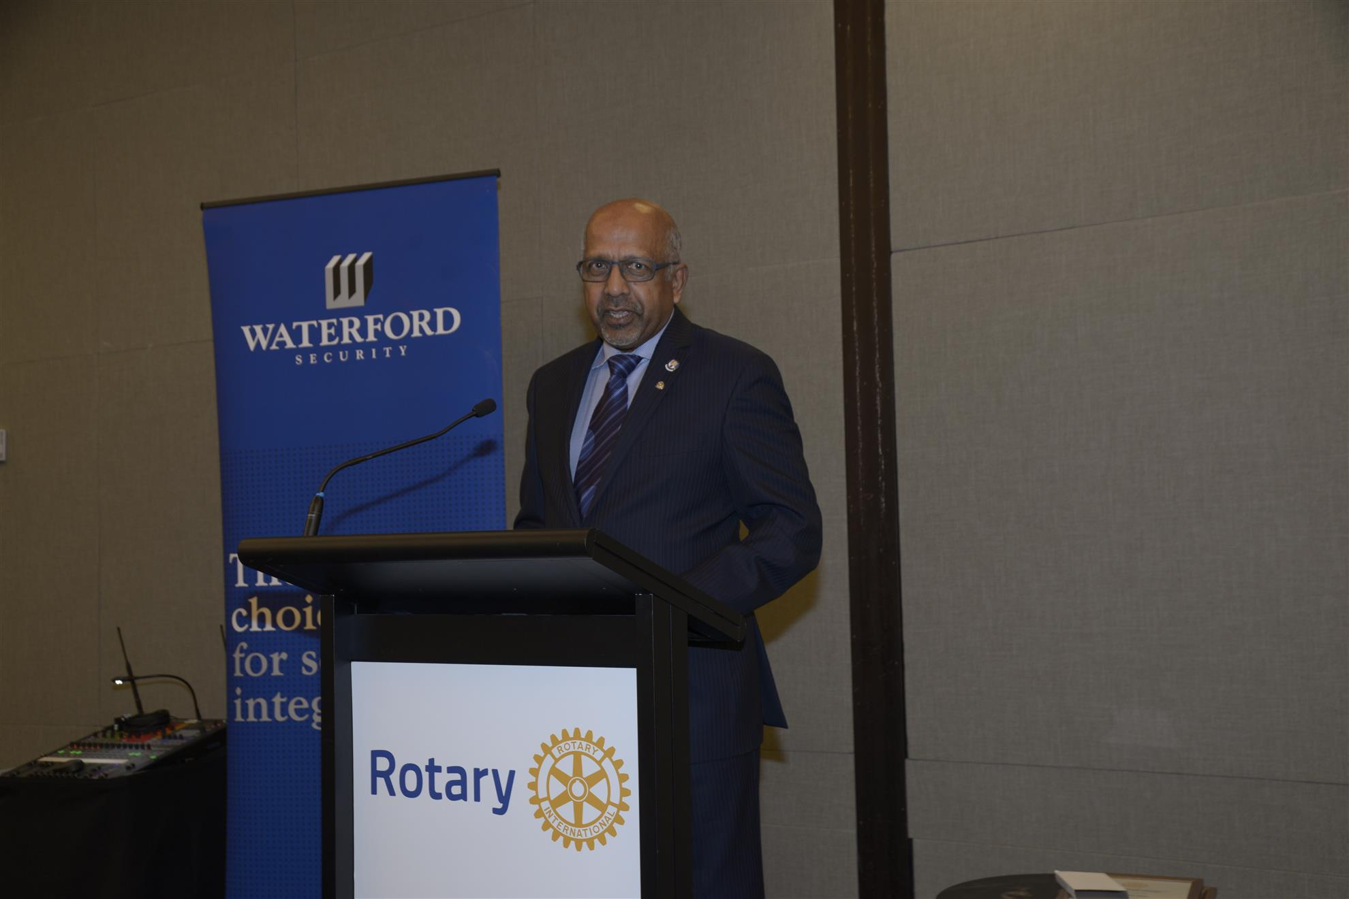
President Mike
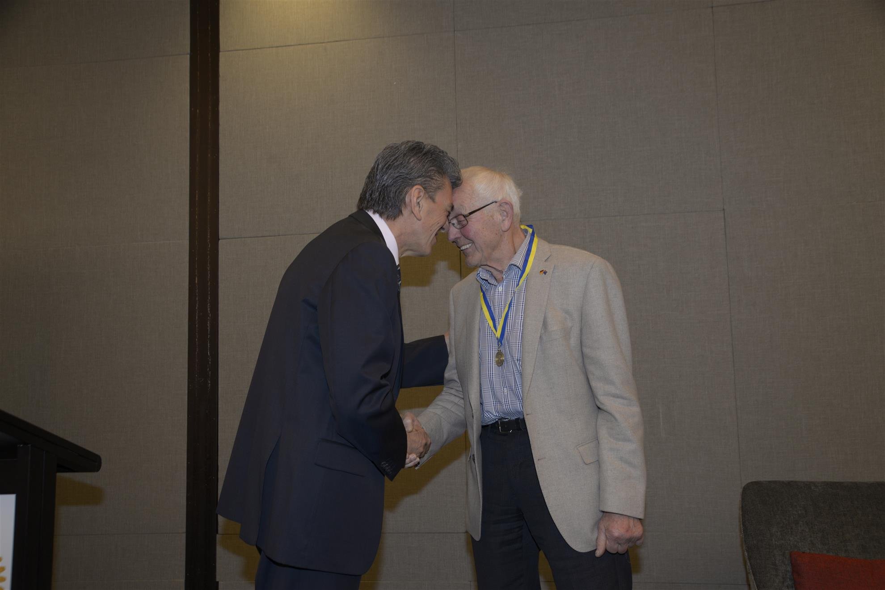
Past District Governor John Mohi presents Mark Dunajtschik with his PHF award
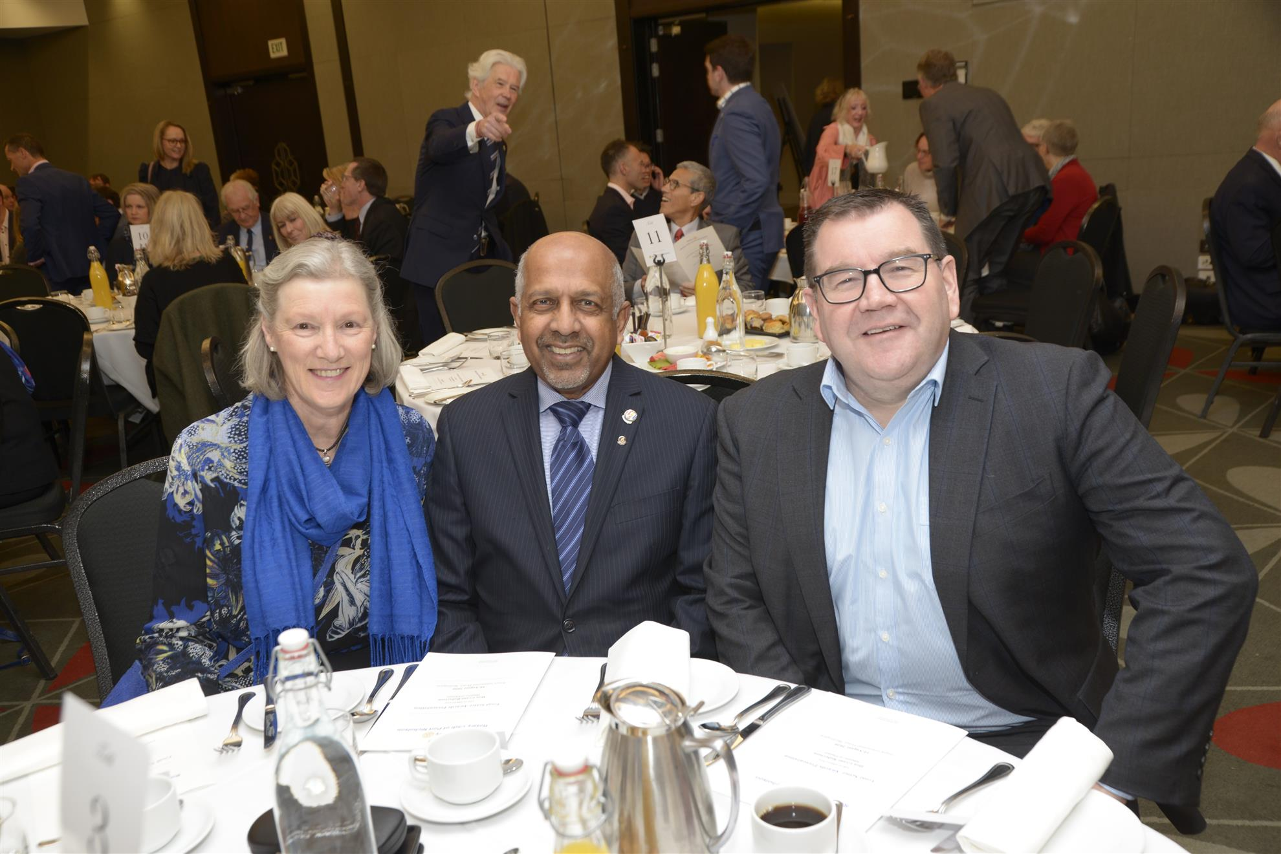
President Mike with wife Sue and Hon Grant Robertson
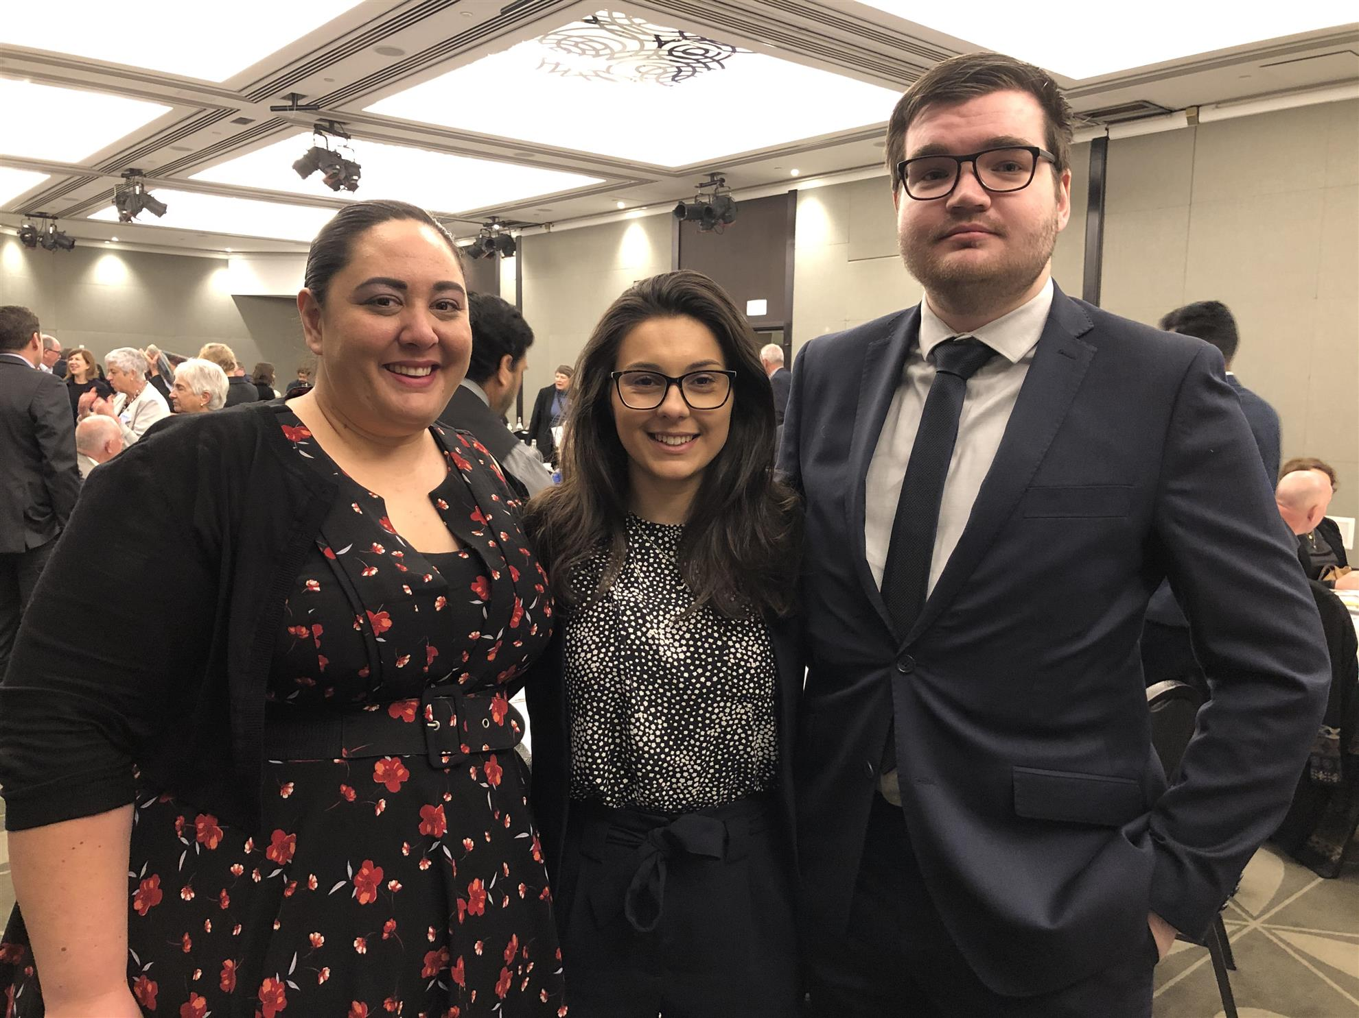
Past Goalsetter Awardees Hineana Tihore (2019), Nadia Cooper (2018) and Sean Ainsworth (2019)
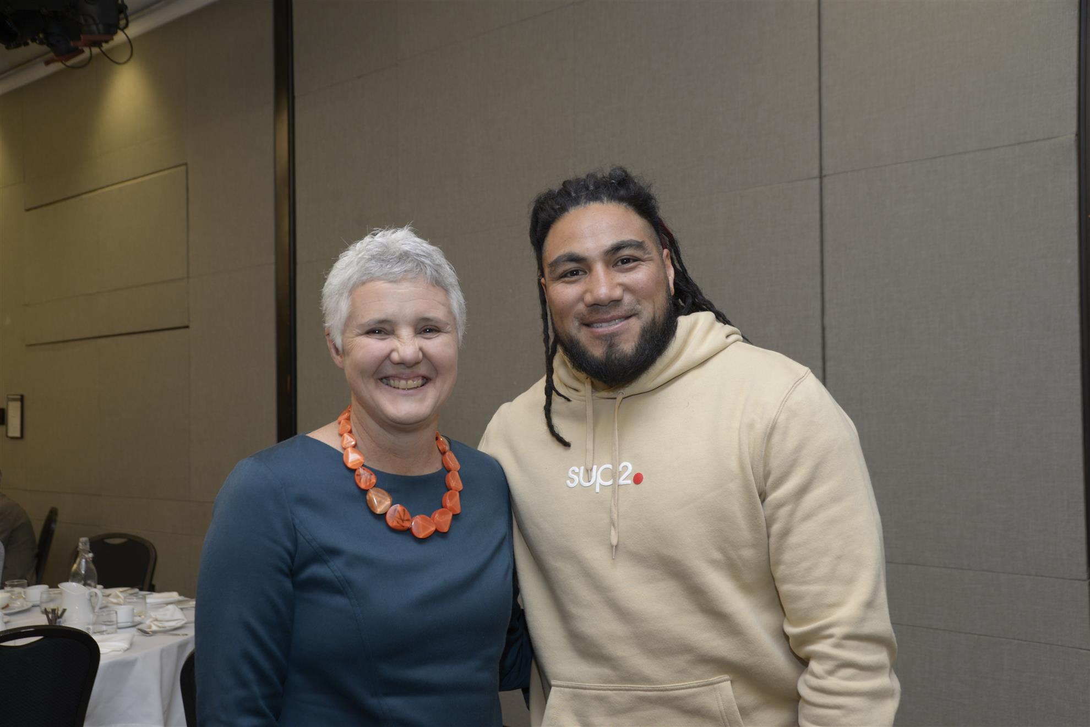
Anne Hare and Ma'a Nonu

Hannah, unable to attend the Goalsetters Breakfast was presented with her award at the Club's meeting on 5 August.
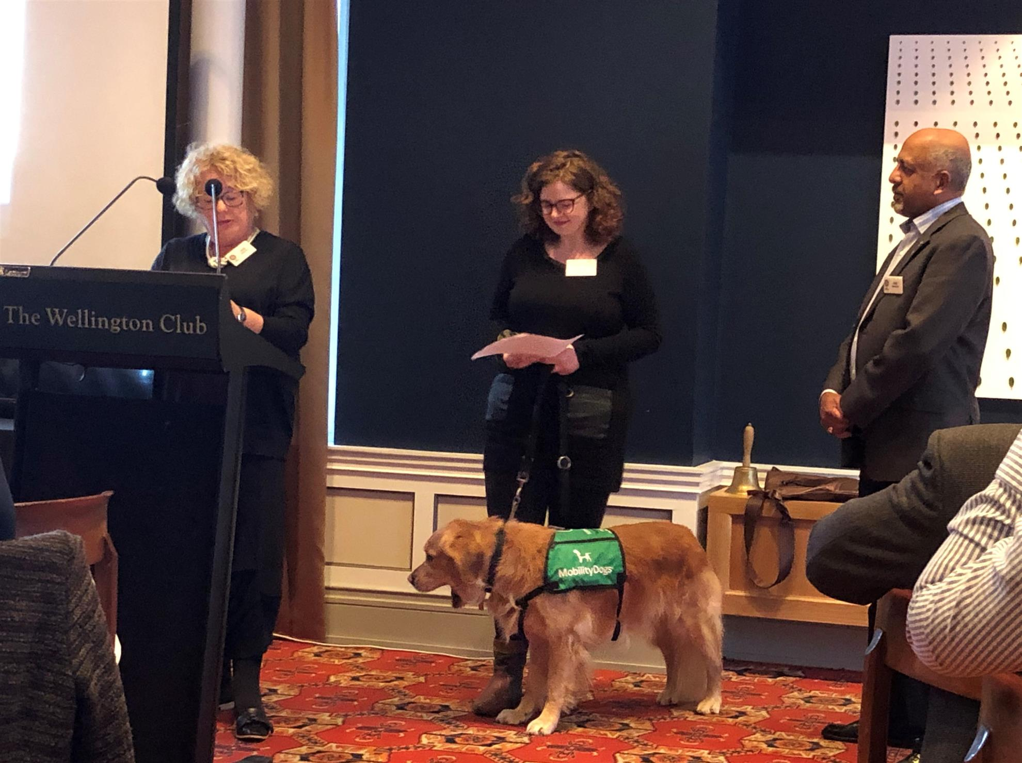
Jane Paterson introducing Hannah Gibson and Mr Darcy. President Mike looks on.
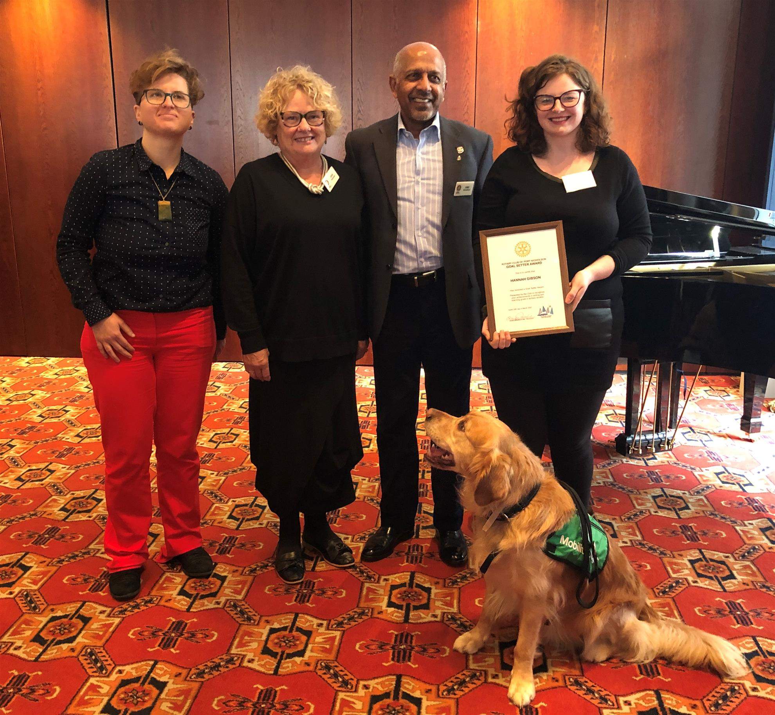
Dora Morolli, Jane, President Mike, Hannah and Mr Darcy after the award presentation.
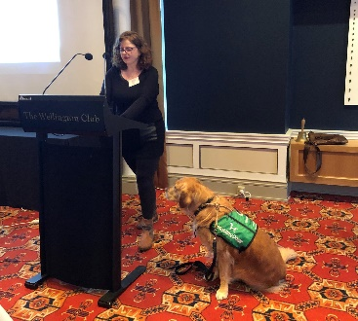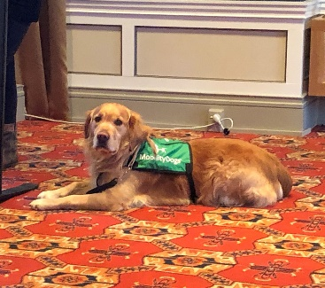
Mr Darcy

