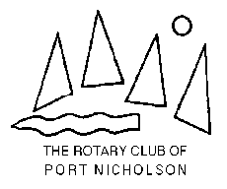
Monte carlo
Fun night
Saturday 28th September 2019 – 6.30 for 7pm start
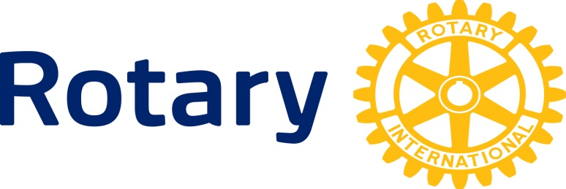
Wellington Bridge Club – 17 Tinakori Rd Thorndon
Raising funds for Rotary’s ambulance for Samoa project

Featuring – Under and Over (7s) – Roulette – Blackjack (21 / Pontoon ) - Poker – plus Horse races
Dress for the occasion or come as you are.
Raffles – Prizes – Cash Bar – Supper
Admission by pre-paid ticket $30 - including playing chips and supper
To secure tickets please contact Rick 022 071 0064 or Darryl 029 801 5515
beerich@xtra.co.nz or darrylrossnz@gmail.com

Please pay on line: Rotary Club of Port Nicholson Charitable Trust
03-0502-0407484-00 Reference your name and Samoa

