Here is the March 2020 Newsletter, from District Governor District 9930.
This month he covers what you can do, as a Rotarian, to get through whilst also serving your community. So do have a good look at it.

Please click here.

Keep safe and well

Kind regards
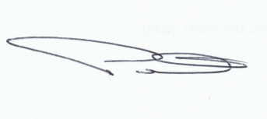
Peter Maxwell
District Governor 2019/20
Rotary District 9930

