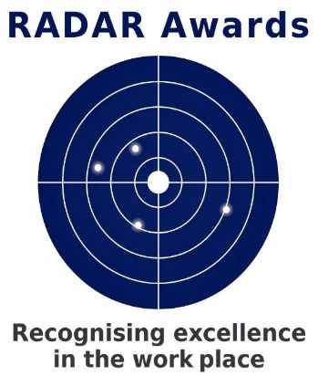
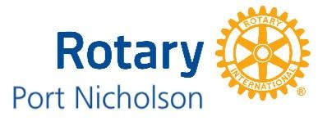

Nomination Form
RADAR Awards (2026)
Wednesday 14 October (7.00-8.30am)
The Wellington Club (88 The Terrace – Level 5)

(Please email this completed form to Steve Lawton (slawton745@gmail.com) by 14 September)
Company/employer/workplace
Business address
Nature of business
Name of person completing this form
Role
Phone
Email
Your Nomination for a RADAR Award
Name
Role
Contact details (Needed for arranging an interview)
Phone
Email
Describe their role?

Why do you consider this person worthy of the ‘RADAR Awards’?
Provide an example of their ‘excellence in the workplace’. (Additional pages may be used)

Signature of person completing this form
Please note; due to the popularity of these Awards, we have had to limit nominations to one per organisation. The nominee or their organisation should have links with Central Wellington. This year there will be 4 ‘RADAR Awards’ presented.
Note: The Club will be interviewing all nominees. Please ensure the person you nominate is aware of this requirement.

