
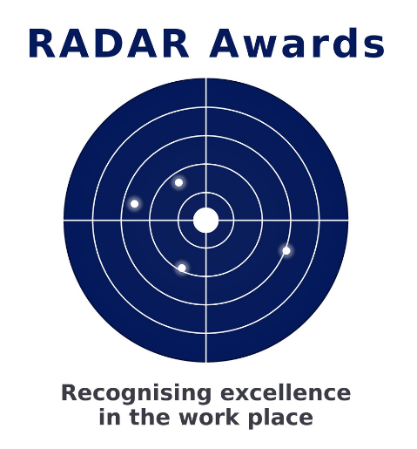

Guidelines for ‘RADAR Awards’ Scheme
Briefing notes for prospective nominator

Primary Objective of the ‘RADAR Awards’ Scheme
To promote high levels of achievement in the workplace by enabling employers and members of the public, through Rotary, to recognise and acknowledge individuals who consistently demonstrate excellence in personal conduct and work performance
Guidelines Award
- ‘RADAR’ awards are a Rotary-sponsored initiative that has been widely recognised and adopted throughout Australasia.
- The ‘RADAR Awards’ Scheme reflects Rotary’s commitment to excellence, guided by the principle “Do it once, do it right” — helping to build a stronger community and a better New Zealand.
- The scheme recognises excellence across all aspects of performance and personal responsibility, including quality of work, productivity, safety, initiative and integrity at all levels of employment and volunteering within the community.
- The scheme is not a competition, and there are no “winners” in the strict sense. It is anticipated that each organisation will submit one nomination. Should this present any difficulty, nominators are encouraged to discuss the matter with the ‘RADAR Awards Convenor (Steve Lawton).
- An award represents formal recognition of an individual whose performance and workmanship are consistently of a high overall standard.
- It is important that recipients are also regarded by their peers and colleagues as worthy of this recognition.
- The scheme aims to strengthen positive employer–employee relationships and to promote a broader sense of community pride in individual achievement.
- Nominations are welcomed by members of the public and individuals working within businesses in Wellington CBD and surrounding areas.
- Awards will be presented at ‘RADAR Awards’ presentation breakfast. Nominators, colleagues, friends, and family of recipients are invited to attend as paying guests. The recipient and their nominator will attend as guests of the Club.
- Each recipient will be presented with a suitably engraved plaque in recognition of their achievement.
Nomination Form >>>

