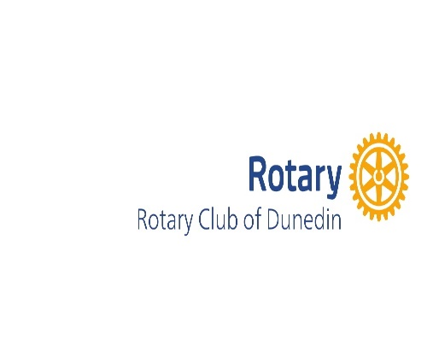

Greetings from the one and only Rotary Club of Dunedin! Oh wait, is there another Rotary Club of Dunedin?
Our beautiful town is located along St. Joseph sound, an estuary of the Gulf of Mexico. We are the home to Honeymoon and Caledisi Islands, regularly voted two of the top 10 beaches in the U.S, and the most visited state parks in Florida. We were the principal sponsors of the Nature Center which bears our name on Honeymoon Island.
We are a club of 50 members devoted to our community and to children of our community. We have given out over $510,000 in scholarships to hundreds of high school students for merit scholarships. We pay for and stock Little Free Libraries around the town and county where children can trade books or keep them at no cost.
We are strong supporters of our local food pantry, Dunedin Cares, where no person from Dunedin or Clearwater is turned away for food needs. We support Pack a Snack for children in schools who might not have a meal over the weekend or when school is not in session.
Over the last five years we have supported 70 charities helping so many with needs including free dental and medical care, homelessness, human trafficking, children with disabilities and historic preservation.
Bless you and the work you are doing in your hometown. Your Trees for Families site looks wonderful. Your work with wetlands protection is excellent!
Please come see us and have a beer at one of our 8 breweries! Best wishes,

The Rotary Club of Dunedin!

Received 16/2/26
when member Robert MacDonald was unable to visit as cruise ship cancelled by storms.

