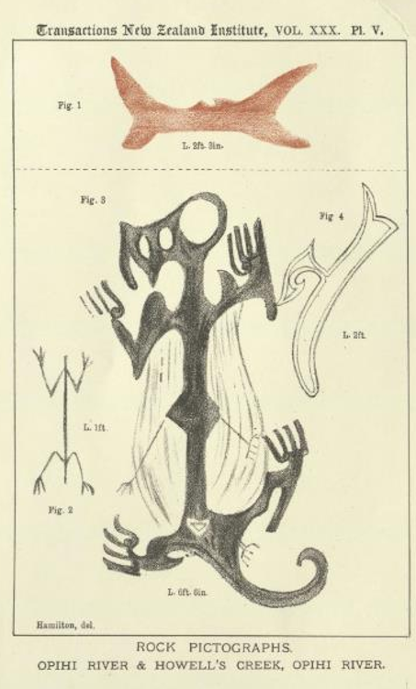
The first recording of the famous Opihi taniwha rock painting by Augustus Hamilton in 1897.

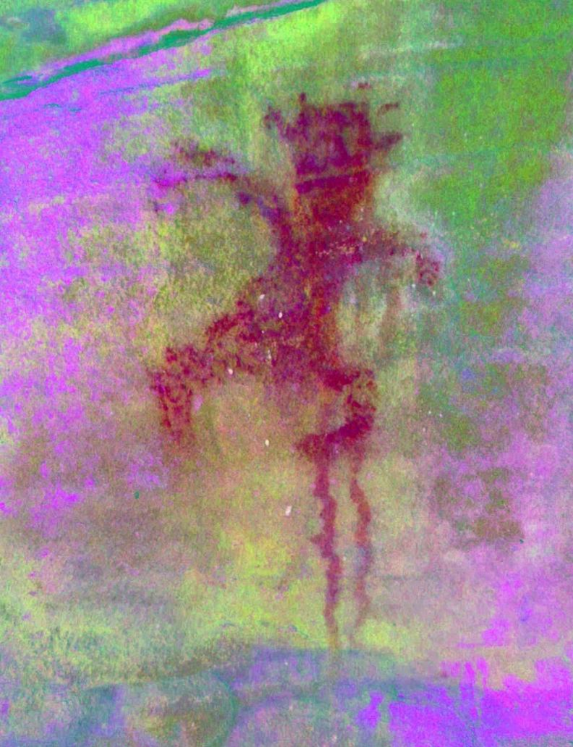
A digital enhancement of a red painted tiki (human) with head ornamentation – possible feathers in the hair. Dribbles show the red ochre paint was very runny when applied. It is located in a small cave inland from Moeraki was said to have been marked for what iwi understood was the inland boundary of the historic Kemp Purchase land sale.

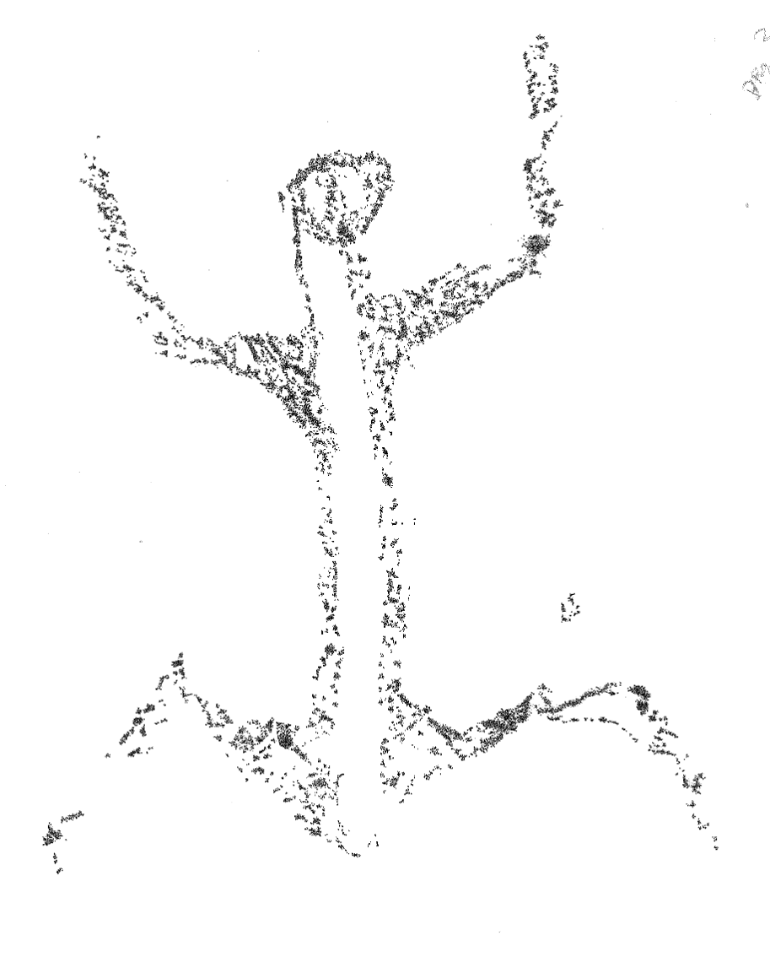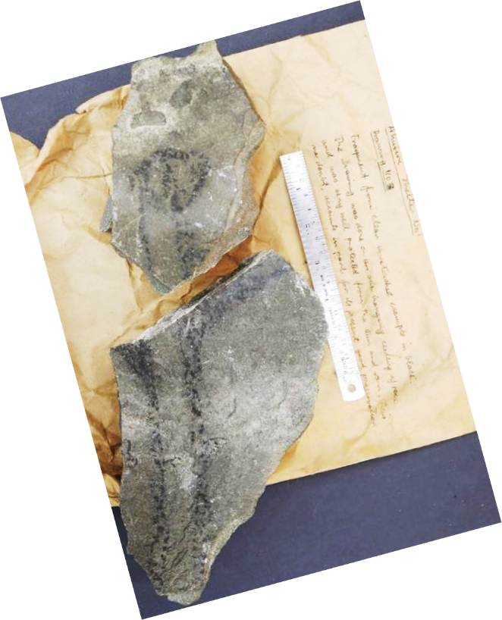
Fragments of a tiki (human) figure from Ahuriri River, now flooded by Lake Benmore.

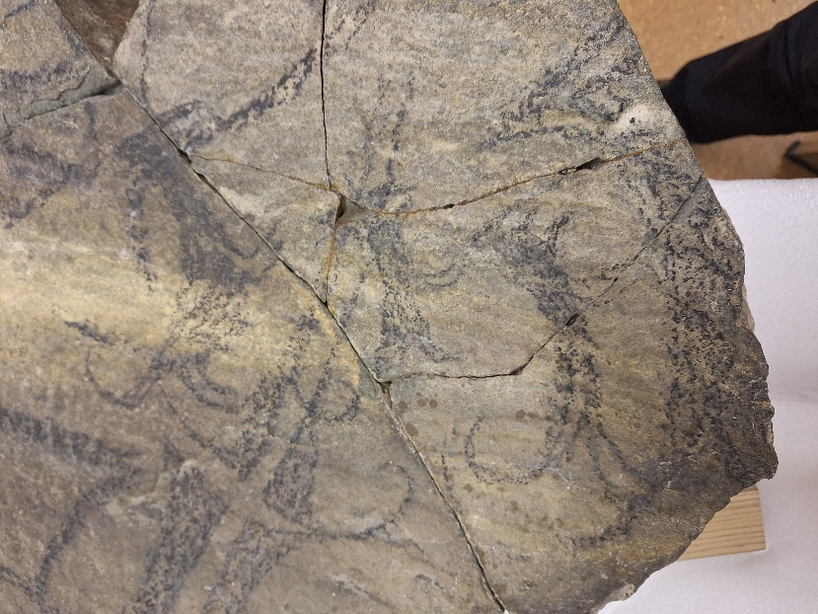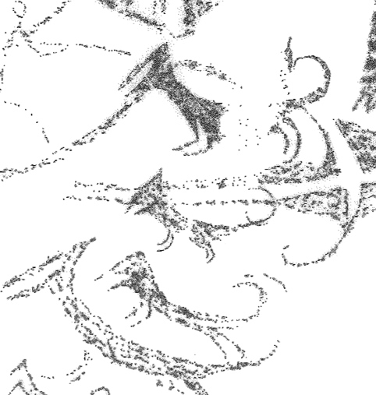
The famous dog motifs salvaged in the 1950’s from Ahuriri before flooding for the Benmore hydro lake, upper Waitaki. These will feature in a special exhibition of Māori rock art opening at Tūhura Otago Museum late 2027.

