Sending a group email on Clubrunner
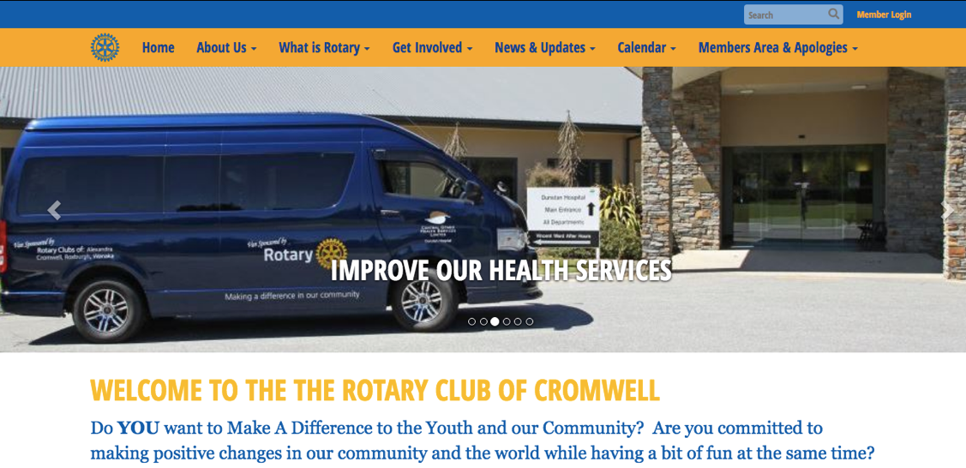
- Go to https://cromwellrotary.club/
- Login in to Clubrunner – member Login– Top R) corner

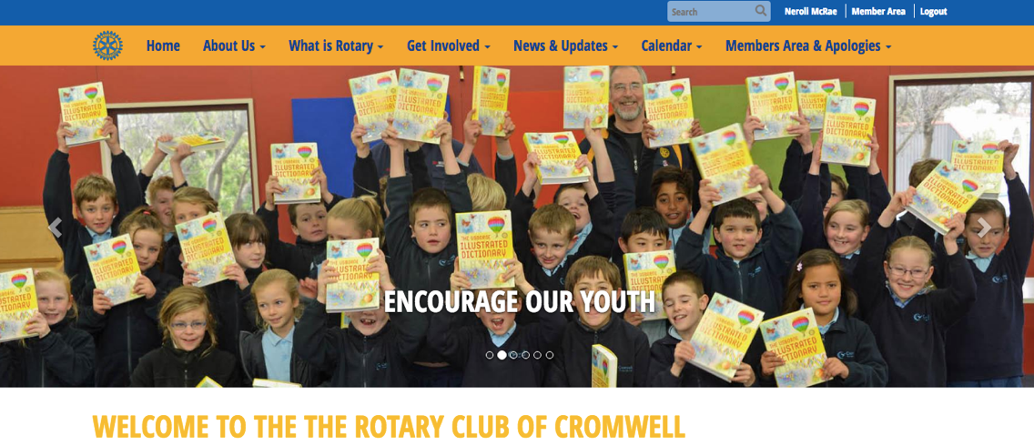
- Members Area – Top R) corner
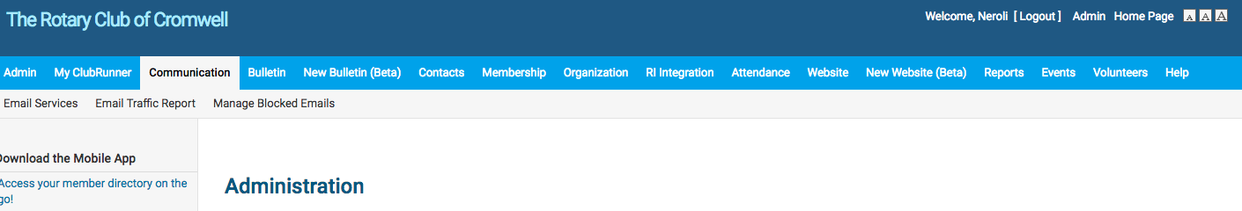
- Communication
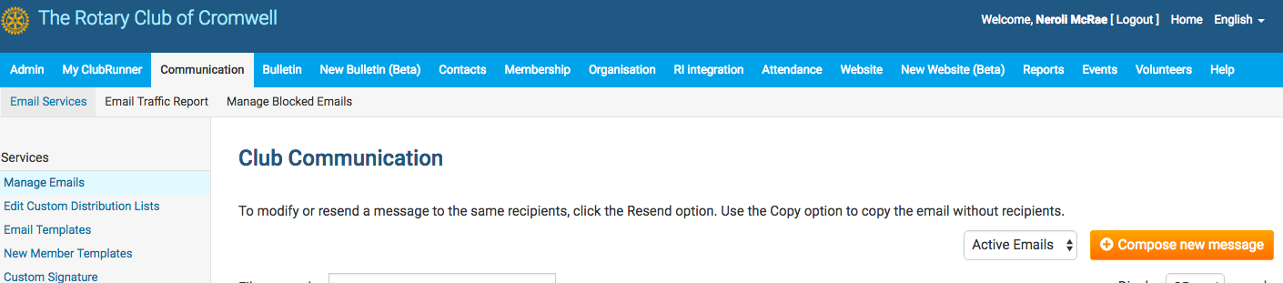
- Email services

- Compose new message

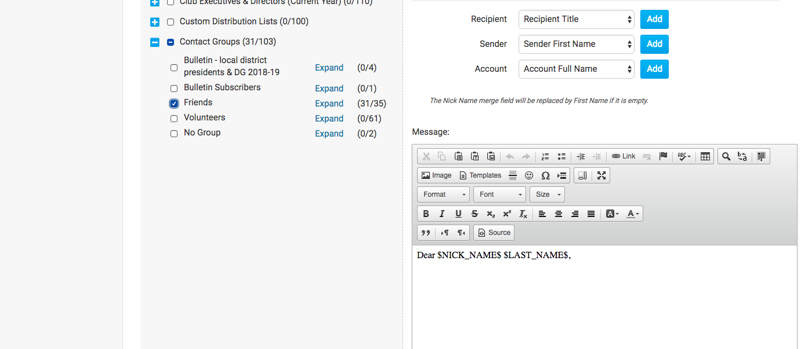
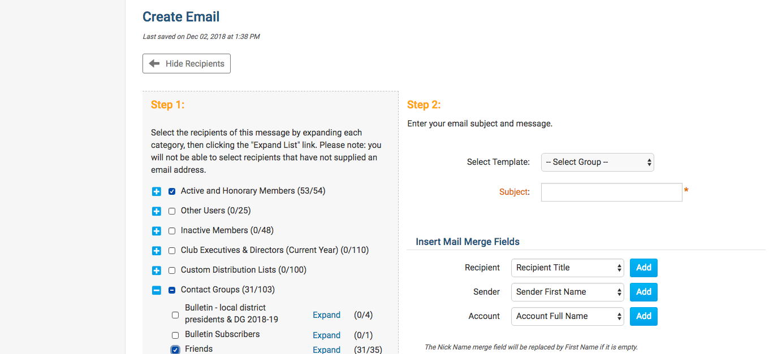
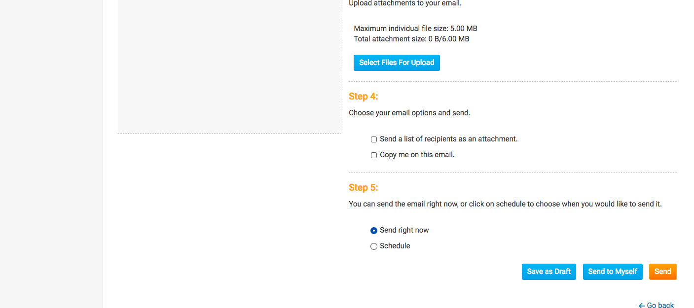
- Tick “active & honorary members” (Or click on blue cross to expand and select individuals)
- For “Friends of Rotary” click and expand on “Contact groups”
- Insert heading
- Start your email. The first name (Nick name) & last name are already inserted. I usually delete the last name.
- You can add an attachment
- Once you have finished your email you can “Save as a draft” or “send to myself” to check it

