**Checking on volunteer sign ups on Clubrunner**



* Login in to Clubrunner – Top R) corner



* Members Area – Top R) corner

To Check on sign ups

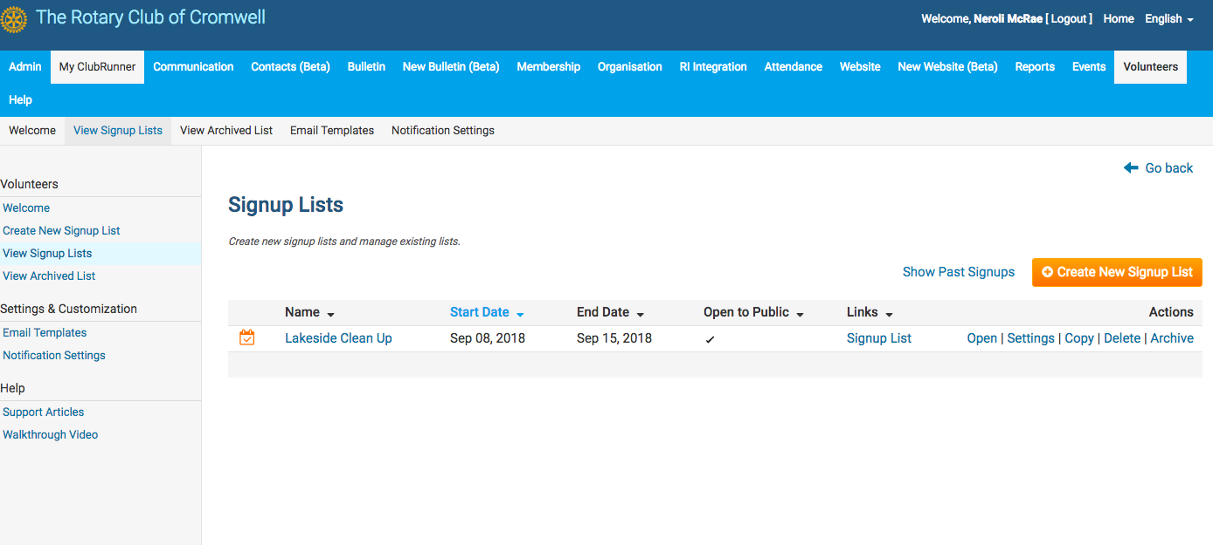

* ‘Volunteers’ – Light blue line -top R) corner
* ‘View Signup Lists’ – Grey line – L) corner
* Click on the list name you would like to check
* For good info watch ‘Walkthrough video’ Under ‘Help on L) hand side