**Annual Fete**

For three of the last four years the Club has held a community fete in conjunction with St Edmund’s Anglican Church, Wembley. Each fete has been held in the grounds and hall of the Church on a Saturday in November and have been fully supported by both Rotary Cambridge members and the parishioners of St Edmunds. An organising committee comprising Rotary and Church members starts the organisation at least 6 months before the event.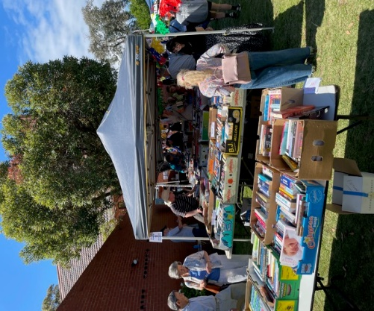

A collection of goods for sale commences months before the event and all items are donated, without exception. Advertising of the event is done by extensive pamphlet dropping at houses and units in the Cambridge area, posters in shop windows, community radio and by word of mouth. There are a variety of stalls including cakes, jams, books, white elephant, clothing, toys, plants etc, plus there are morning teas available, a number of raffles, a silent auction and a sausage sizzle.

The fete runs from 8.30am – 1.30pm and the stalls are manned by members of Rotary, Church parishioners, friends and family. The fetes have all been extremely well attended by the local community and over $55,000- in total has been raised, split equally between Rotary Cambridge and St Edmund’s. Rotary’s proceeds are all used for community and other Rotary projects.