Backpack Blitz
In conjunction with Officeworks the Club has provided 30 school bags filled with school equipment to Lake Monger Primary School. The school has a large demographic of immigrant children and it is intended to help out needy families in reducing the cost of sending their children to school. Each backpack also contains a library bag donated by a voluntary ladies sewing group.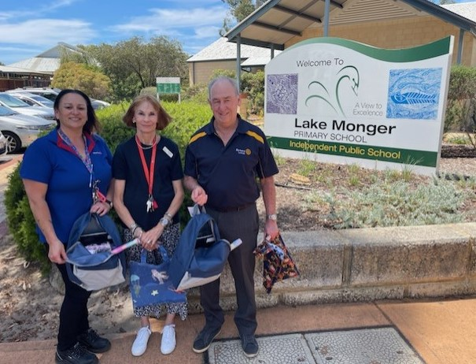
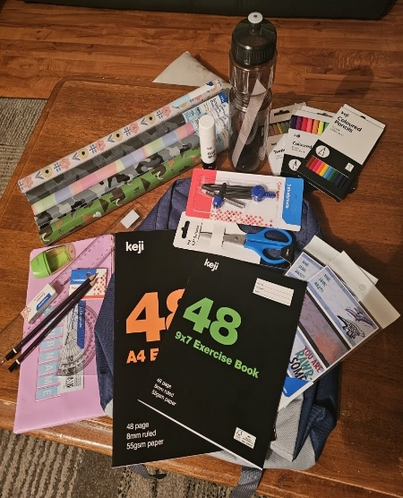
Officeworks provide the bags and school supplies at a reduced cost and the Club pays for the shortfall. The school selects those families to receive the backpack.
Lake Monger Primary School is most appreciative of Rotary Cambridge’s initiative and we have arranged with Officeworks to continue the programme for another year, with a view to making it an ongoing project.

