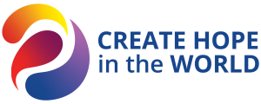 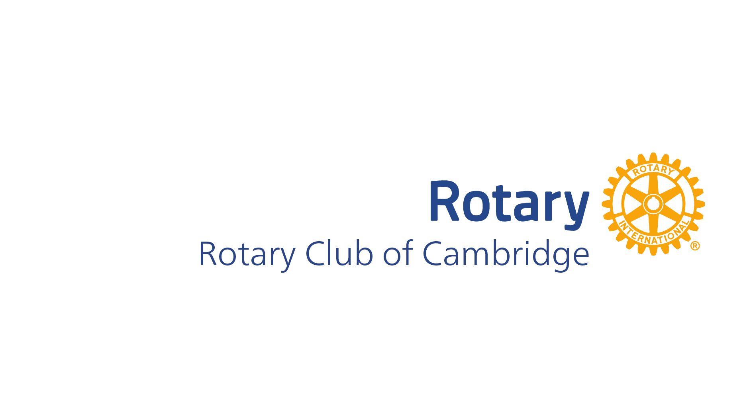

District 9423

**CAMBRIDGE COURIER**

___________________________________________________________

##### Information about our next Rotary Meeting (usually held at Cambridge Bowling Club, 7.10 for 7.30 am):

##### Wednesday 1st November 2023

**Speaker: Peter Kennedy Topic: Referendum Analysis**

**On Duty: Speaker Host, Introduction & thanks: Rod Lane Set up/Pack up: Peter Wagner**

***NEWS FROM LAST WEEK***

***GENERAL NEWS ITEMS***

Members enjoyed a Mandurah Getaway and a dinner in Dawesville. Cate Barlow was re-elected to the Cambridge Council, and Max Puddy received life membership at Lake Monger Community Shed. Jim Berry leads the RSL Poppy Day collection, Jeremy needs helpers for the Wembley Junior District Club, and Peter Pearse is organizing a driver education event on November 30. Peter also reported steady Fete collections and the need for trestle tables. Janet is progressing and we wish her well.

***I lost my wife’s audiobook; now I’ll never hear the end of it!***

**Coming up soon**

**Wednesday 8th November 2023**

Speaker: Josh Haliday, CO of Australian Airforce Cadets

Topic: The Airforce Cadets

Speaker Host, Intro & thanks: **Stan Robins**

Set up/pack up: **Graham McHarrie**

**IF A MEMBER CAN’T ATTEND, OR WANTS TO BRING A VISITOR, PLEASE ADVISE LIBBY LARSEN BY EARLY MONDAY MORNING**

**Either by telephone (0438 462 917) or email (**[**libbylarsen@westnet.com.au**](mailto:libbylarsen@westnet.com.au)**)**. Bulletin Editor: Roger Veary

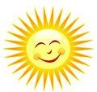

*Birthdays: Frank Nathan (27 Oct)*

*Wedding anniversaries: none this time*

*Rotary anniversaries: none this time*

Our guest speaker at our meeting was Peter Kennedy, a highly respected political reporter in Australia. Peter Kennedy has been a prominent figure in the world of political reporting, known for his insightful analysis and in-depth coverage of political events. During his presentation, he shared the implications of a recent referendum that resulted in a "no" vote. The referendum results were as follows:

* 40% Yes
* 60% No

While some areas like Curtain and Floreat voted "yes," the overall result was decisive, with a majority of "no" votes. However, it's worth noting that not everyone has accepted this outcome.

Peter Kennedy mentioned the importance of understanding how Aboriginals and Torres Strait Islanders are living, highlighting a cross-country trip from Perth to Cairns, where he observed distressing living conditions. This experience emphasized the significance of being connected to the broader community.

He also discussed the challenges in the referendum process, including the lack of detail on how the proposed "Voice" would work. Despite the referendum outcome, he underscored the need for progress and unity in Australia, reinforcing that we are all Australians, and that progress is being made and we must continue to close the gap.

Peter Kennedy's extensive career in political reporting has made him a knowledgeable and influential figure in Australian politics. His insights shed light on the ongoing discussions and challenges facing our nation.