**Club Community Partnerships**

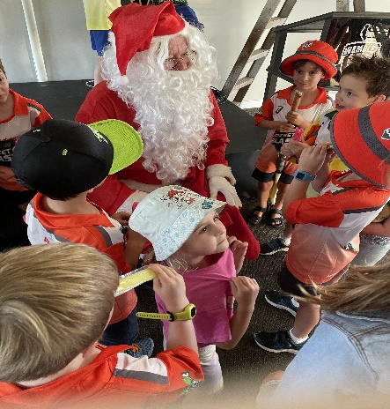During the cricket season and out of school holidays, club members arrange a sausage sizzle every Friday evening for the Junior Blasters. By having the continuity club members have become very much part of the junior cricket community. While it may seem that a mere sausage sizzle is not a very good use of time week after week, the community spirit that is engendered by these events creates an enormous amount of goodwill and community spirit. This program includes a special visit by Santa on the final event before the Christmas break. These are events which are hugely enjoyed by the cricket organizers, the parents, the cricketers and the rotary Club members as well. A couple of people cooking sausages on a grill

Moves are now afoot to establish a similar relationship with the City of Perth Surf Lifesaving Club. Applications are being submitted to Lottery West and the Rotary Foundation for a grant to help fund a new Surf Boat for the Surf Club.