Rotary Club of Cambridge

The Rotary Club of Cambridge actively supports and participates in local community functions and events.
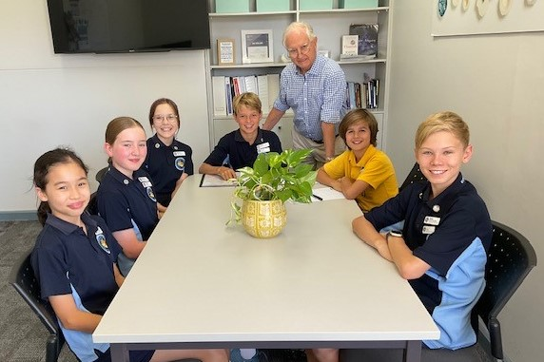
Particularly strong ties have been established with primary schools across the greater Cambridge area. Through the Club’s Schools’ Programme, student councils are taught how to run a formal meeting and then monitored and guided throughout their tenure by an experienced club member. Assistance is also given to the Art Teacher at City Beach Primary School and the sustainability Group at Churchlands Primary School. These are termed Life Skills and are detailed below. A Rotary School Values Award programme has been instituted through which a prize is presented at the schools’ graduation ceremonies.
From time to time, through articles in the local press and database contacts, members of the public are invited to attend Club meetings when specialist speakers make presentations on topics of interest to the greater community.
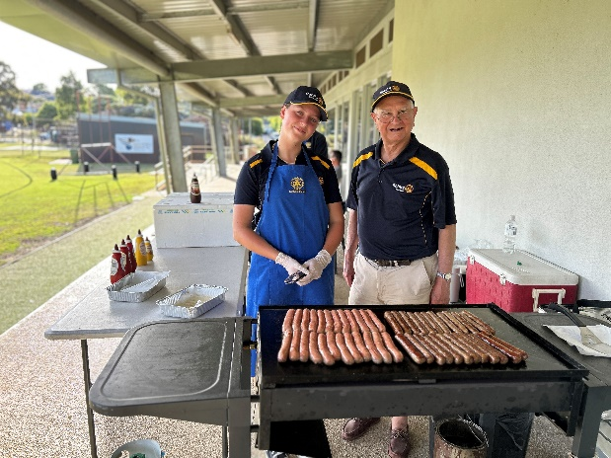
Additionally the Club is forging ties with local sports clubs, offering assistance where needed. Over a number of years Cambridge Rotarians have organised the Friday after practice sausage sizzles at the Wembley District Junior Cricket Club – a mutually beneficial activity much enjoyed by the Rotarians, their families and the junior cricketers alike.
The Club hosts public speaking competitions for both primary and high school students, it sponsors attendance at the Rotary National Youth Science Forum while its participation in the Rotary Youth Exchange programme goes back many years.
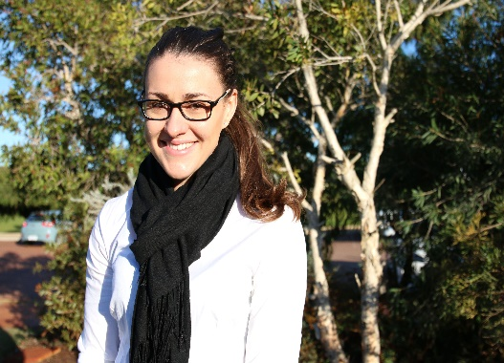
The Club is very proud to have sponsored Janice Malcolm, a recipient of a prestigious Rotary International grant, who in September 2019 was awarded her Ph.D. degree by McGill University in Montreal. The Club also participates in other Rotary Youth programmes which are offered to students through their schools.
The Club’s many community activities include the Club President’s attendance at the Town of Cambridge Citizenship Ceremonies, and participation in the ANZAC Day and Remembrance Day Ceremonies.
All Club members assist with the Arbour Day sausage sizzles for primary school students, the Poppy Day Collection, the Rotary WA Driver Education Programme for Year 10 students and the Salvation Army Red Shield Appeal.

The Club works closely with the Town of Cambridge on projects of mutual benefit and Club members are very appreciative of the close ties that have been developed with the Town. Such projects include the development of a Community (Men’s) Shed, the proposed Trees for Life Project and the sponsoring of drinking fountains on the City Beach North Walking Trail.

For many years the club has had as its overseas project, the East Java Hearing Project. The club has also been instrumental in donating Peace Poles to 13 Primary Schools in the Cambridge area. It has recently donated backpacks sponsored jointly with Officeworks to needy children. It has also rune an annual fete to raise funds for many causes.

The Club’s members meet on Wednesday mornings at 07.00 for 07.30 when a light breakfast is served. Join Rotary for social interaction and engagement.
Get involved in community projects and enjoy the personal fulfilment of being a Rotarian.

