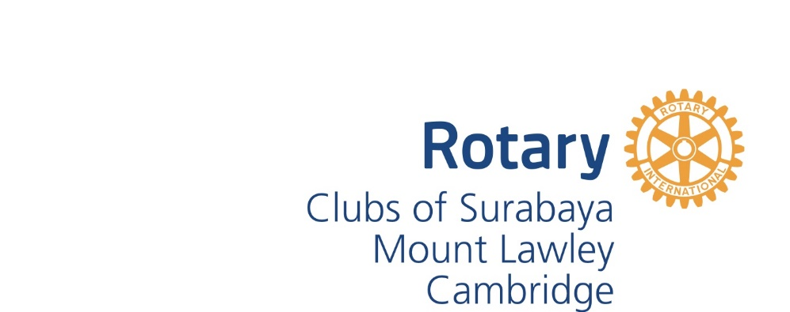**Rotary East Java Hearing Project**

**Project Plan 2020**

**Background**

The Rotary East Java Hearing Project began in 1996 by focussing on improving medical treatment and early intervention help for deaf children in Surabaya, centred initially on the Dr Soetomo Hospital and Karya Mulia School for the Deaf. Critically important threshold detection of hearing loss was lowered from 7 years, to 5, to 3 over the initial 1996 to 2006 program. This first stage was led jointly by the Rotary Clubs of Surabaya and Cambridge (then Floreat) with a Rotary International Humanitarian Matching Grant of US$15,000 and equal sums of US$7,500 from the two Rotary Clubs. It grew to cash-and-kind assets of about Aus$250,000. The project was progressively linked with, and helped by, Sister State relationships between East Java and Western Australia since 1990.

During and subsequent to the initial phase of the project, Rotary collaborated with HearingAID-East Java (formerly known as the Patricia O’Sullivan Humanitarian Project Inc), a private organisation in WA also providing support to Karya Mulia School and hearing centres in East Java. Representatives of Rotary and HearingAID East Java have travelled to Surabaya on many occasions to do training and to visit Hearing and Communication Centres in Surabaya and nearby Regencies. Nurses and teachers were brought to Perth for intensive training in basic audiology testing of infants and teaching the deaf in 2012. UWA Masters students have completed four research projects focused on the Project.

In 2014 the Rotary Clubs of Cambridge, Mount Lawley and Surabaya supported the purchase of an audiometer and tympanometer for use in early testing and intervention. Funding of the $7,950 cost was assisted by a Rotary District Grant of $3,000.

Such is the success and longevity of this project, that Karya Mulia School is now a “must visit” for Western Australian politicians and dignitaries visiting East Java, Indonesia.

In 2017 we commenced the current phase of the Teacher Exchange project. Surabayan teachers of children with hearing disabilities are gaining new and added skills through a 5-year program. A group of children sitting on the floor
Teachers are selected annually for specialist training in Perth by experts at Telethon Speech and Hearing and the Western Australian Department of Education. Returning to Surabaya, interns collaborate with Perth experts in further training for fellow teachers. In each of 2018 and 2019 two teachers from Surabaya have visited Perth and two Perth teachers have travelled to Surabaya. Over the duration of the project the increasing collegiate cohort of trained interns will share, expand and spread their new skills in mentoring teachers and parents.

**About Karya Mulia School for the Deaf**

Karya Mulia School for the Deaf is located in Surabaya, East Java. It is the biggest School for Deaf Children of its kind in the Province which has a population of some 39 million people.

There are 200 students enrolled at Karya Mulia, ranging in age from 4-18 years. There are 50 teachers on the staff, none of whom have a formal qualification as a teacher of the deaf.

A program for early detection and diagnosis of deafness in children under the age of 3 has been implemented at the school. This is complemented by an early intervention program to promote language and communication development.

The school is undertaking a capability building program to improve the outcomes for its students. This program requires resources and equipment to achieve the goals that have been set.

**Feedback from Dr Lenny Harjono, Principal Karya Mulia School for the Deaf, 31 March 2019**

*“I would like to thank you for everything that you have prepared for Pak Adib and Bu Endah while they were there. They told me that they were treated well. They also learned a lot and hopefully they can share it to everybody here.*

*I really appreciate what you have done to Karya Mulia especially to the teachers when you gave us this opportunity. It is a very valuable experience for teachers.*

*I am now still in process on taking their experiences especially everything related with teaching especially how teachers share their knowledge to the students and how students apply it. I would like to be able to copy it so I can have improvement to teaching method in Karya Mulia especially in elementary level. I feel that I reach my goal when Sipuntini and Agung went there and share their knowledge here. It is also supported by Kara and Kelly's visit to Karya Mulia when they shared their knowledge in kindergarten level. I feel that I am successful enough to improve teachers' knowledge and perception in kindergarten level.*

*May you are always in good health so you can continue do good to others. Thank you all so much.*

*Regards*

*Lenny”*