Life Skills for Primary Schools
The club runs a program with local Primary Schools to teach Life Skills to the students especially those elected to the Student Council.
The first part of the program is to coach the Student Council how to run a formal meeting and to monitor them throughout the year so that they move forward to the next stage of their lives equipped to understand the workings of committees. All participants are given a Guide for them to be able to refer to whenever they become involved in a club or other group activity requiring some formality to be observed. This element is operated at Floreat Park, Woodlands, Churchlands and Wembley Primary Schools. The program is greatly appreciated by the entire school community.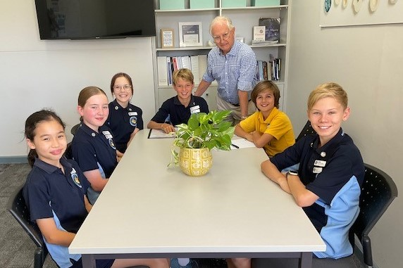
The second element in the program is the teaching of motor skills to Year 6 students in the Art Class at City Beach Primary School. This was greatly encouraged by the Art teacher at the school, Dr Sue Girak. To quote her, she says that she is able to teach the students many more skills by having Rotary members to assist her and expand her scope.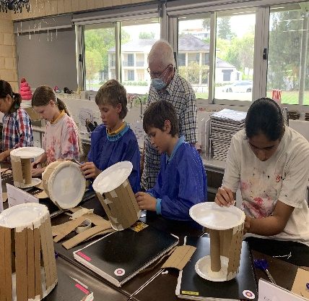
The third element in the program is the teaching of Sustainability practices to Year 5 students at Churchlands Primary School. From the Rotary perspective, particular emphasis is placed on developing a vegetable garden where the students can learn to sow, plant and then harvest the products of their efforts. 