Cambridge Club in Western Australia adopts Rotary100 Peace Pole Project
Occasionally an unexpected project comes along - one that really catches on. This is true of the Rotary Centenary R100 Peace Pole Project initiated by the Rotary Club of Canberra Burley Griffin. It is such a simple project that so easily brings the message “May Peace Prevail on Earth” to so many young people.
Quite by chance the Peace Pole project landed at the door of the Rotary Club of Cambridge. A representative of the Peace Pole Foundation approached several schools in Perth with a view to their installing Peace Poles as part of the aim to install 100 poles in 100 schools by World Peace Day. One of those schools approached the Rotary club of Cambridge. Their request was a simple one: “Please could our club sponsor a Peace Pole for them?” Not having previously heard of the project, the school was asked to send the background information. This school was Mount Hawthorn Primary School. The club agreed to finance that pole and, thinking it was such a good project, it was decided to extend the offer to all the schools in the club’s area of focus. All the schools approached (initially eight in all) accepted the offer with considerable enthusiasm. Over time, that initial number has grown a bit such that twelve have been installed at Primary Schools and one at a church.
All the schools have indicated that they will mark World Peace Day annually with a “Peace Assembly”. Rotary Cambridge will be invited to attend these ceremonies.
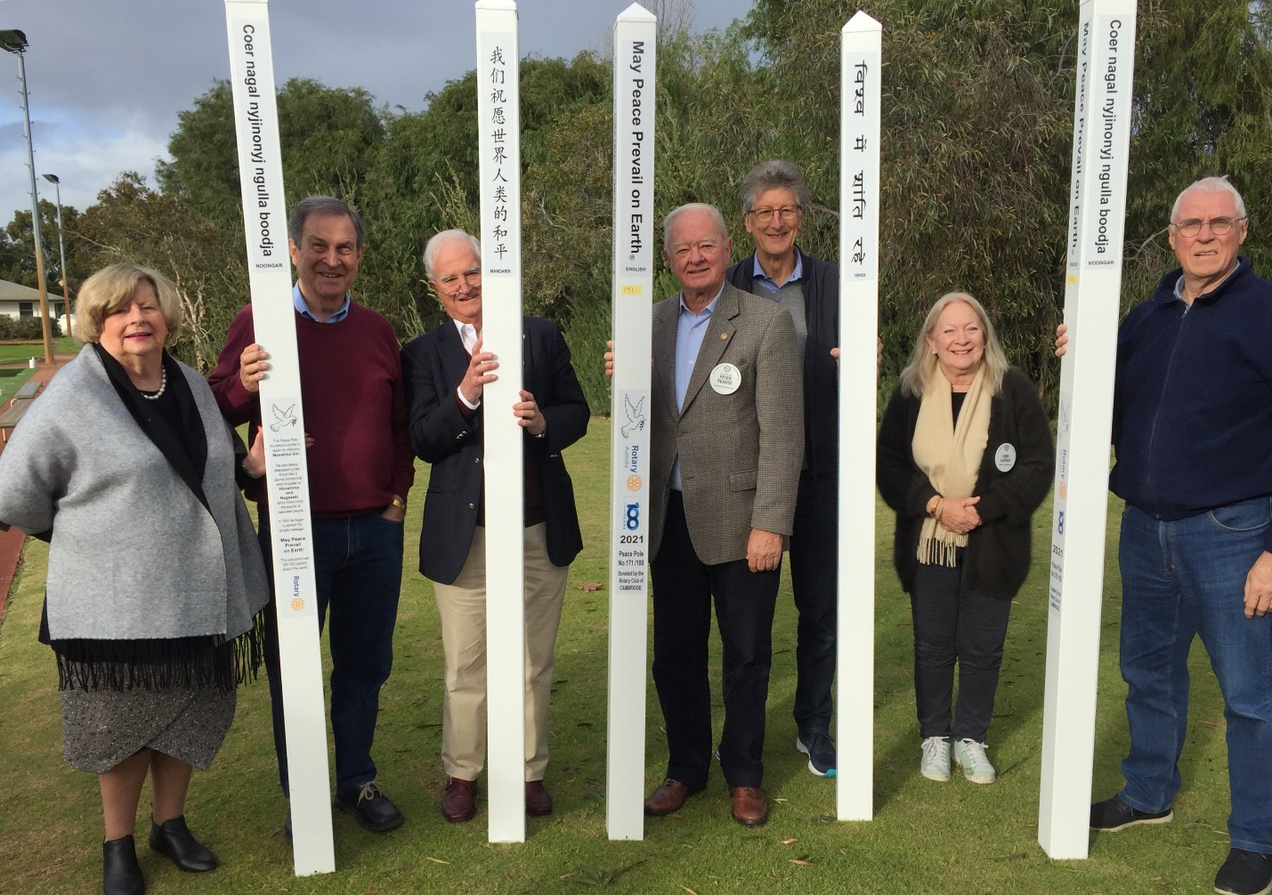
Figure 1. Rotary Club of Cambridge Board members with Peace Poles
The schools have all been very enthusiastic about the overall concept and are all very proud to have the poles erected on their premises. As one school principal remarked , “this Peace Pole project ticks all the right boxes for them and exactly reflects the values they are trying to instill in the students”. They have all had extensive discussions between the staff and the students concerning the message on the pole and the best places to site them.
The ceremonies themselves have enabled the club to highlight the Areas of Focus of Rotary International; particularly the Promotion of Peace and Disease Prevention and Treatment.
There is no doubt that the project will expand and gain momentum once other clubs have bought into the project and discovered firstly, how easy it is and, secondly, how much goodwill and community contact are generated in the process. The club also hopes to have poles installed in some of the local parks as has been done in Canberra.
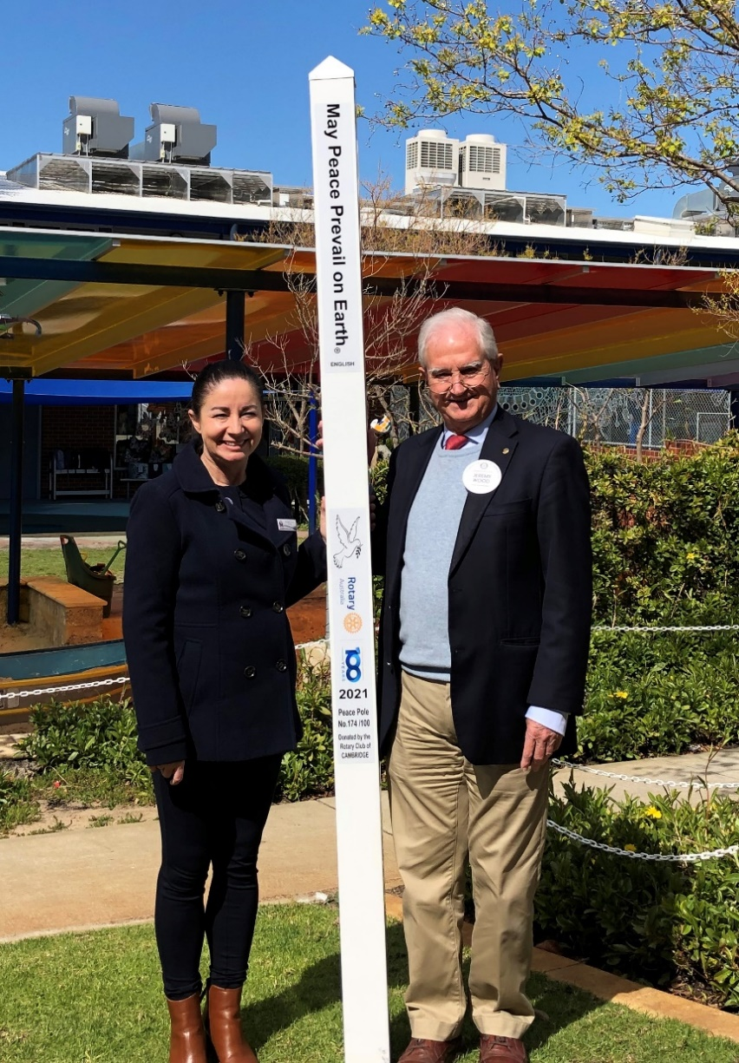
Figure 2. West Leederville Primary School Peace pole with School Principal
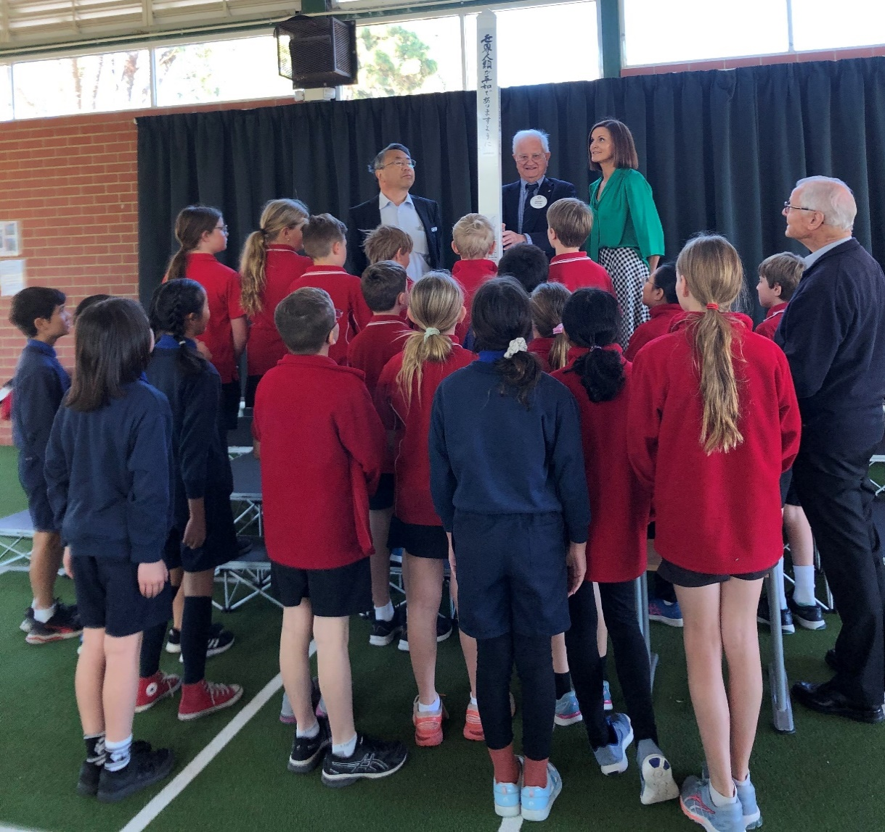
Figure 3. City Beach Primary School and Japanese School of Perth - students admiring the Peace Pole
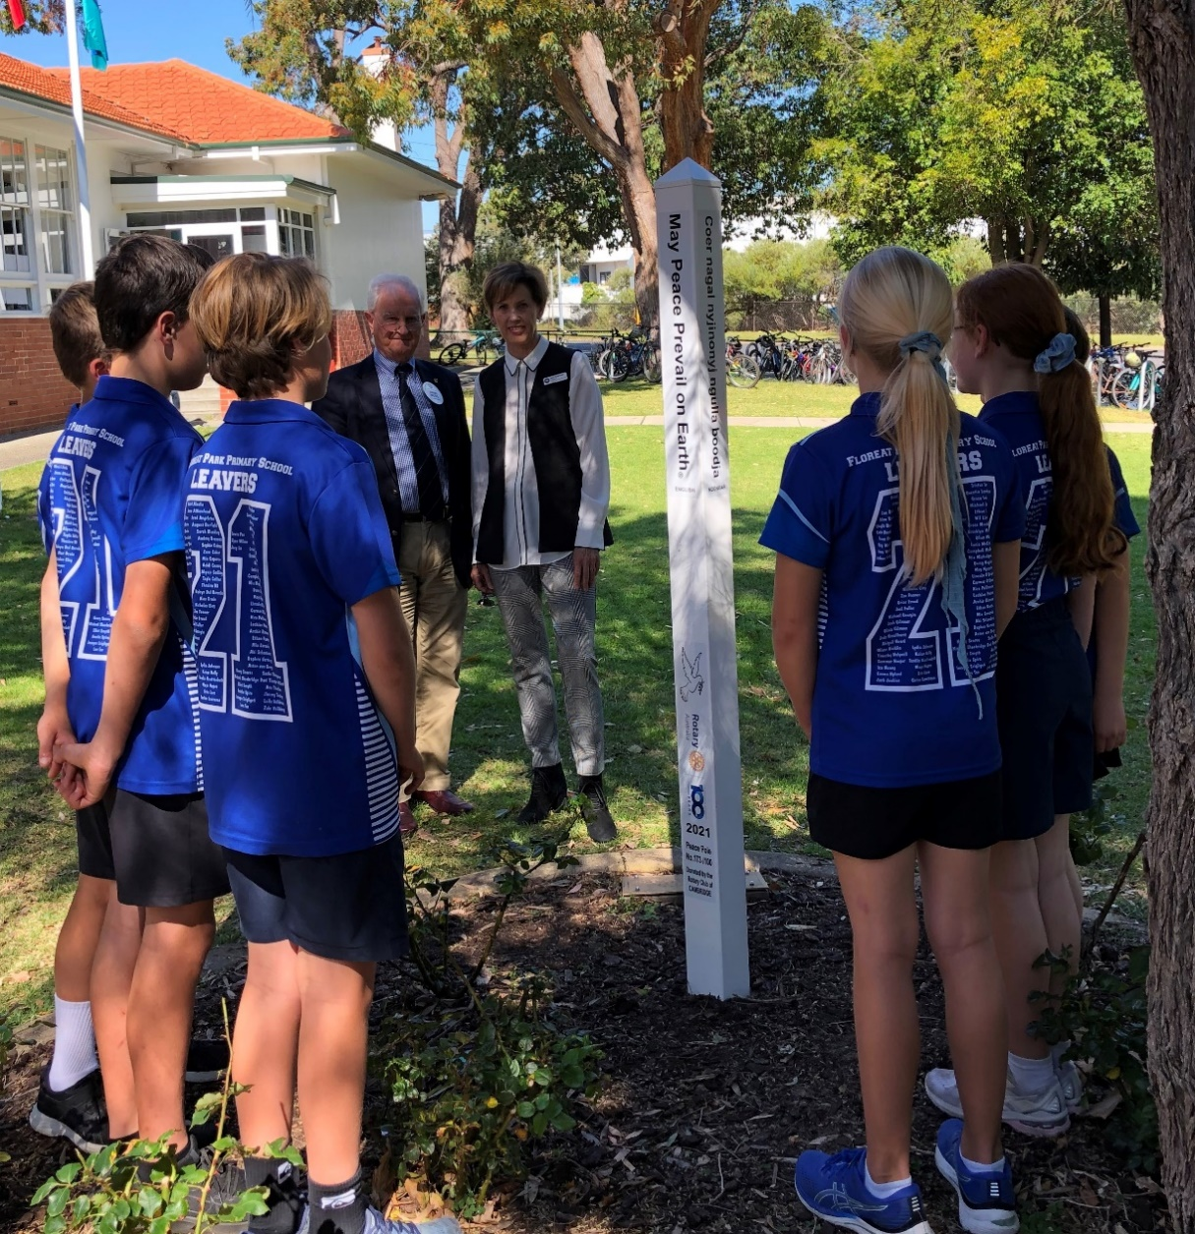
Figure 4. Floreat Park Primary School Peace Pole with School Principal and Student Councillors
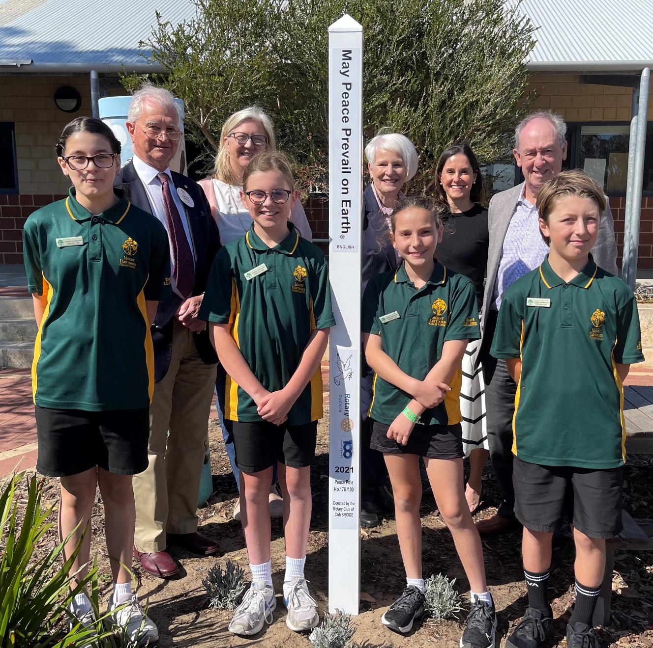
Figure 5. Mount Hawthorn Primary School Peace Pole with Student Councillors

This has been the most fantastic project. Club members have all enjoyed visiting the schools and attending their ceremonies. The good relations and contacts that have been made with all of the local schools over a long period have been enhanced dramatically.
An acknowledgement is extended to the Rotary Club of Canberra Burley Griffin, and Michael Raby in particular, whose assistance has allowed the project to be implemented so smoothly. Also, Peter Clapinski who handled the manufacture and shipping of the poles was extremely helpful.

