Combined Clubs of the Sunshine Coast

Sunshine Coast
Rotary and University of the Sunshine Coast Community Fund
Advancing tertiary education opportunities through a partnership between
the combined Rotary Clubs of the Sunshine Coast and the University of the Sunshine Coast
Annual Joint Meeting of all Sunshine Coast Rotary Clubs
Wednesday 24th August 2022

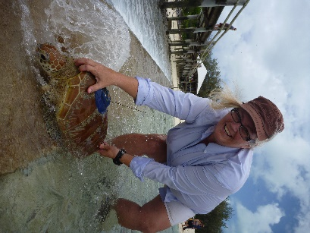
Dr Kathy Townsend's research focuses on issues such as marine conservation and human impacts on the marine environment. Kathy's research programs draw their strength from a multidisciplinary approach and focus on global scale issues, such as the impacts of marine debris and marine pollution.
Kathy actively contributes to a greater understanding of the conservation status of marine species identified by the IUCN Red List for threatened species. Kathy has provided expert advice and influenced policy development at all levels of Australian government and internationally. Kathy has been fortunate to live and work on marine research stations for over 20 years and brings a broad knowledge of tropical and semitropical ecosystems.
Kathy takes her role as a mentor to young scientists very seriously. She is consistently ranked highly by both students and peers for her teaching and community engagement techniques. As lead academic of the internationally renowned scientific programs “Project Manta” and “Turtles in Trouble”, the research has been featured on multiple international documentaries, including BBC David Attenborough’s Great Barrier Reef and Nat Geo Wild's "Manta Mystery”.
Where? Innovation Centre, USC. Free Car Parking (Map at www.usc.edu.au)
Time? Bar opens 6pm to 7.15pm Cost? $30pp (Includes 2 course meal)
Dinner Served from 6.15pm Meeting commences 7.15pm sharp
Book Online/ Purchase Raffle Tickets
https://mooloolabarotary.org/rusccf/
(Any problems call Ian 0419 796 290)

How to Donate: Each club is encouraged (but not obliged!) to make a club donation
(if possible by the 30th June 2022)
By donating direct to the University of the Sunshine Coast: Account No: 14-786-4575,
BSB: 084 004, Acc.Name: University of the Sunshine Coast, Ref: 061 + Club Name

Any Questions:
President – Ian Barnett 0419 796 290 ian_barnett@bigpond.com
Secretary - Wendy Gilson 0437 747 462 wendygilson3@bigpond.com

RUSCCF webpage link: www.usc.edu.au/RUSCCF
All Sunshine Coast Rotarians, Partners and Friends are welcome!
Your Fund awards three annual scholarships to postgraduate students selected by USC. Each Recipient must have
completed his/her undergraduate degree at USC and be enrolled in postgraduate studies at Masters or Doctorate
level. Each year’s recipients are introduced to Rotary club members at this annual Joint Meeting. Your Fund has
awarded over $160,000 since 2001. Recipients are available to speak at Coast Rotary clubs.

Guest speaker Associate Professor Dr Kathy Townsend + Rotary fellowship + Meet
your Rotary Scholarship recipients at this unique Sunshine Coast Rotary event!

