Combined Clubs of the Sunshine Coast

Sunshine Coast
Rotary and University of the Sunshine Coast Community Fund
Advancing tertiary education opportunities through a partnership between
the combined Rotary Clubs of the Sunshine Coast and the University of the Sunshine Coast
Annual Joint Meeting of all Sunshine Coast Rotary Clubs
Wednesday 12th May 2021
Professor Helen Bartlett commenced as the third Vice-Chancellor and President of the University of the Sunshine Coast (USC) on 17 August 2020.
Prior to joining USC Professor Bartlett was Vice-Chancellor and Chief Executive of Monash University Malaysia from 2013 to 2017, and Pro Vice- Chancellor and President of Monash University’s Gippsland Campus from 2008 to 2012.
Professor Bartlett brings to the USC extensive international experience, having held various leadership roles in universities across Australia, the United Kingdom, Hong Kong and Malaysia.
Professor Bartlett attained a Bachelor of Arts at Northumbria University, a Master of Science (Public Policy) and a PhD from the University of Bath.
A research specialist in health and aged care, Professor Bartlett’s career includes

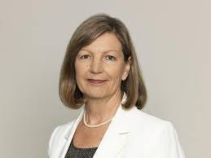
inaugural Director at the Australasian Centre on Ageing at the University of Queensland, the Oxford Centre for Health Care Research and Development and the Oxford Dementia Centre at Oxford Brookes University.
Professor Bartlett was conferred as an Emeritus Professor at Monash University in 2017. She is the current Chair of the Regional Universities Network, an expert member of the Australian Government Council for International Education, and also a member of the Australian Government’s National Priorities and Industry Linkage Fund Working Group.

Where? Innovation Centre, USC. (Map at www.usc.edu.au maps Free car parking)
Time? Bar opens 6pm to 7.15pm Cost? $30pp (Includes 2 course meal)
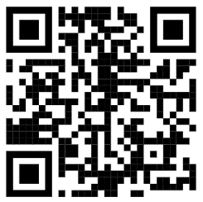
Dinner Served from 6.15pm Meeting commences 7.15pm sharp
Book Online/ Purchase Raffle Tickets
mooloolabarotary.org/rusccf
(Any problems call Ian 0419 796 290 )

How to Donate: Each club is encouraged (but not obliged!) to bring a club donation cheque to
the meeting (payable to University of the Sunshine Coast), or pay direct to: Account No: 14-786-4578,
BSB: 084 004, Acc.Name: University of the Sunshine Coast, Ref: 061 + Club Name

Any Questions:
President – Ian Barnett 0419 796 290 or ian_barnett@bigpond.com
Secretary - Wendy Gilson 0437 747 462 or wendygilson3@bigpond.com

RUSCCF webpage link: www.usc.edu.au/RUSCCF
All Sunshine Coast Rotarians, Partners and Friends are welcome!
Your Fund awards three annual scholarships to postgraduate students selected by USC. Each Recipient must have
completed his/her undergraduate degree at USC and be enrolled in postgraduate studies at Masters or Doctorate
level. Each year’s recipients are introduced to Rotary club members at this annual Joint Meeting. Your Fund has
awarded over $160,000 since 2001. Recipients are available to speak at Coast Rotary clubs.

Guest speaker Vice-Chancellor Professor Helen Bartlett + Rotary fellowship + Meet
your Rotary Scholarship recipients at this unique Sunshine Coast Rotary event!

