The Rotary Club of Pakuranga invite you to join The Ultimate
17 Day Rotary Tour of New Zealand 6th – 22nd April, 2018.
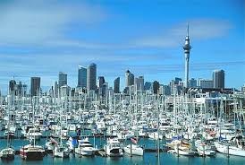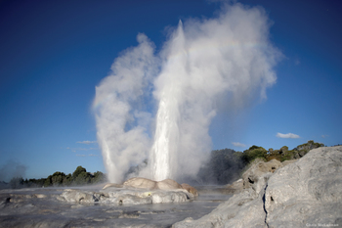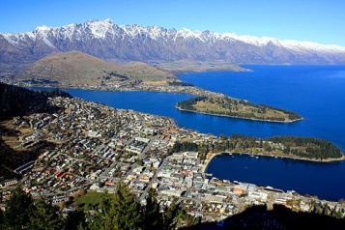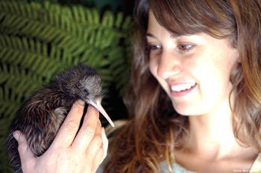

The Tour Key points and Highlights are:
- The Tour includes 4 Rotary fellowship events.
- The planned Tour size is limited to 26 persons. (Within a 30/33 seater coach.)
- Accomodation will be 4 to 5 star and includes all breakfasts.
- A professional ‘Top Tour Guide’ will travel throughout the Tour.
- An optional 4 day pre-tour to Northland/Bay of Islands is also offered.
Here are some of the 62 tours/visits, of which all but one is included within the Tour price:
Kelly Tarlton's Sea Life Aquarium, Auckland Sky Tower, 2 hour tour of ‘Hobbiton’, Te Puia ( Rotorua centre of Maori culture and geothermal wonders), Huka Falls, Napier wine tasting, Wellington’s
Te Papa Museum, Weta Workshops, Ferry to Picton, Hanmer Springs, Lake Tekapo, Lake Pukaki, Arrowtown, Queenstown, Milford or Doubtful Sounds, Dunedin and Christchurch City Tours.
Below are two of the typical comments we received from all our 2017 Rotarian tourists:
- We thought the tour was fantastic. Sharron (the Tour Guide) was brilliant.
- We thoroughly enjoyed every minute of the tour and you are to be congratulated.
The 17 day Tour Price is approximately: US$4,870pp share-room. US$6,300pp single.
The 4 day pre-tour Price is: US$1,125pp share-room. US$1,420pp single. To receive the full 9 page itinerary email both peter.hawkins@xtra.co.nz and john.mcmillan@xtra.co.nz

