

Rotary Club of Balwyn Centenary Grants
Rotary Club of Balwyn Inc.
A0022555U
To celebrate the 100th anniversary of Rotary in Australia in 2021 the Rotary Club of Balwyn (herein after called RCB) will donate a significant portion of its annual income generated from its Camberwell Sunday Market to assist other Rotary Clubs in Australia in their humanitarian endeavours. Since 1976 the Sunday Market has become a Melbourne icon and tourist attraction and the many millions of dollars generated from the Sunday Market has enabled the RCB to start many major community projects and assist in philanthropic initiatives within Australia and internationally.
It is the sincere wish of the Rotary Club of Balwyn to share the Club's good fortune by providing Balwyn Centenary Grants (herein after called BCG) to other Rotary Clubs to give their members the opportunity to fulfill their dreams in making the world a better place. Subject to the Sunday Market returning to pre-COVID-19 trading patterns the RCB will commit approximately $1,000,000 over the next 5 years to aid other Rotary Clubs in Australia.

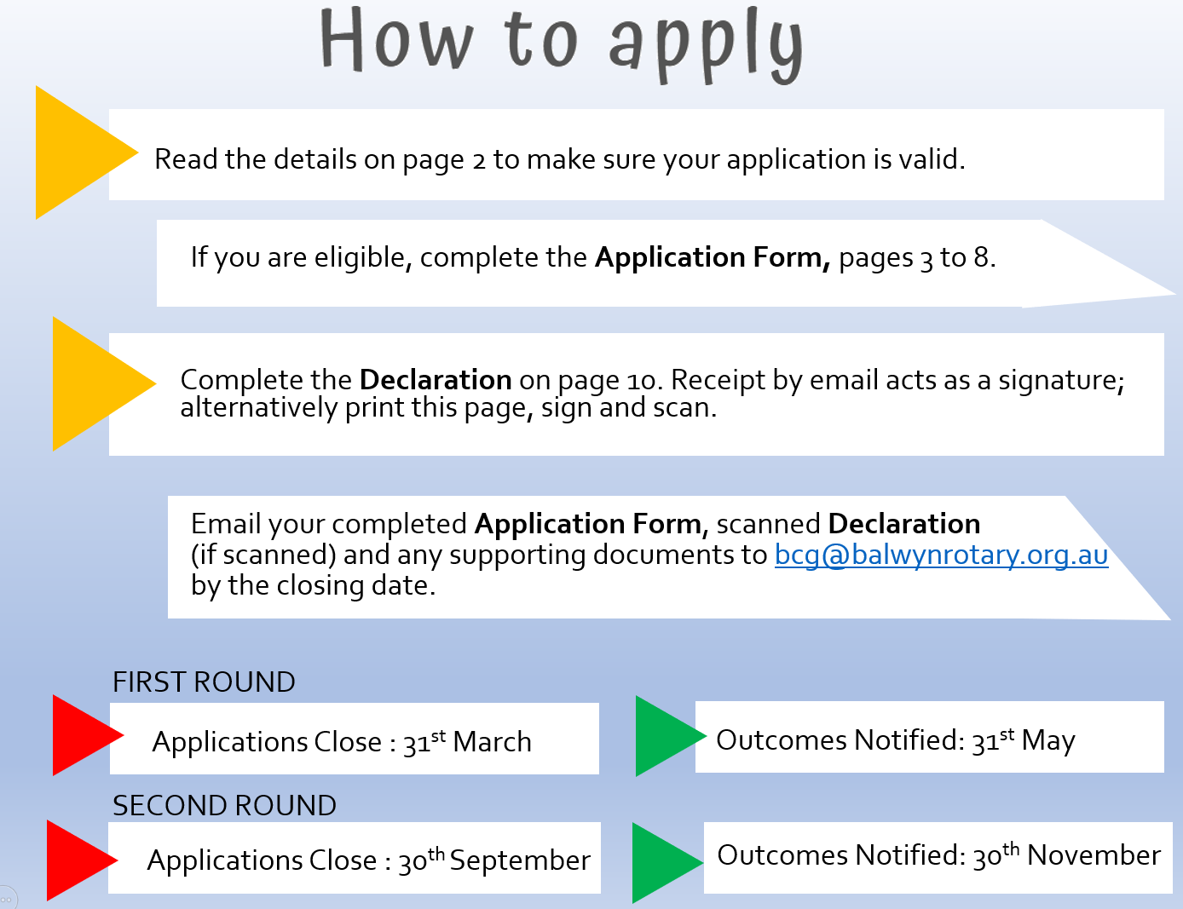

Grant Conditions / Information Overview
 | Only Rotary Clubs in Australia are eligible to apply for a BCG;
 | Grants will be available from $10,000 to $50,000;
 | There will be two funding rounds per year;
 | All Rotary Clubs and Rotarians throughout Australia are herein called the Applicant and third-party organizations that receive BCG's funding via a Rotary Club application are herein called the Recipient Organization;
 | Applications will close on March 31st for the first round and September 30th for the second round and outcomes will be notified by May 31st and November 30th of each year respectively;
 | Applications will only be received on-line at bcg@balwynrotary.org.au;
 | All applications must comply with rules and policies of Rotary International;
 | If the applicant is registered for GST, the amount applied for should be inclusive of GST;
 | The Application Form is quite extensive to enable a complete understanding of your request to avoid the need for further communication with the Applicant.

Areas of Focus
The Rotary Foundation’s seven Areas of Focus will apply to international projects and the four areas listed below are more applicable to Australia wide projects.

Community and Social Development
Environment
Indigenous Support
Youth Support

Preferences
New rather than existing projects;
Projects directly benefitting a larger number of persons or community organisations;
Projects other than International that can be completed within 12 months from the date of grant approval;
Projects that can demonstrate that the benefits and outcomes can be sustained without further funding from the BCG;
Acknowledgement of the financial assistance provided by the Rotary Club of Balwyn would be appreciated.

Exclusions
 | Research projects;
 | Grants to individuals;
 | Grants to medical organizations / facilities;
 | Grants to religious organizations, political organizations and related entities;
 | Re-imbursement for projects either completed or in-progress;
 | Projects where the anticipated outcomes are not able to be measured;
 | Funding for administrative costs beyond the advised completion of the project;
 | Funding for recurrent costs;
 | Funding of government and government related entities;
 | Further submissions from Rotary Clubs that have not had their Acquittal Form accepted by RCB;
 | Fundraising and public relations activities;
 | Purchase of land and buildings;
 | Personal and travel expenses;
 | Expenses for and or related to Rotary events and programs;
 | Multiple unrelated projects under one grant;
 | Projects previously applied for to BCG.

Application Form
ROTARY CLUB DETAILS
Rotary Club Name
ABN Number
Registered for GST | ☐ Yes ☐ No
Rotary District
Residential Address
Residential Address | State |  | Post Code
Postal Address if different to above
Postal Address if different to above | State |  | Post Code
Rotary Club President Contact Details
Name
Mobile
Email
Rotary Club President Elect Contact Details
Name
Mobile
Email
Primary Responsible Rotarian Contact Details for this Project
Name
Mobile
Email
Do you or the third-party require RCB to provide a Privacy Statement for this application |  |  |  | ☐ Yes ☐ No

PROJECT DETAILS
1.1 | Project name
1.2 | Brief project description  (Limit of 250 words)
1.3 | Amount of grant sought
1.4 | What will the funding from the BCG be used for?
1.5 | What are the payment requirements for this grant?
1.6 | Project start date  (Date needs to be consistent with application close dates / outcome dates)
1.7 | Project end date
1.8 | Which area of focus does the project belong to? | ☐ Community and Social Development  ☐ Indigenous Support  ☐ International | ☐ Environment  ☐ Youth Support
1.9 | Rotary values knowledge sharing. Would you be prepared to share the ideas and the results of your work with others?
1.10 | If this application is not successful, will the project still proceed? | ☐ Yes ☐ No

COMMUNITY IMPACT
2.1 | What are the identified needs that will be addressed by this project?  Please provide data sources.
2.2 | Why should this project be implemented?
2.3 | Where will the project be delivered?
2.4 | How many people will directly benefit from this project?
2.5 | What specific activities do you plan to carry out?
2.6 | What are the expected outcomes of the project?
2.7 | What is the greatest risk(s) to the project, and how do you plan to address the project risk(s)?

GOALS & OUTCOMES
3.1 | Are there any other organisations conducting similar work or programs? Describe who they are and how this project links to existing work
3.2 | What is your project’s point of difference?
3.3 | What makes your organisation best placed to deliver it.
3.4 | How will you monitor the project?
3.5 | Provide details of how you plan to sustain / continue the project after the BCG grant.
3.6 | Specify a minimum of two measurable project goals according to which you will be required to report in the BCG Acquittal Form. You should ONLY specify short-term goals that you intend to achieve during the life of the project.
3.6 | Goal 1
3.6 | Goal 2
3.6 | Other

THIRD PARTY DETAILS
4.1 | Does your project involve a third-party? | ☐ Yes ☐ No
4.2 | Name of the third-party organisation
4.3 | Is the third-party organisation registered as a charitable organisation? | ☐ Yes ☐ No
4.4 | Primary purpose of third-party organisation
4.5 | Does the third-party organization or your Rotary Club have either direct or indirect (via a related entity) access to sufficient uncommitted cash or capital reserves to undertake the project? | ☐ Yes ☐ No
4.6 | If YES, please explain why you are applying for the BCG.
4.7 | Does the third-party organization or your Rotary Club have a foundation or trust fund?
4.8 | Does the Rotary Club or its current members have or has had a relationship with the third-party organization? | ☐ Yes ☐ No
4.9 | Is there any potential conflict of interest? | ☐ Yes ☐ No

Statement of Endorsement
If the third-party organization would like to endorse the project, please include their statement of endorsement.

FINANCIAL AND BUDGET DETAIL
5.1 | Have you applied for a Global Grant?  If NO, do you intend to apply?
5.2 | Have you applied for funding for this project to other bodies? | ☐ Yes ☐ No
5.3 | If YES please indicate which one(s) and whether you have been successful/or when you expect to know the outcome.
The BCG Committee may require the third-party organization and /or your Rotary Club to submit a copy of the latest Annual Report and financial reports or statements if available.
Your itemised budget should be in Australian Dollars (A$) and include the following headings where applicable

Confirmed grants from other funding sources
Contribution from third-party
Applicant’s contribution
Unconfirmed funding requests
BCG’s request
Other
TOTAL Income

Salaries
Consultant Fees
Capital Costs
Rent
Administration
Equipment
Advertising/promotions
Other
TOTAL Expenditure

To submit your application, send the completed form to bcg@balwynrotary.org.au
(You will receive a response from our support team as confirmation of your submission.)
Applications will close on 31-March for the first round and 30-September for the second round.
Outcomes will be notified by 31-May and 30-November of each year respectively.

Balwyn Centenary Grant Terms & Conditions
These Terms and Conditions are to be read in conjunction with the Balwyn Centenary Grant
(BCG) application documentation regarding the project and the payment of the BCG by the Rotary Club of Balwyn (RCB).
By applying for a BCG, applicants and third parties agree to abide by these terms and conditions. if an application does not comply with the BCG application documentation as outlined or abide by these terms and conditions, it may be ruled invalid and withdrawn from further consideration.
Not every application, (whether- or- not it meets the selection criteria) will necessarily receive a grant, the ultimate decision as to whom and to what amount, will be at the sole discretion of RCB and no further correspondence and/or communication may be entered into regarding the decision, the process or the outcome.
- Successful applicants and recipients may be contacted by RCB and/or its representatives for the purpose of validation and the conducting of all required due diligence prior to finalisation of any proposed grant. All applications become the property of RCB.
- RCB reserves the right to at any time prior and/or during the grants process, to verify the validity of said offer and to disqualify any applicant that is not in accordance with these terms and conditions or any other matter that RCB considers material to the validity of said offer.
- Any funding received from the BCG must be spent solely for the purpose to which it was intended as per the approved application including in such time period as specified.
- Should the actual cost of the project for which the grant is applied exceed the proposed cost, neither RCB or any of its related bodies will be responsible or obliged in any way for making up any shortfall or to pay any monies additional to the agreed grant amount.
- The RCB may at its sole discretion vary the amount of the grant provided through the program. Notwithstanding, any such grant from RCB the grant amount will be deemed to include GST (if applicable) and the applicant has sole responsibility to arrange its own taxation issues.
- If at any time the stated purpose of the project for which the grant is offered is no longer viable or for whatever reason cannot be completed, the Applicant must immediately advise the RCB of the inability to continue, at which time the RCB will at its sole discretion discuss alternative options or retrieve in full the amount of the grant provided.
- Signage or promotional material must comply with Rotary International’s policies for the use of the name “Rotary” and other Rotary logos, emblems, and graphics, as outlined in sections 34.040.6. and 34.040.11. of the Rotary Code of Policies.
- The Applicant shall not by act or omission, do or say anything or cause anyone to say or do anything that may prejudice or be detrimental to or cause damage to the name and reputation of the RCB or Rotary in general.
- The Applicant must complete the BCG Acquittal Form within one month of project completion date.
- The Applicant must provide the organisation’s bank account details on advice that a grant has been approved. Grant funding will not be paid in cash or be deposited into the bank account of any individual.
- The Applicant must repay the full or relevant part of the BCG amount to RCB within 30 days of receiving a formal notice from RCB in any of the following circumstances a. RCB has overpaid the Applicant
  - Any or all payments that are incorrectly claimed; or
  - An amount of the funding is unspent at the project completion date; or
  - RCB pays the Applicant an amount that it is unable to spend in accordance with the funding purpose requested in its application; or
  - The Applicant has mis-represented or misused the funding amount by paying for a purpose other than described in the application and approved by RCB; or
  - Any other terms and conditions not abided by as deemed at the sole discretion of RCB
- In addition to personal delivery, participants in the BCG program agree to utilise electronic communication in any connection with the program (including invoicing) provided by posting on a website or sent via email.
- The RCB retains as its right, the ability to suspend or terminate its BCG program at any time and without notice other than to those directly involved in the program.
- These terms and conditions may be amended and / or revised at the discretion of the RCB.

Declaration
I certify that all the details supplied in this application and the attached documents are true and correct to the best of my knowledge.
I have the authority to apply for funding on behalf of the applicant Rotary club and the application has been submitted with the full knowledge and agreement of the management of my Rotary club.
I have read and understood the BCG application documentation and confirm that the Rotary club meets the eligibility criteria
I confirm that the Rotary club is aware of and also agrees to the BCG terms and conditions relating to grants from the Rotary Club of Balwyn.
I agree that I will contact the Rotary Club of Balwyn immediately if any information provided in this application changes or is incorrect.

Declaration by Applicant
I HAVE READ AND AGREE TO THE DECLARATION
President of the Rotary Club of
Name
Signature
Date

Declaration by Third-party Organisation
I HAVE READ AND AGREE TO THE DECLARATION
Name of third-party organisation
Authorised by
Name
Position
Signature
Date
Note: Receipt via email acts as a signature

