January 1, 2018

Dear Mr./Ms. Very Important Corporate President:

The Rotary Club of Hampton Roads is sponsoring the 2017 BIG 40s Hangar Party on Saturday, March 24, 2018 at the Military Aviation Museum, 1341 Princess Anne Road, Virginia Beach, VA.

For over 30 years, the Rotary Club of Hampton Roads has supported and carried out humanitarian and educational programs with the proceeds from our annual major charity fundraiser, raising over $750,000 for children and families.

This year we are offering wonderful sponsorship opportunities to companies and individuals. We also know that many people who attend the Hangar Party could be potential customers for your company so we are offering some great benefits for being a sponsor. It is a win-win!

Corporate sponsorship is vital to the success of our event and this year is no different. I would greatly appreciate your support. Please review the sponsorship levels and let me know which level you would be interested. Feel free to give me a call at 555-555-5555 with any questions and to reserve a sponsorship. I look forward to hearing from you soon.
We are committed to raising funds for our charities and I thank you for your consideration in helping us in this endeavor. Together we can make a difference in the lives of many families in the Hampton Roads area and beyond.

Sincerely,

Extra-ordinary Rotary Club Member
Rotary Club of Hampton Roads

Enclosure

Rotary Club of Hampton Roads
BIG 40’s Hangar Party
2017-2018 Sponsor Levels
Pay online here: http://bit.ly/2BuX1XH

All Sponsorship Levels Include:
- Acknowledgement on all advertising and press releases for the event
- Company logo on Rotary Club of Hampton Roads (RCHR) website
- Name recognition at the event
- Mention at the event

$4,000 Premier – Hangar Sponsor
- Presented by (Your company) on marketing, posters, website, social media, and tickets or receipts
- 10 complimentary tickets (raffle not included) at a reserved table at a prominent spot
- Display table (if desired) at the event
- Full page ad in a prominent location in the event program book
- Signage featuring your logo at entrance to the event
- Company representative given three minutes to address guests during the event
- Special Acknowledgement from the President of the Rotary Club of Hampton Roads during the event

$3,000 Canteen Sponsor
- Canteen Sponsored by (Your company) on marketing, posters, website, social media
- 8 complimentary tickets (raffle not included)
- Display table (if desired) at the event
- Full page ad in the event program book
- Signage featuring your logo at food area
- Special Acknowledgement from the President of the Rotary Club of Hampton Roads during the event

$2,000 Big Band Sponsor
- Band Sponsored by (Your company) on marketing, banners, website, social media
- 6 complimentary tickets (raffle not included)
- Signage right and left side of stage featuring your logo
- Half page ad in the event program book
- Special Acknowledgement from the President of the Rotary Club of Hampton Roads during the event

$1,500 Mustang Sponsor
- 6 complimentary tickets (raffle not included)
- Half page ad in the event program book

$1,000 Corsair Sponsor
- 4 complimentary tickets (raffle not included)
- Quarter page ad in the event program book

$750 Skyraider Sponsor
- 4 complimentary tickets (raffle not included)
- Name or Company listed in the event program book

$500 Warbird Sponsor
- 2 complimentary tickets (raffle not included)
- Name or Company listed in the event program book

$100 Dance Card Sponsor - Name or Company listed in the event program book
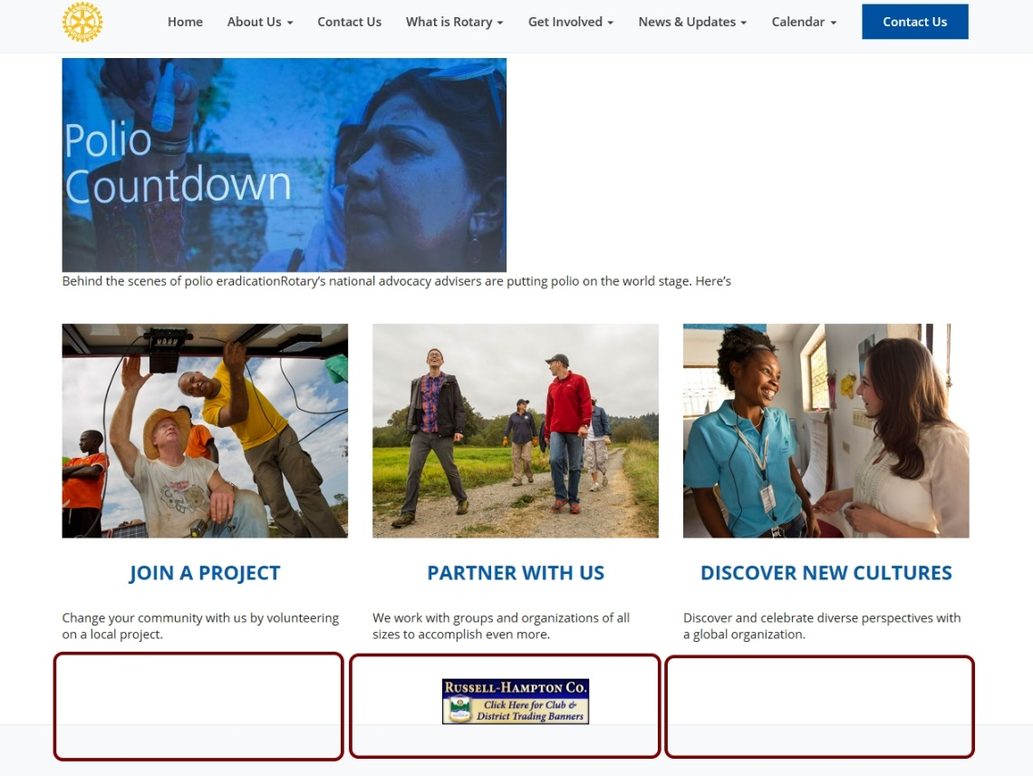

Your
Logo Here
Your
Logo Here

Your company will be prominently displayed on marketing, banners, website and social media

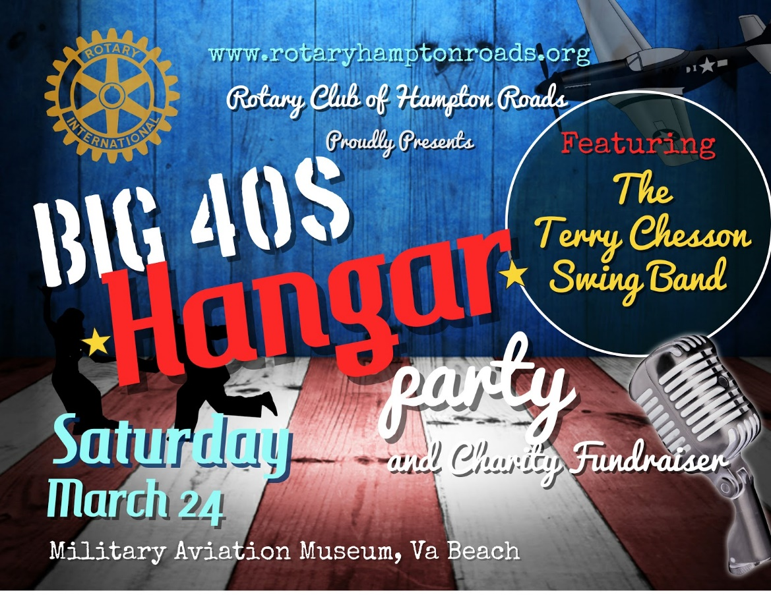
Your Logo Here

Your
Logo Here

Your
Logo Here

Rotary Club of Hampton Roads
Contribution Form

Learn more at rotaryhamptonroads.org
Pay online here: http://bit.ly/2BuX1XH

 | __Corporate Sponsor  __Silent Auction Item  __Individual Sponsor | __Personal Contribution  __Raffle Item  __Other___________
For Personal Contributions

Name ___________________________________________________

Address _________________________________________________

________________________________________________________

For Corporate Sponsors

Company/Organization _____________________________________

Contact for Recognition Letter ________________________________

Address _________________________________________________

________________________________________________________

Name of Rotarian
Submitting Sponsorship ____________________________________

Amount: __________________________________

Make checks payable to The Rotary Club of Hampton Roads Foundation

Mailing Address:
Rotary Club of Hampton Roads
P.O. Box 66123
Virginia Beach, VA 23466-6123

Thank you! Your contribution will make a BIG difference to the children and families in our community and beyond.

