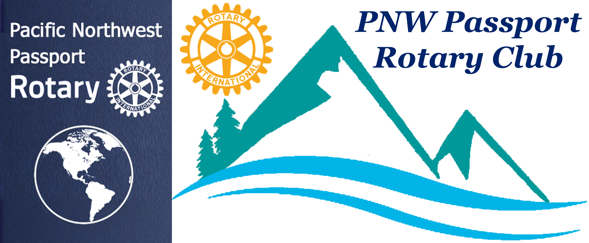
PNW Passport Rotary Board Meeting

Date: March 21, 2019 Meeting start time: 7:02 pm
Location: via GoToMeeting

Attending:
Tim Villhauer, President
Deb Wiggs, Pres Elect
Julie Johansen, Chair, Service Committee
Pati Villhauer, Chair, Engagement Committee
Sean Hogan, Past President
Lindagene Coyle - Co-Treasurer
Joy St John, Secretary

Absent:
Jim Smart, Treasurer

February 5, 2019 Board Minutes:
Moved by: Julie Johansen Seconded by: Pati Villhauer
Approved
Treasurer’s report sent my email:
Moved by: Julie Johansen Seconded by: Deb Wiggs
Approved

President’s Report:

President Tim said we needed to discuss the upcoming AGM, member and new member dues.

Dues for new members were discussed.

Moved by: Deb Wiggs Seconded by: Pati Villhauer

New members into NWP Passport Rotary Club dues would be:
July 1 to December 31st -- $150.00 (US)
January 1st to June 30th -- $100.00 (US)

New Members will receive a letter/invoice from the Club treasurer. New members are to pay their dues within 30-days.

Approved

The dues for NWP Passport Rotary Club members were established.
Moved by: Deb Wiggs Seconded by: Pati Villhauer

An invoice/letter will be sent out by the Club Treasurer May 1st reminding members that their dues for the coming year of $150.00 (US) needs to be paid by June 1st. If members have not paid by July 1st they would receive a follow-up email or phone call asking the members intentions.

Approved

New members to be accepted into NWP Passport Rotary Club:
- Hazel MacDonald
Moved by: Sean Hogan Seconded by: Julie Johansen
- Dale Shea
Moved by: Sean Hogan Seconded by: Deb Wiggs

Approved

The Secretary was asked to keep the Treasurer informed of all new members coming into the Club.

AGM discussion:
Do we have people to fill the Officer positions, it was established we do.

An agenda was established:
- Nominate and vote in our new slate of officers

- President’s Report – will be read by Pati

- President-Elect – Deb Wiggs will speak about her vision for the NWP Passport Rotary Club for the year 2019-2020:
  - Why did you join the NWP Passport Rotary Club?
  - How do you see it existing for you?
  - How do you see your part in the Club?

- Induction of new members by P-DG Lindagene Coyle

There was a discussion around possible future Club speakers. It was suggested that we ask some of our Club members who are making a difference in the world to speak about their projects. Ask Club members who are involved in community projects.

There was discussion around organizing a visioning session. It was established we need this we just aren’t sure of dates yet. P-Elect Deb needs to speak to Lynn Spencer.

There was discussion regarding the Club joining Rotary World Help. The cost to join is $10.00 per member. There was discussion of raising our dues by $10.00 to account for this but it was decided it wasn’t necessary.

It was proposed the PNW Passport Rotary Club join Rotary World Help as of July 1, 2019.
Moved by: Julie Johansen Seconded by: Pati Villhauer

Approved

Meeting adjourned at: 8:13 pm
Next Meeting: Date: Location:
Minutes Submitted by: Joy St. John, Secretary

