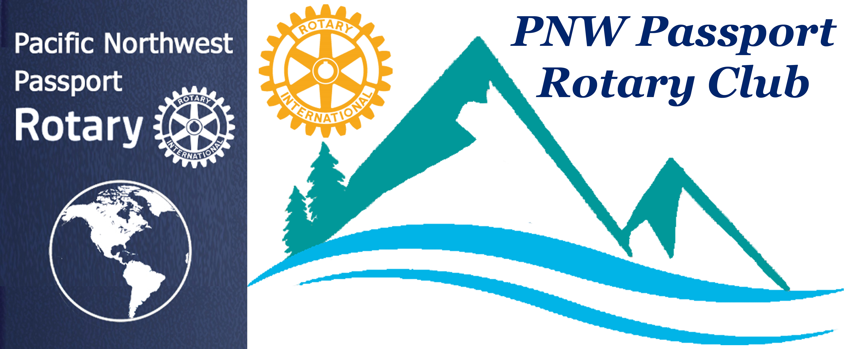

PNW Passport Rotary Club Meeting Notes
Date: November 15, 2018
Time: 7:00 pm
Place: Roadhouse Grill, South Surrey, BC

Sadly our President Tim still has not been able to resolve the problem of his coming across the border. Hopefully this will be resolved in his favour shortly.

Patti and Joy asked Lindagene if she would lead our meeting as our Past District Governor and member of the PNW Rotary Club. We discussed the format of the meeting.

Lindagene opened the meeting by thanking everyone for coming out. She explained the room we were to be in had some painting and staining done recently consequently there was still the smell of these products. She suggested because we don’t get the opportunity to meet and chat with everyone very often we should start with each member introducing him or herself and explaining why they chose the PNW Passport Rotary Club. There were 14 members present and each took their turn.

The common theme for many members as to why they joined PNW Passport Rotary Club was because it was a bolder new way to remain a Rotarian. Some of us acknowledged, as past Rotarians and those who had moved from other Clubs the flexibility offered by a Passport Club was also very appealing. A few members had been Rotarians for many years before deciding they just couldn’t keep up with the commitment or for one reason or another the dollars required to belong to a traditional Rotary Club. Another prominent reason for belonging was the opportunity to help multiply Rotary Clubs with their Service Projects.

Our Club member Navjit Sangha is also a Rotarian at the Newton Rotary Club where she is the Secretary; she is also a member of the Fraser Valley Rotaract Club. As well Nav holds down a full time job!! She is what the saying coined by Lucille Ball meant….
‘If you want something done, ask a busy person to do it. The more things you do, the more you can do.’

Our member Steve Gable is extremely involved with Rotary World Help. He is Web/ Public Relations/ Special Projects Master. Our member Jim McGrandles is a Director.

Steve gave a brief explanation on how Rotary World Help works. It made Steve very happy to see how this project appealed to many members present. He stated the organization always needs help loading a container. The organization would like to see some younger Rotaracts and Rotarians coming out to help with the lifting of items to the container. He would keep us up-to-date with loading dates of containers.

Containers shipped 389
Number of countries receiving aid 60
Estimated value of goods shipped $136,155,000
Estimated people benefitting 11,670,000

Lindagene thanked everyone for sharing what was appealing to each of them as why they joined the PNW Passport Rotary Club.

Lindagene reminded everyone of the importance of having a Visioning Session for a new Rotary Club. Our Vision Session will be in held in January 2019 President Tim is getting a date organized with Ms Spence, District Visioning Co-ordinator

Lindagene explained Club Insurance: In USA RI arranges Club insurance and the cost is included in the RI dues invoice. In Canada each district arranges club insurance and it is invoiced with the district dues.
Patti Villhauer, Engagement Committee Chair: explained what the meeting on December 20 at Burger Bob’s was going to a fellowship meeting the laughter and good fun is the most important part as we continue get to know each other not the exchange/passing of Christmas Gift.

Patricia Selby, Foundation Chair: Talked about November being Rotary Foundation month. She hoped each of us had contributed an amount to RI it could be directed to Polio Plus. We could contribute to Lee Harman’s goal of raising a million dollars for Polio Plus with his trip in Miss Vicki. It was restated that every cent donated under Miss Vicky would be going to Polio Plus. Lee Harman and his friend are personally paying all the expenses of their the trip themselves. Patricia’s Paul Harris jug, which she found in a thrift store, raised $350.00. Thank you Patricia for donating this item. It was the District Governor Linda Murray’s husband who had the winning bid apparently he was thrilled to get the jug in particular as it is Linda’s year as our DG.

A quote from Lindagene on the importance of donating to Rotary Foundation:

“It’s not a donation but an investment in a better world!!”

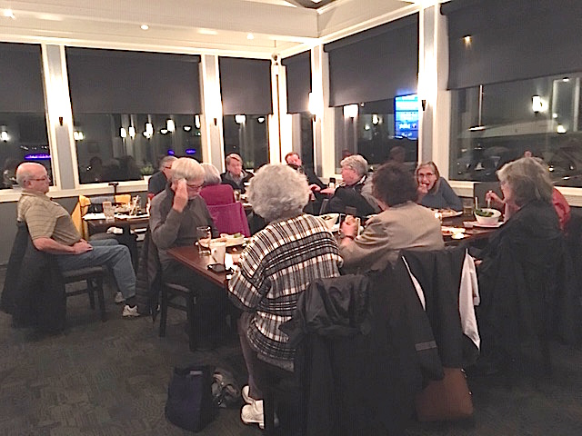

Next Meeting: December 8, 2018
In Rotary We Remain --- Service Above Self
Minutes prepared by: Joy St John, Secretary, PNW Passport Rotary Club

