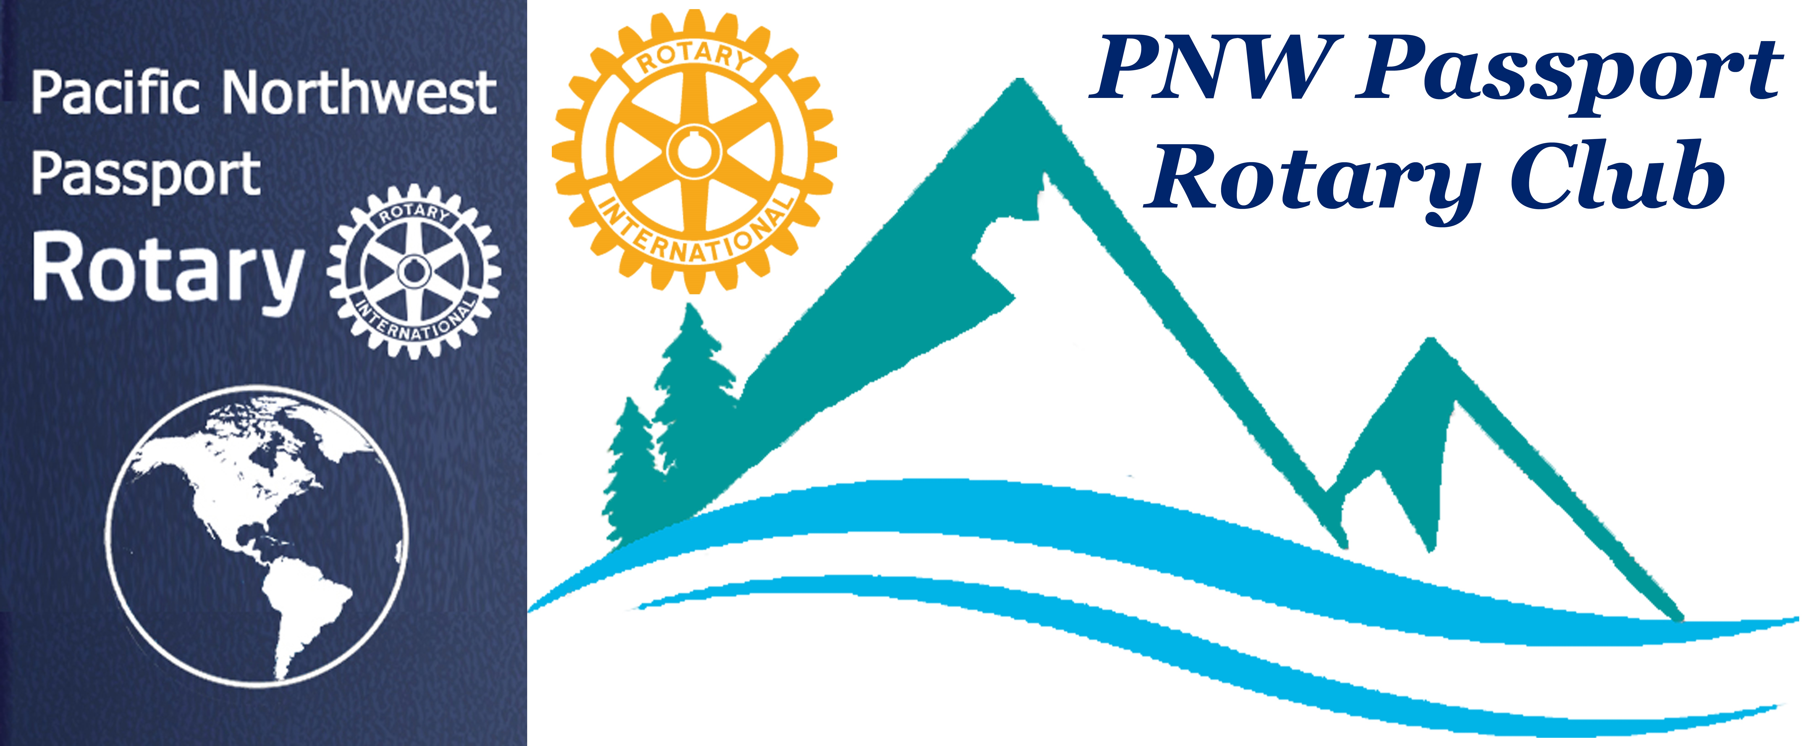

PNW Passport Rotary Club Meeting Notes
Date: October 24, 2018
Time: 6:45 pm
Place: Bob’s Burger & Brew

President Tim opened our meeting with a moment of reflection:
As we gather here today as members of Rotary, let us pray in our own way that we are ever mindful of opportunities to render our service to fellow citizens and our community. Today we strive to help in our own way to help eradicate Polio; we pray that all of us will be as generous as is within our capabilities. Let us continue to strive to do Good in the World. Amen

President Tim asked if we had any visiting Rotarians -- We had none
President Tim asked if we had any Birthdays or Anniversaries – we had none

President Tim – made the announcement of our next meeting.
Our next meeting will be on November 3rd before the District Rotary Foundation Dinner at 5:30 in Northwood Hall. The meeting would be at 3:30 pm details would be send to us as Pati was finding a location close to Northwood Hall.
President Tim encouraged everyone to come to the Foundation Dinner there is going to be an amazing speaker a Polio Survivor Joan Toone. Please sign up through our website.

President Tim – said the next Board Meeting was going to be on November 8th at 7:00 pm via Go To Meeting. There would be a NWP Rotary Club meeting on November 15th in Canada with details to follow. There would be a Board meeting on December 6th, a Club meeting on December 8th in Canada possibly at the Rotary Field house. December 12 6:00 pm at Bob’s Burger & Brew a fun fellowship evening of a White Elephant gift exchange. More information to follow on that fun filled evening.

There were no reports given.

President Tim introduced our guest speaker:

Lee Harman, MD, FACS
He has been a Rotarian for 34 years with the Rotary Club of Arlington, Washington
Lee:
- was Centennial President 2004-05
- Assistant Governor 2008-11
- District Polio Plus Chairman 2011-12
- Endowment/Major Gift Adviser, TRF 2012-13
On the personal side of Lee
- Founder/Managing Partner The Harman Eye Clinic now retired
- Cataract/Refractive Surgeon
- Fellow American College of Surgeons
- Fellow American Academy of Ophthalmology
- US Navy Flight Surgeon
- Captain, Medical Corp, USNR (ret)
- Private Pilot: Instrument rated, single, multi-engine land & sea

Married to his wife Judy for 44 years, they have two children and two grand children
He is Arch C. Klumph Society Member 2012
He is known for saying …. “I owe more to Rotary than I can ever pay back.”

Lee Harman To End Polio

Lee informed us that he & Miss Vicky are on a very busy trek here in District 5050 to raise awareness to End Polio and his desire to raise 1 million with the challenging 10,000 mile trek Beijing to Paris, which begins on June 2, 2019! He will be making this trek with a long time friend. Their goal is to complete the trek in their beloved Miss Vicky a 86-year old car. Miss Vicky has had a few upgrades but not many they will still feel the many bumps along the trek and have to traverse the roads with care.

Lee also gave us up-to-date information on the way the World Health Organization is trying to contain polio they have determined administering a vaccination is the best way, then give the drop at a later time. He also explained the first years that Rotary was raising funds went mostly to putting together the methods that Rotary could best get children worldwide help. It was by administering polio drops. The Bill Gates Foundation still continues to support Rotary and their efforts to eradicate Polio from the World. Will we ever be able to eradicate this disease yes but only if we continue to give polio vaccinations to newborn children worldwide.

Past District Governor Lindagene brought along Rotary items to auction off what ever your bid is what you were to donate to End Polio. The gifts were great and it was a fun way to donate. Thank you Lindagene.

President Tim inducted our newest member Anita Sangha. Marietta Ostberg her sponsor introduced Anita to the Club and told us a little bit about why Anita would make a fine Rotarian.

Patricia Sibley brought along a piece of pottery that she is going to take to the Foundation Dinner to be auctioned off. She found this special item in a Thrift Store. It is a jug to celebrate the 25th Anniversary of Rotary by potter Albert Gay. President Tim also had Sea Hawk tickets that are to be auctioned off.

President Tim adjourned the meeting at 8:00 pm

We all went out to admire Miss Vicky as well as wish Lee best of luck on his fundraising to help Rotary’s goal to End Polio & his personal goal of doing the trek Beijing to Paris June 2019!!!

Next Meeting November 3, 2018 Northwood Hall
In Rotary We Remain --- Service Above Self

