Please Note Upcoming Dates

April 27 -- rotary World Help Date
Rise Against Hunger, Bellingham WA
or where ever you choose to be a Rotarian Helping
May 8 -- Rotary Executive Meeting – All welcome to Join
GoToMeeting online
May 11 -- Rotary Meeting 4:00 pm – 6:00 pm
Roadhouse Grille, Surrey, BC
May 23 -- Rotary Meeting 6:00 pm – 8:00 pm
Bob’s Burger & Brew, Birch Bay Sq, WA

PNW Passport Rotary Club Meeting Notes

Date: April 25, 2019 Time: 6:00 pm
Place: Roadhouse Grill, Surrey, BC

We were reminded of an important one year anniversay ours!!
PNW Passport Rotary Club --- March 3, 2018!!

President Elect Deb welcomed us to the meeting. Because of her special interest in literacy and love of reading she asked the members in attendance to tell us about a special book they may have read recently or a book they are presently reading or read as a child.

Irma Mohammed: said she was about to read a book that was ten years in the making, “A Woman in Between” brings together the intriguing story of Dr. Victoria Chung, the first Asian Canadian to earn a medical degree in Canada. Meet authors Dr. John Price and Dr. Ningpu Yu!
Rosemary Jones: is reading the bestseller book Becoming Michelle Obama.
Allen Stockbridge: said he was reading the book Power and wishes he had read it years earlier.
Patricia Sibley – talked about the Libby App for libraries.
Julie Johansen – spoke about a book she was reading about Ted Roosevelt.
Mary Wilson – talked about ‘When She Woke’ a fable about a stigmatized woman struggling to navigate an America of a not-too-distant future, who embarks on a path of self-discovery that forces her to question the values she once held true and the righteousness of a country that politicizes faith.
Mary also told us about the magazine Fast Company a monthly American business magazine published in print and online that focuses on technology, business, and design. It publishes eight print issues per year.
Lindagene Coyle – told us she is presently reading books by Janet Evanovich in particular the Plum series. She listened to the audiotape of Red Tent.
Some had finished and some were starting to read ‘The Tattooist of Aushwitz’ a beautiful, illuminating tale of hope and courage is based on interviews that were conducted with Holocaust survivor and Auschwitz-Birkenau tattooist Ludwig (Lale) Sokolov—an unforgettable love story in the midst of atrocity.
Then there were some of us that haven’t been doing a lot of reading of late due to one reason or other. I for one love to watch NetFlix documentaries, the last one I watched was Chasing Perfection about how athletes and sports have evolved will continue to evolve with technology and research.
P-E Deb thanked the group for helping us to continue to know each other.

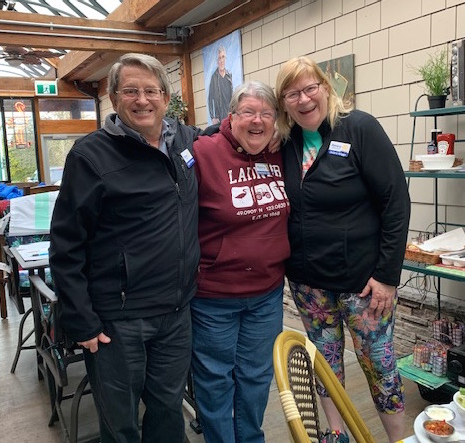
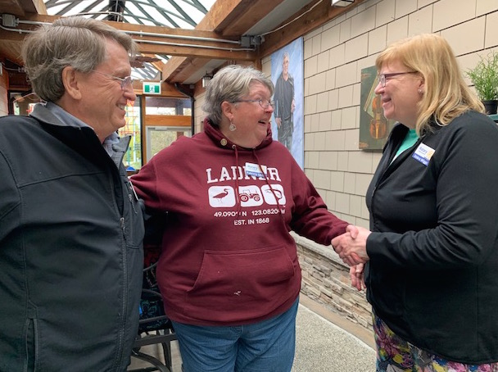
P-E Deb said as a third generation Rotarian it was an honour to call Patricia Sibley up to receive her Paul Harris plus five pin. She thanked Patricia for all her hard work over the years for Rotary in the world and her community in particular Rotary Foundation. Allen Stockbridge pinned the Paul Harris on Patricia.

The PNW Passport Rotary Club members thank you Patricia and feel lucky to have you as a member.

Allen Stockbridge asked for an update from the recent District 5050 Rotary Conference.

P-E Deb said she was unfortunately only at part of the conference. Some stand out points for her were:

- The tour of the Boeing Plant – having a huge interest in planes this was a real thrill to go to this plant the largest in the world, with its own weather system, bigger then Disneyland.
- The talk by Paul K. Chappell, he is the Peace Literacy and Leadership Director for the Nuclear Age Peace Foundation.
- P-E Deb said she also found the talk on renewable waste management very interesting.

P-DG Lindagene – said she thoroughly enjoyed in the House of Friendship. Sixteen Rotary Clubs presented their projects. Some of the displays were the Shelter Boxes, IPA (International Project Alliance) on water & education. The Rotaracts who are going to Guatemala to install stoves were present. P-DG Lindagene said she would like to establish more Rotary Fellowship programs locally. She belongs to the Wine & Whiskey Fellowship group.

Patricia Sibley said she went on a Quilters Friendship to Iceland. It was a fantastic experience to be in another country learning about their quilting techniques with the bonus of seeing the country. Patricia also said there was a Boundary Bay Quilters Guild “Quilts by the Bay” Quilt Show – May 4 & 5, 2019.

P-E Deb and P-DG Lindagene announced that Rotary International has now changed the status of Rotaracts:
Quote: Among the most important, the Council elevated the status of Rotaract clubs. The change broadens the definition of membership in Rotary International to include Rotaract clubs. The change is intended to increase the support that Rotaract clubs receive from RI and to enhance their ability to serve.
“We need to be an inspiration to our young partners, so they will continue doing the great service that they do,” said RI President Barry Rassin when he presented the measure. “This sends a strong message that they are truly our partners in service.”
In many ways, the Rotaract experience will not change. Rotary clubs will still charter and sponsor Rotaract clubs. Rotaract clubs will still have their own standard constitution and their own unique club experience. Members of a Rotaract club will not be called Rotarians. And Rotaract clubs will not immediately pay dues or receive other benefits, such as the official magazine that Rotary members receive. The Board will determine a dues structure over time.
The measure simply expands the definition of membership in Rotary International to include both Rotary and Rotaract clubs.

Service Committee: Julie Johansen

Julie reminded us that April 27 was Rotary Work Day. One project our Club would be working at was Rise Against Hunger.

Engagement Committee: Pati Villhauer

Pati said Roger Kelley is going to be speaking to us about Project YES at an upcoming meeting. She is hoping to have some one from the Mercy Ships come and talk to us both in Canada and the US.

New Business:

P-E Deb spoke to us about her goals for the coming year. She’d like us to become even more involved with other clubs’ projects within District 5050. She spoke to what service hours we should be recording for submission to Rotary International. She said service hours don’t need to be just working on a Rotary project but can be volunteering within our community or broader. Wearing our Rotary pins shows that Rotary helps wherever there is a need for a volunteer.

Secretary Joy said she would be asking the membership for those types of hours and she would record them for submission to Rotary International. We would work to improve the Club’s knowledge of our member Marietta Ostberg’s app for recording our hours. Please watch for this information. Until then Joy would be requesting members to send her their hours of volunteering. Send them weekly, every two weeks or monthly whatever is convenient for the member.

P-Elect introduced our speaker for our meeting. Hazel MacDonald one of our newest members. Hazel had been a Rotarian for a very brief time in Kingston, Ontario. After a trip with a friend, her friend’s family who are Rotarians & her daughter to India on End Polio trip she knew she wanted to be a Rotarian again to continue helping locally & around the world.

Hazel spoke to the history of how Rotary began helping to end polio around the world. How there were over 100 countries with polio and now only three countries. India was one of the first to have a visit from End Polio Team. Now India is polio free. Hazel spoke about how rewarding it was to be able to help out especially when seeing the children & their parents. She spoke about how the village embraced the team from those they administered the vaccine to, to the older children and the Rotarians of the area. It was such a rewarding trip for her and her daughter. The team was in that particular village for one day only from 9:00 am to 1:30 pm when they ran out of vaccine. Her friend, Sharon Miller brought along menstrual kits to leave for the women of the village.

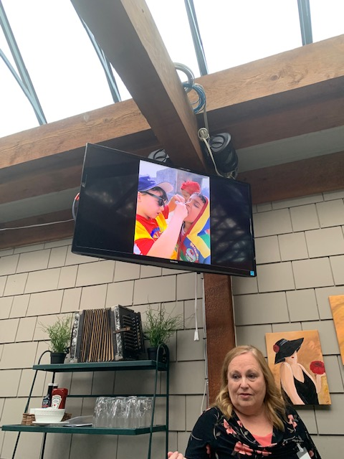

P-E Deb thanked Hazel for her presentation. The presentation was heartwarming on so many levels. Thank you Hazel for joining our Club we will benefit from your experience.

Meeting adjourned at: 8:00 pm Notes taken by: Joy St. John
Next Club Meeting: May 11th Roadhouse Grille, Surrey, BC 4:00 pm – 6:00 pm

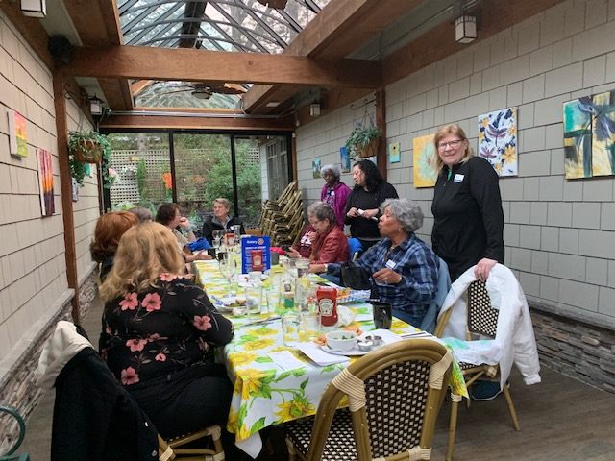
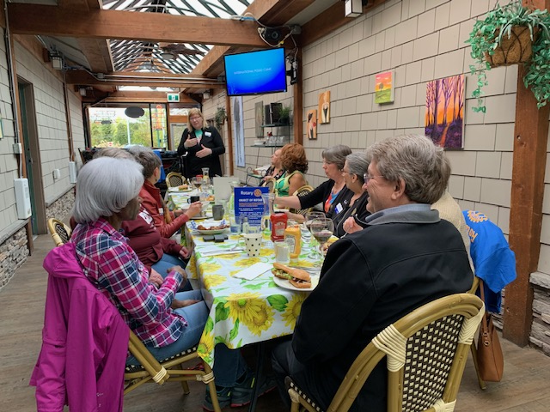
Wonderful fellowship at the PNW Passport Rotary Club Meeting

