**PNW Passport Rotary Club Meeting Notes**

**Date**: FEBRUARY 21, 2019 **Time**: 6:15 pm

**Place**: Roadside Grille, Surrey, BC

**Club Attendance:** 6 members 5 guests

**Presidents Report**:

President Tim wasn’t able to make the meeting P-President Sean graciously stood in for him.

President Tim did share with us his Moment of Reflection that Sean put on the screen:

Tonight, from two democratic nations, which prove that a border can be shared for centuries in peace, we are men and women gathered in the spirit and support of Rotary International, our own Club and Rotary District 5050.

As we enjoy our fellowship, help us to remember how fortunate we are to be able to serve our brothers and sisters around the world through our great organizations, and its astonishing Foundation!

Amended, Joseph Coons, Bellingham

P-Past Sean welcomed us to tonight’s meeting. He asked us to introduce ourselves. This is just a few of the introductions of the 11 in attendance for our meeting:

Hazel MacDonald: belonged to a Rotary Club in Kingston, Ontario for a short period of time. She has now moved to British Columbia. She would like to re-join Rotary after recently going with Rotary to a Polio Clinic in India. She found us on the Internet she feels we might be just the Club she has been looking for. We hope to see her application soon.

Bonnie Sutherland: she is with the North Delta Rotary Club. Bonnie came tonight because of our topic AERES. She has traveled with Sean promoting AFRETECH Aid Society.

Frank Jarvis: has been a Rotarian for 24-years, he is with the North Delta Rotary Club. His passion is RYLA he has been involved with the program for years.

Patricia Sibley: this is her fourth Rotary Club. We hope to be the last and the best. Patricia’s son-in-law is the forklift driver with Rotary World Help. She has helped with many shipments. She is an extremely busy lady. One of her other volunteer projects is with the White Caps where is has been working her magic for four years.

P-President Sean: gave us a wonderful treat he showed us a video from his Antarctic trip with Carol (his very special wife) before going to Africa. He encouraged all of us if we ever had the opportunity to take this trip it was well worth every penny.

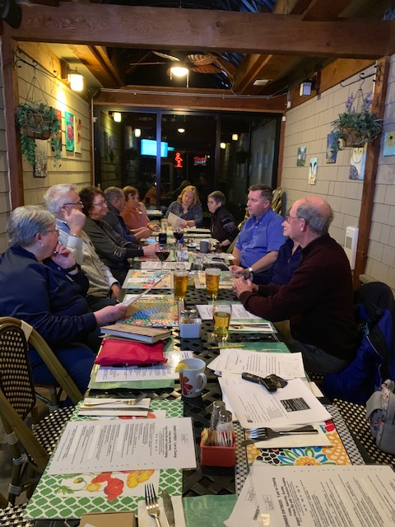We continued to watch the video while eating and socializing. It was a spectacular video with amazing scenery. There were many questions for Sean regarding what we were seeing. Thanks Sean for sharing your pictures with us.

P-President Sean our keynote speaker introduced our topic for tonight ARES (African Ruggedized Education System).

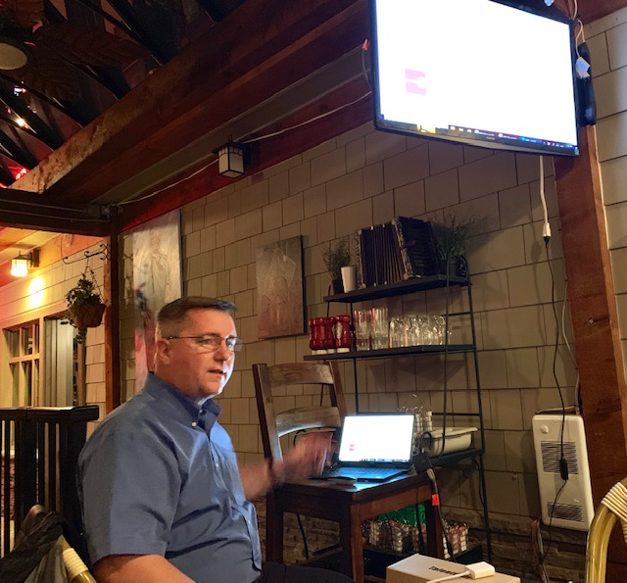

P-P Sean said he got involved with this fantastically important project after talking to Bonnie and Don Sutherland. Bonnie and Don visited Kenya a few years ago being educators they saw the need for Kenya’s education system to be updated. They first started with old recycled computers with connection to a very antiquated Internet. Sadly they found on the return trip the equipment wasn’t working parts had been removed (stolen). With this sad knowledge they returned home to figure out how they could make a better system!!! They reached out to a tech friend (Mark Knittel) for suggestions!! He built the system they now use!! It is Education in a Box.

Mark Knittel, a member of the Bellingham Rotary Club, in Washington, USA and IT Director of AFRETEH Aid Society. He felt there had to be a better way and there was AFRETECH Aid Society a volunteer non-government organization, it has been collaborating on ARES installations and training local teachers in Kenya for two years now. The system is successfully up and running in a dozen Kenyan schools and one in Uganda.

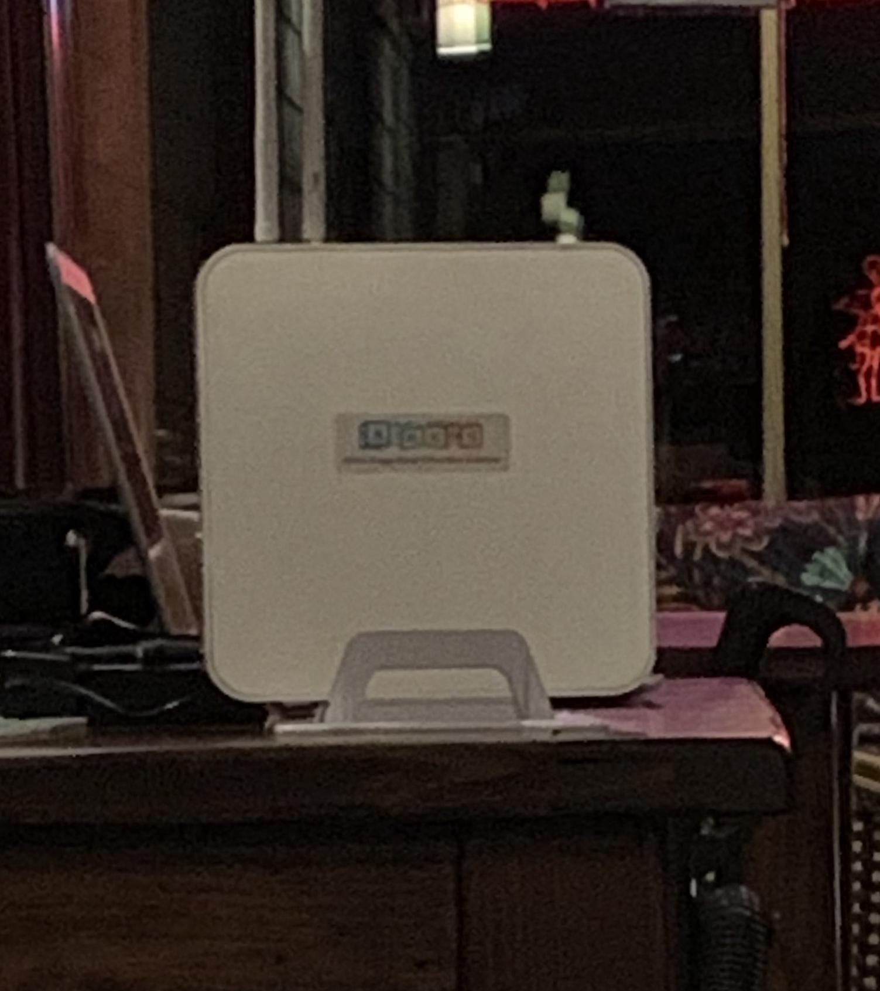

This box holds so much information for teachers from K to University level!!! At first some teachers were skeptical but once they saw the capabilities they were 100% on board with using it.

The server is really rugged – it can work all day on a single charge, a plus where power is an intermittent commodity.  Up to 40 devices (tablets, smartphones, laptops, wifi enabled desktops) can connect to multiple ARES’ sites at the same time.  And this server withstands heat and dust, cannot be fried by power surges, is not compromised by power outages, and has few moving parts to minimize maintenance. The server is locked up every night. It doesn’t seem to grow legs this way.

Using ARES, teachers and students can sit under a tree in Turkana and still have access to educational resources, pre-school to post grad.  It is an efficient, cost-effective way to deliver massive amounts of content to classrooms starved for resources.

The project is funded totally through donations. Please go to their website: <http://www.ares.education/home.html> there you will find the many ways you can help fund this project which they hope to take to other countries. If you feel you’d like to volunteer on their next trip please connect with Sean or Bonnie. Volunteers pay their own way but AFRETECH Aid Society will give you a tax receipt for a portion of your trip. Their website is: <http://www.afretech.org/>

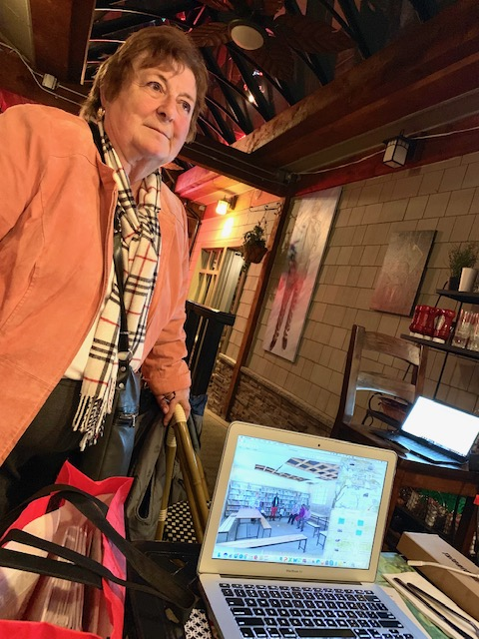ARES is in need of another tech/designer or more.

Along with putting in the server they take books and set up libraries for the schools. The joy in a child’s face when he or she looks at the books is worth so very much and does wonders for ones heart. Bonnie had endearing pictures of the smiles brought to the faces of many. As well as the stories these children told her.

This project got underway when four Rotary Clubs in District 5050 raised $5,000. that money was matched.

P-P Sean couldn’t stress enough the need for this project because of the wonders it brought to the children in bettering their education and knowledge of the world.

Joy thanked Sean and Bonnie for the very heartfelt informative presentation.

**Meeting adjourned at**: 8:25 pm **Notes taken by**: Joy St. John, Secretary

**Next Club Meeting:**

**Date: March 9, 2019 Time: 4:00 – 6:00 pm**

**Location: Roadside Grille, Surrey, BC**

**PACIFIC NORTH WEST PASSPORT ROTARY CLUB**

**March – May 2019 CALENDAR**

**Please mark these dates on your calendar!!!**

|  |  |  |
| --- | --- | --- |
| **DATE** |  | **PLACE** |
| **March 2** | **Rotary Leadership Institute** | **Everett WA** |
| **March 9, 4-6:00 pm** | **Meeting - Roadside Grille** | **Surrey, BC** |
| **March 13, 7-8:30 pm** | **Executive Board Meeting** | **Go to Meeting** |
| **March 23, 8:am-3pm** | **District Training Assembly**  **Kwantlen Polytech University** | **Surrey, BC** |
| **March 23, 3:30-5:pm** | **PNW Passport Rotary Club Annual General Meeting** | **Sean & Carol’s home Surrey, BC** |
| **March 27,** | **Important volunteer opportunity: Whatcom County North Rotary Career Choices Fair -- they are in need of more speakers and volunteers** |  |
| **March 28, 6-8:pm** | **Meeting, Bob’s Burgers & Brew** | **Birch Bay Square, WA** |
| **April 10, 7-8:30pm** | **Executive Board Meeting** | **Go to Meeting** |
| **April 11-14** | **District 5050 Conference** | **Tulalip Casino, WA** |
| **April 13, 4-6:pm** | **Meeting, Tulalip Casino** | **WA** |
| **April 25, 6-8:pm** | **Meeting, Roadside Grille** | **Surrey, BC** |
| **April 27** | **Important volunteer opportunity**  **& Rotary Work Day: Rise Against Hunger. They need volunteers and donations.** | **WA** |
| **May 8, 7-8:30 pm** | **Executive Board Meeting** | **Go to Meeting** |
| **May 11, 4-6:pm** | **Meeting, Roadside Grille** | **Surrey, BC** |
| **May 23, 6-8:pm** | **Meeting, Bob’s Burgers & Brew** | **Birch Bay Square** |